# **A** R**eport on**

# Predictive Modelling

# By

# Ritu Utkarsha

**Problem 1**: Linear Regression

The comp-activ databases is a collection of a computer systems activity measures .  
The data was collected from a Sun Sparcstation 20/712 with 128 Mbytes of memory running in a multi-user university department. Users would typically be doing a large variety of tasks ranging from accessing the internet, editing files or running very cpu-bound programs.

As you are a budding data scientist you thought to find out a linear equation to build a model to predict 'usr'(Portion of time (%) that CPUs run in user mode) and to find out how each attribute affects the system to be in 'usr' mode using a list of system attributes.

DATA DICTIONARY:  
-----------------------  
System measures used:

lread - Reads (transfers per second ) between system memory and user memory  
lwrite - writes (transfers per second) between system memory and user memory  
scall - Number of system calls of all types per second  
sread - Number of system read calls per second .  
swrite - Number of system write calls per second .  
fork - Number of system fork calls per second.  
exec - Number of system exec calls per second.  
rchar - Number of characters transferred per second by system read calls  
wchar - Number of characters transferred per second by system write calls  
pgout - Number of page out requests per second  
ppgout - Number of pages, paged out per second  
pgfree - Number of pages per second placed on the free list.  
pgscan - Number of pages checked if they can be freed per second  
atch - Number of page attaches (satisfying a page fault by reclaiming a page in memory) per second  
pgin - Number of page-in requests per second  
ppgin - Number of pages paged in per second  
pflt - Number of page faults caused by protection errors (copy-on-writes).  
vflt - Number of page faults caused by address translation .  
runqsz - Process run queue size (The number of kernel threads in memory that are waiting for a CPU to run.  
Typically, this value should be less than 2. Consistently higher values mean that the system might be CPU-bound.)  
freemem - Number of memory pages available to user processes  
freeswap - Number of disk blocks available for page swapping.  
------------------------  
usr - Portion of time (%) that CPUs run in user mode

* 1. **Read the data and do exploratory data analysis. Describe the data briefly. (Check the Data types, shape, EDA, 5-point summary). Perform Univariate, Bivariate Analysis, Multivariate Analysis.**

**Solution:** Exploratory data analysis (EDA) is used to analyse and investigate data sets and summarize their main characteristics, often employing data visualization methods. It helps determine how best to manipulate data sources to get the answers we need, making it easier to discover patterns, spot anomalies, test a hypothesis, or check assumptions.

**HEAD OF THE DATASET**: First 5 records of the dataset

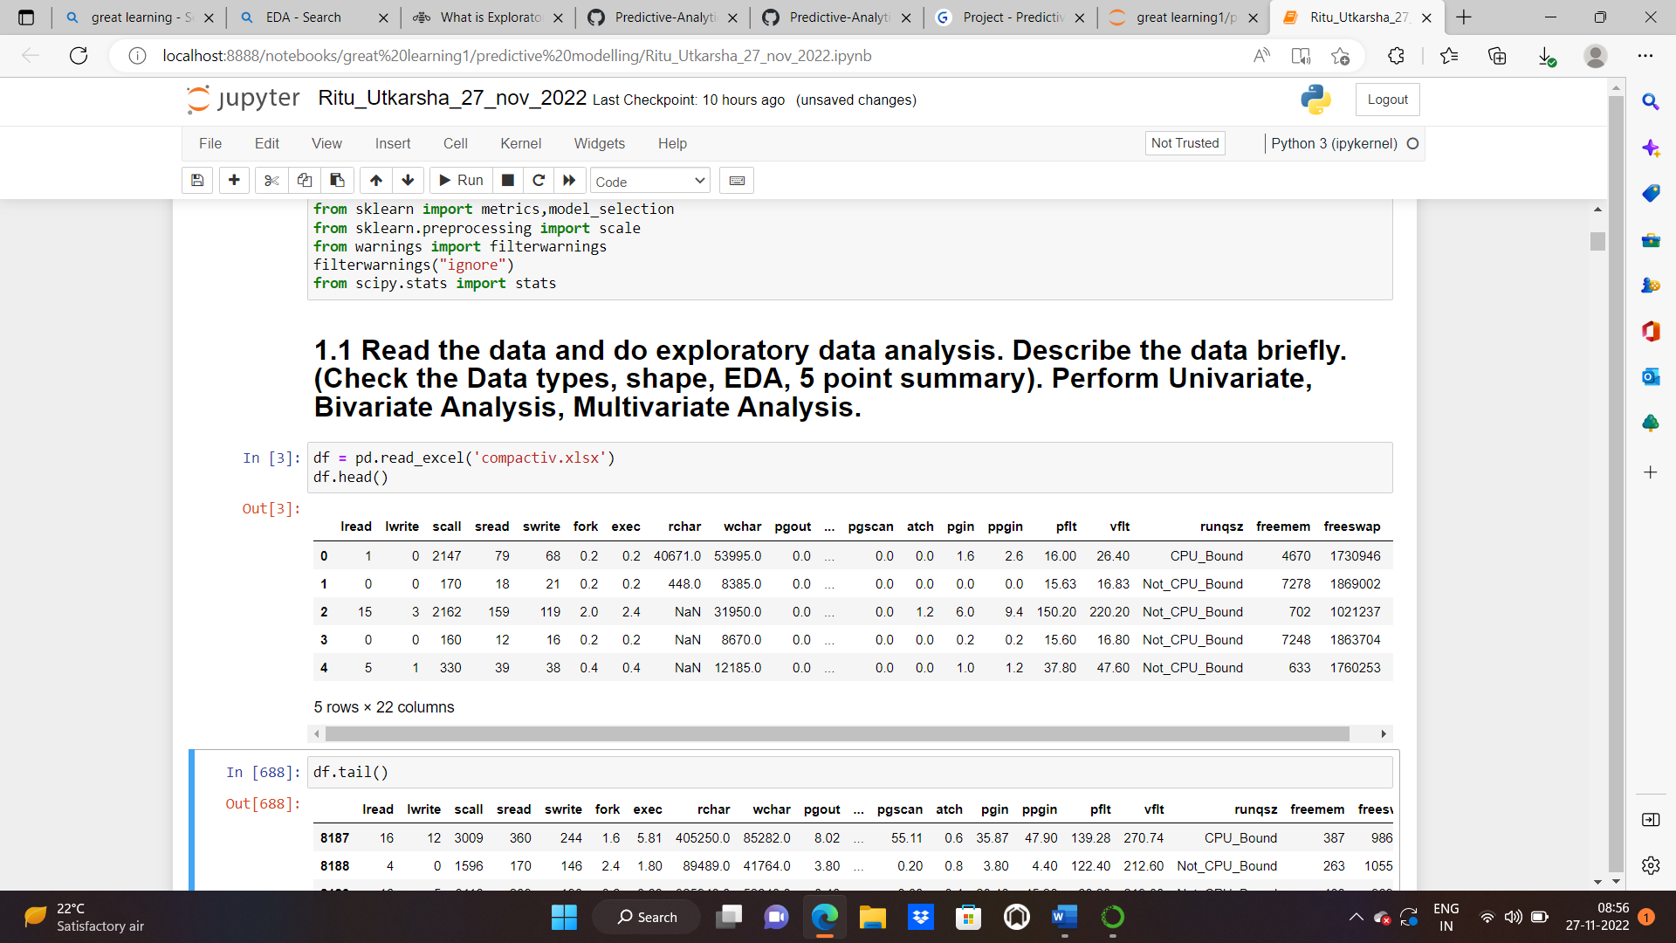

**TAIL OF THE DATASET**: Last 5 records of the dataset

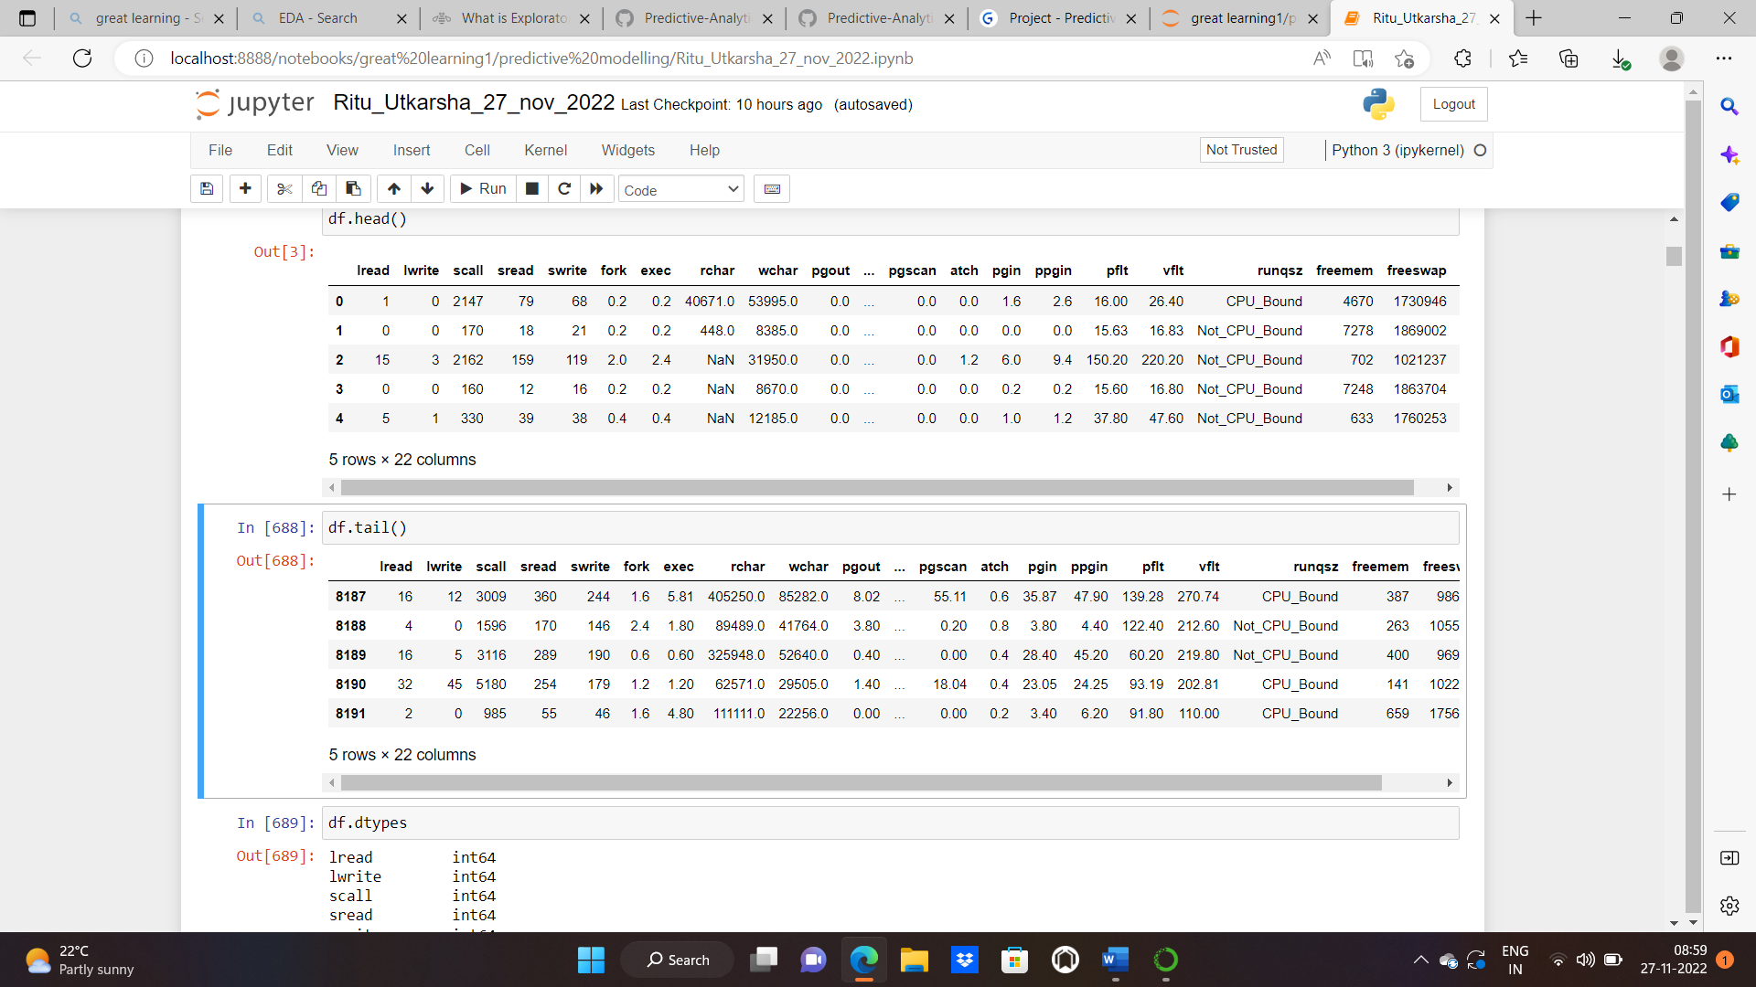

**DATATYPES OF EACH COLUMN IN THE GIVEN DATAFRAME:**

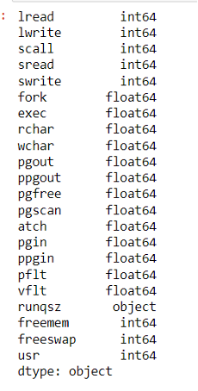

**SHAPE OF THE DATASET:**

Shape attribute tells us number of observations and variables we have in the data set. It is used to check the dimension of data. This dataset has 8192 observations (rows) and 22 variables (columns) in the dataset.

**INFO:** It is used to get a quick summary of the dataset. It comes handy when doing exploratory analysis of the data. To get a quick overview of the dataset, we use .info function.

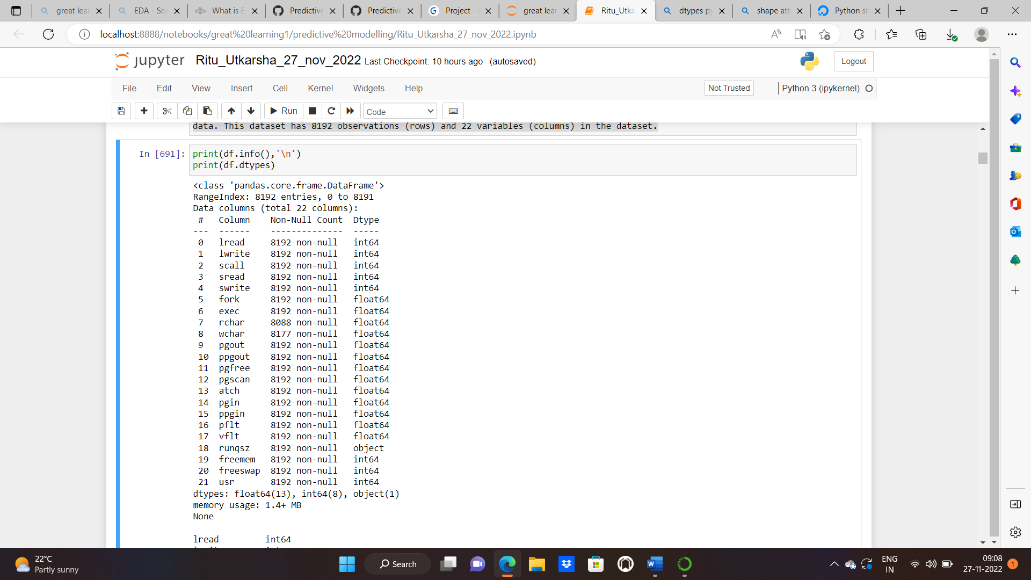

13 columns are of float data type,8 is of integer types and 1 is of object type. There are missing values in “rchar” and “wchar” columns. Memory used by the dataset: 1.4+ MB

**DESCRIPTIVE STATISTICS:**

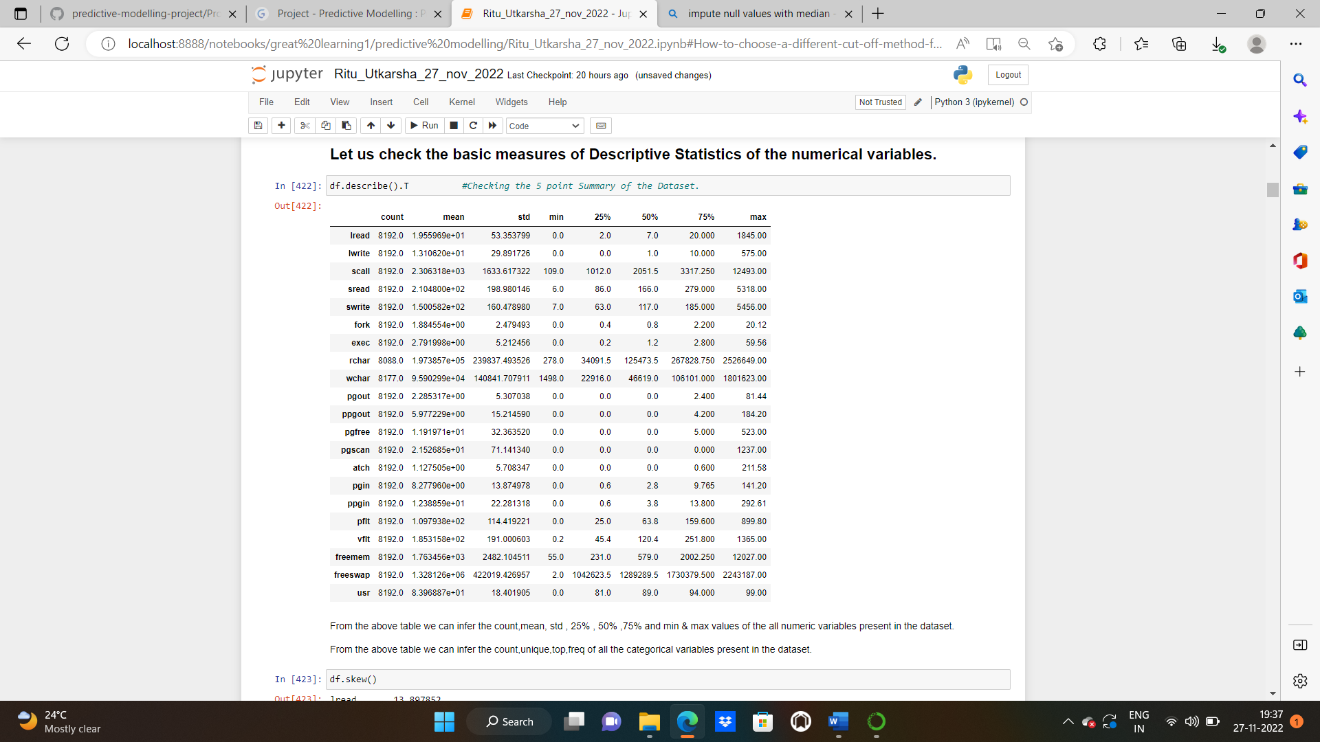

From the above table we can infer the count, mean, std , 25% , 50% ,75% and min & max values of the all numeric variables present in the dataset.

From the above table we can infer the count,unique,top,freq of all the categorical variables present in the dataset.

**NULL VALUES**: We have 104 missing values in “rchar” and 15 missing values in “wchar” columns.

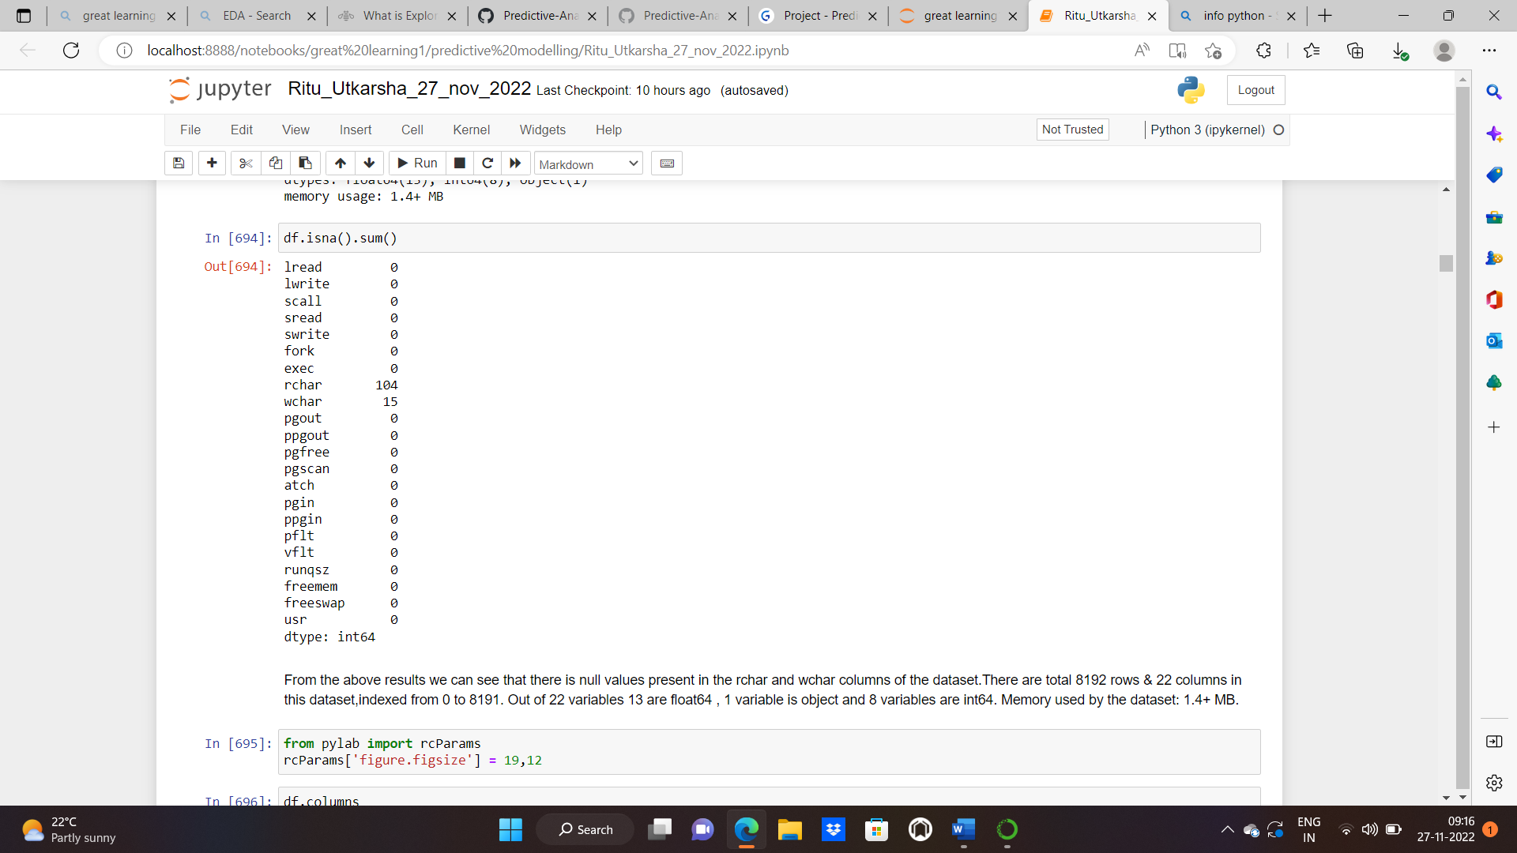

**CHECKING UNIQUE VALUES IN CATEGORICAL VARIABLE:**

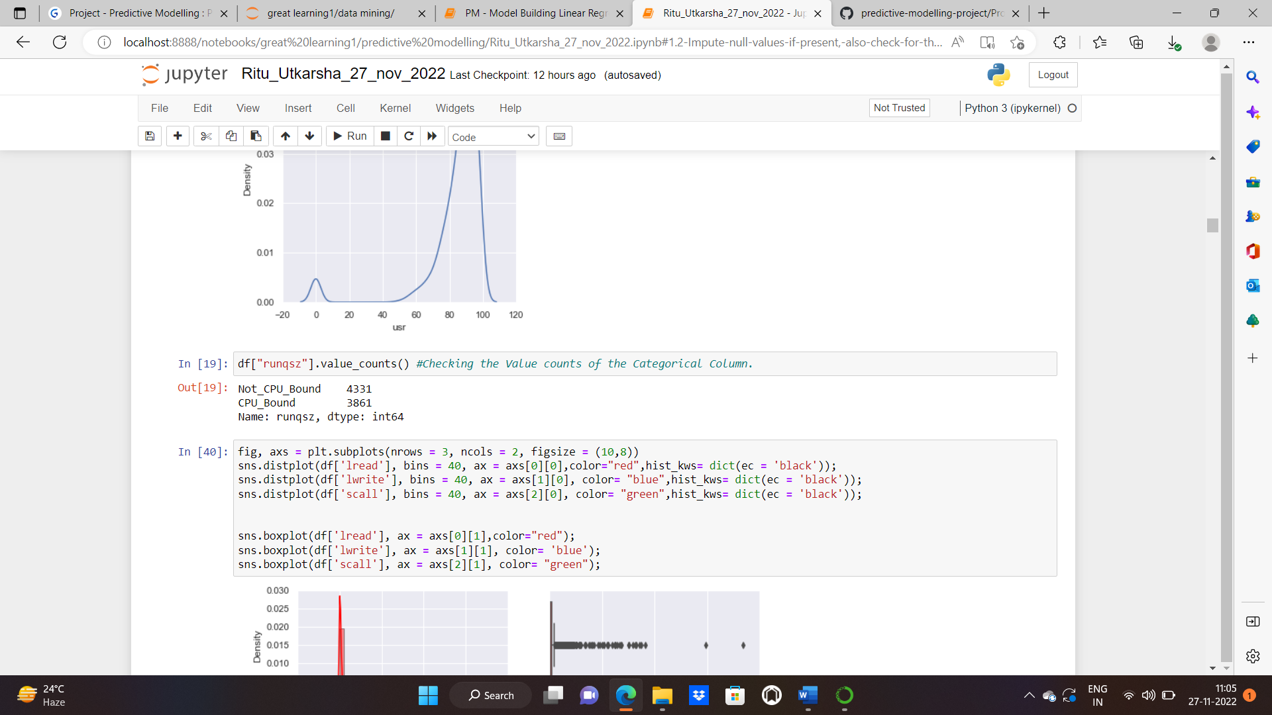

**UNIVARIATE AND BIVARIATE ANALYSIS:**

**Univariate analysis** is the simplest form of analysing data. “Uni” means “one”, so in other words your data has only one variable. It doesn’t deal with causes or relationships and it’s major purpose is to describe; It takes data, summarizes that data and finds patterns in the data.

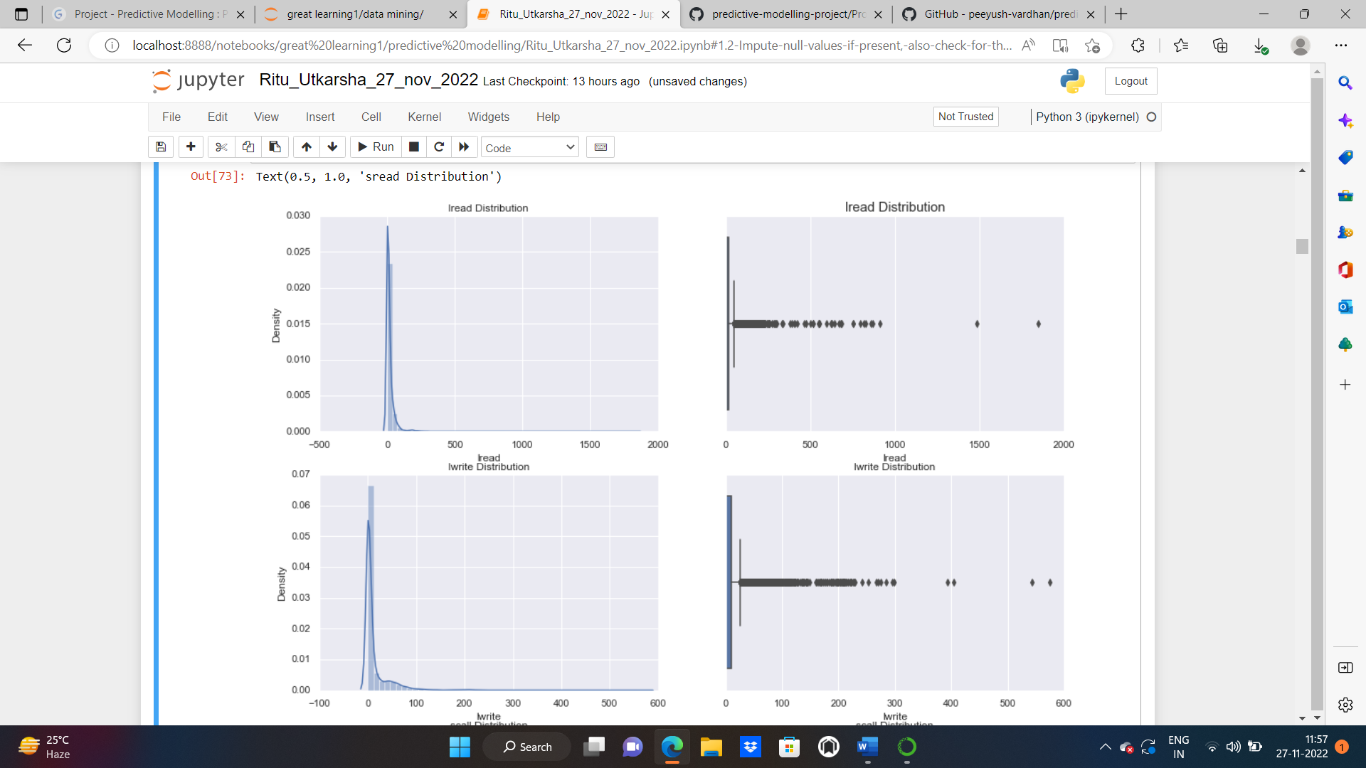

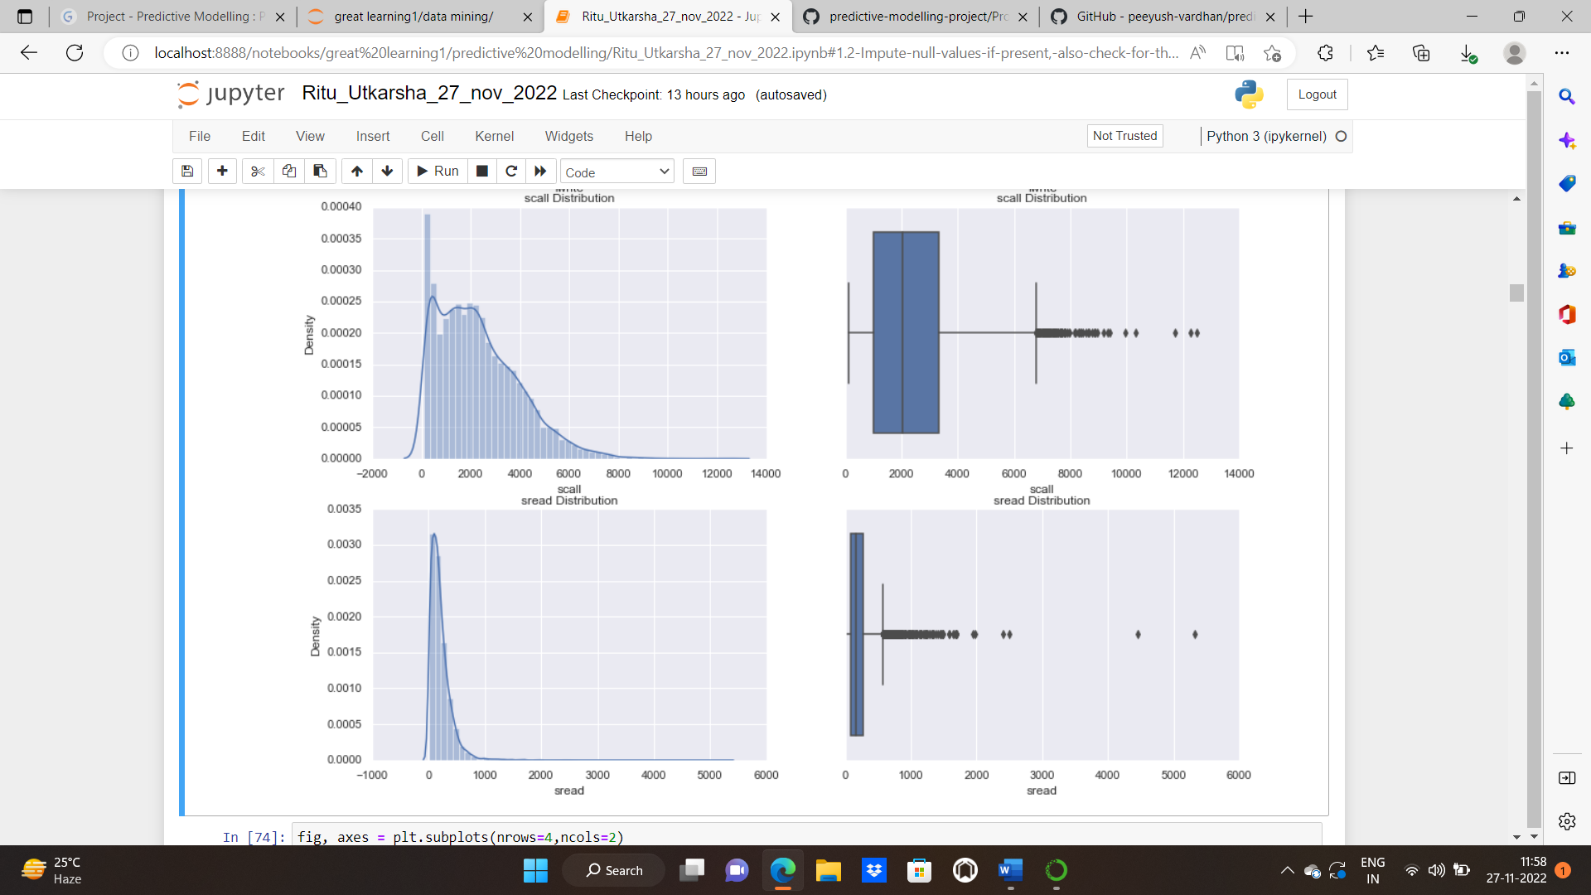

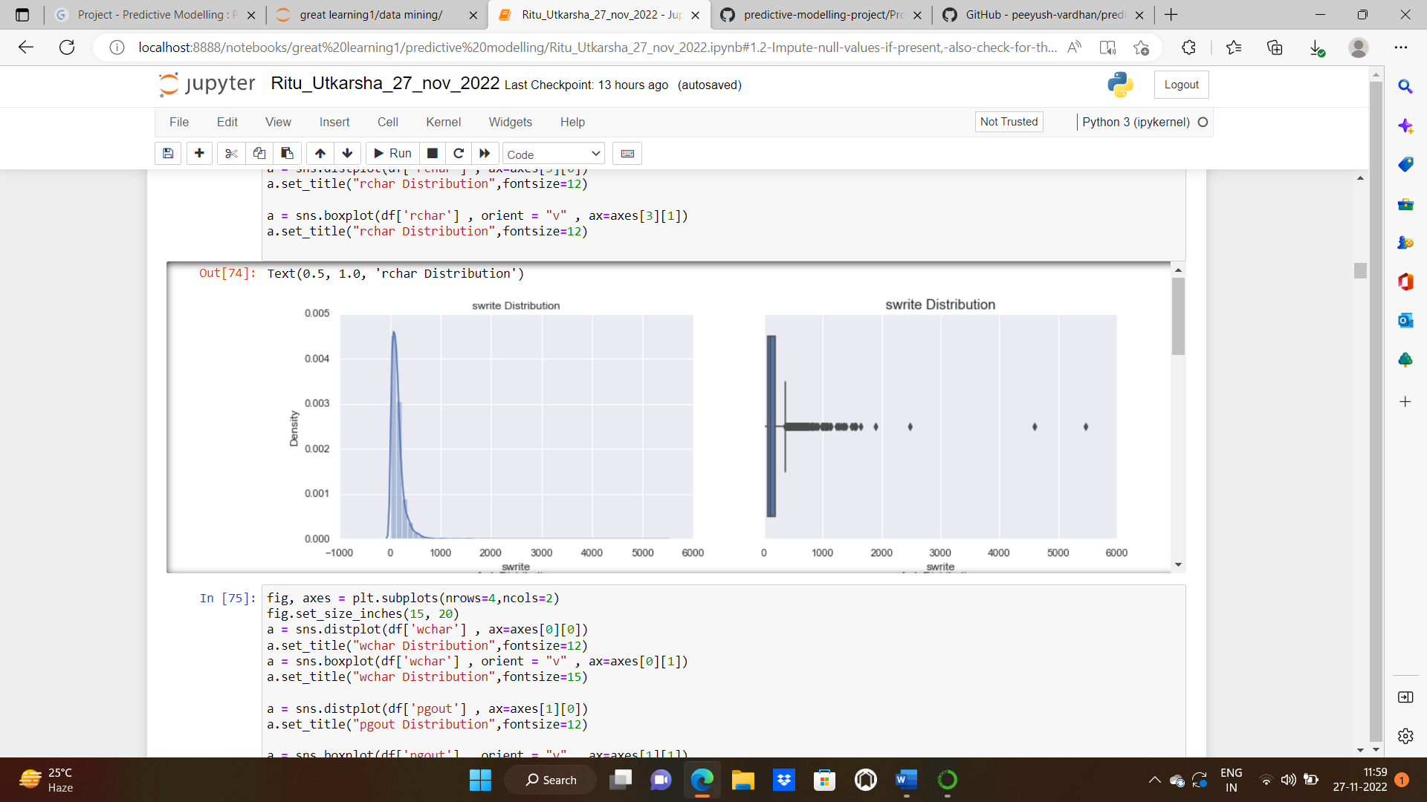

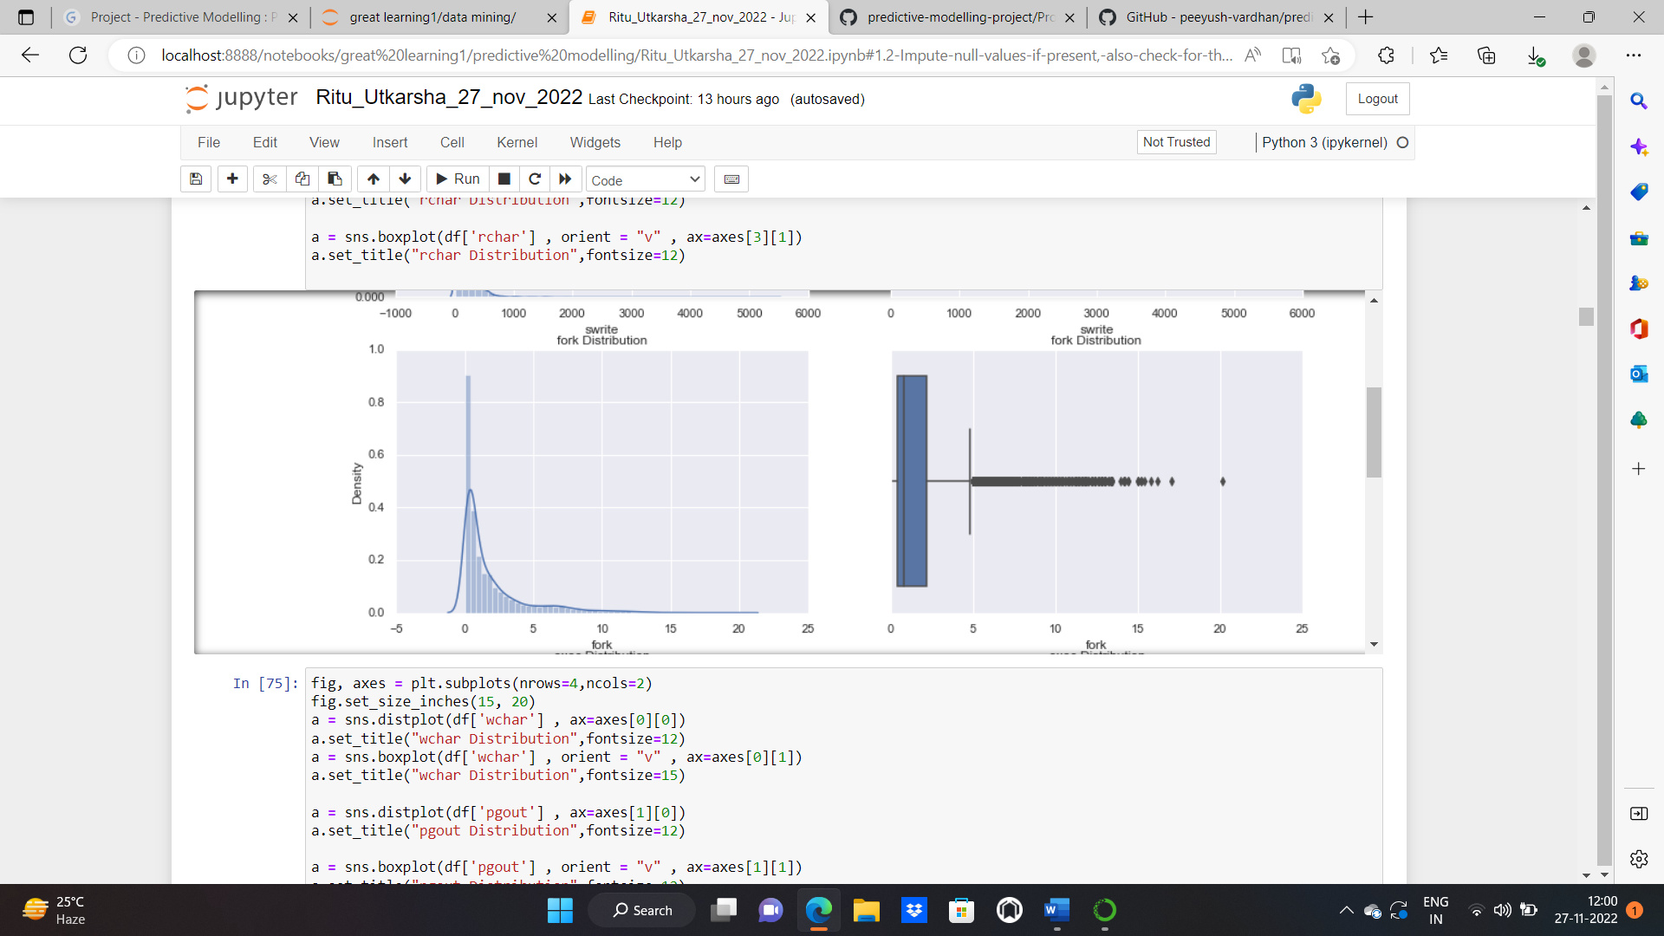

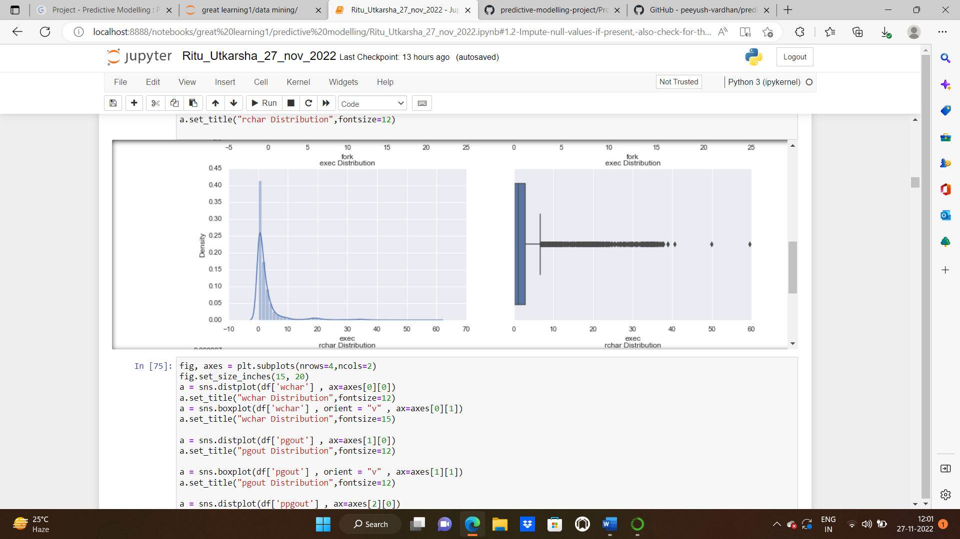

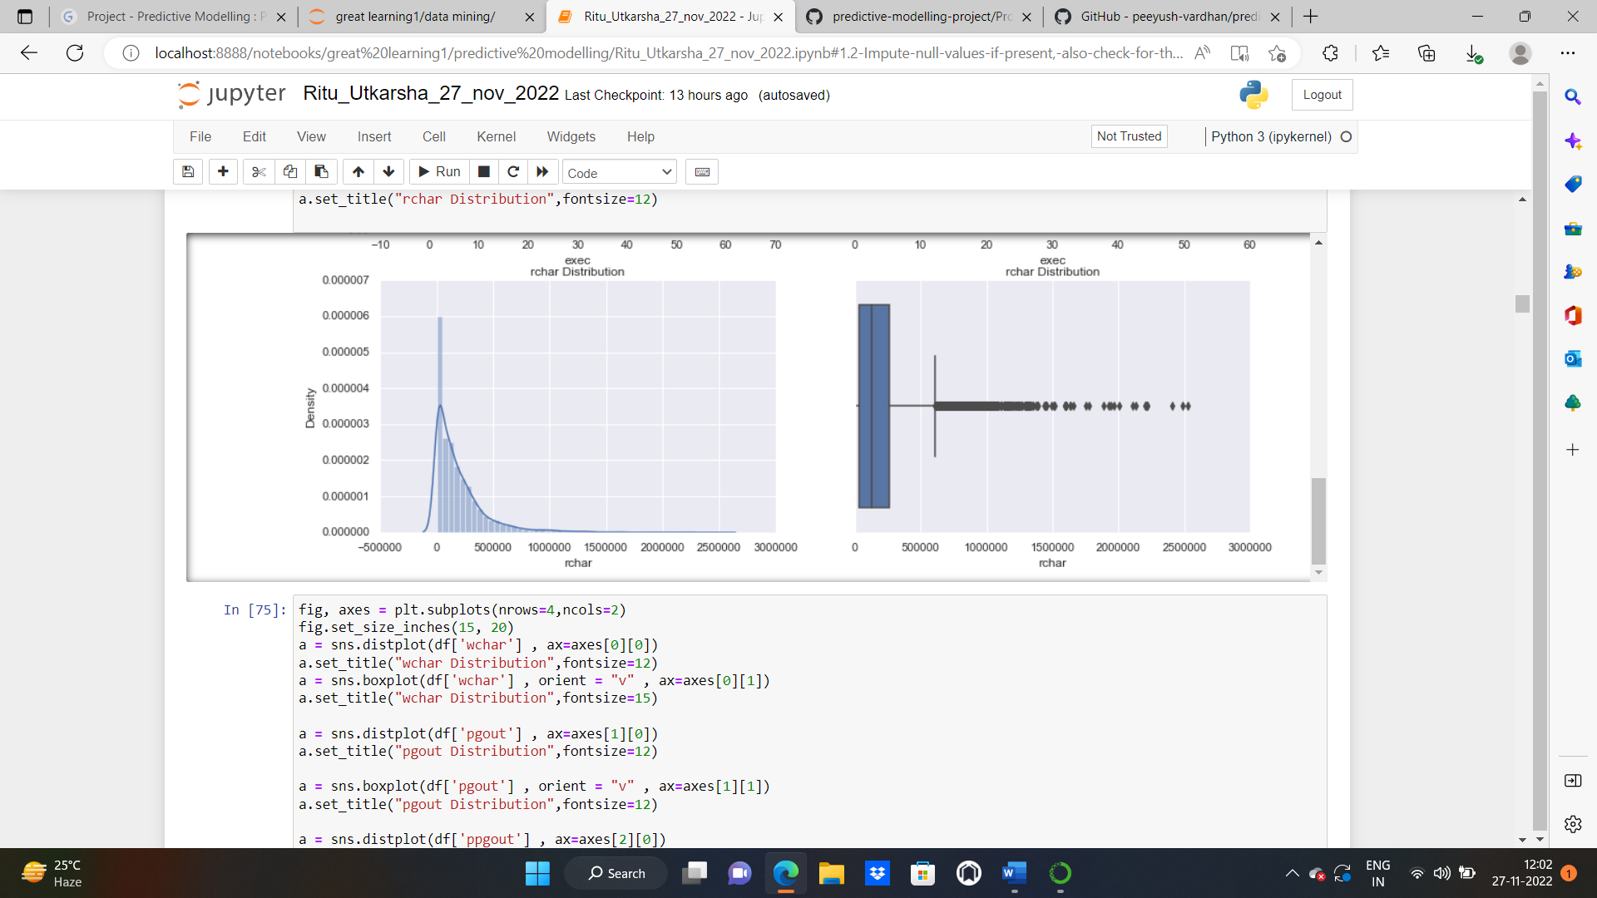

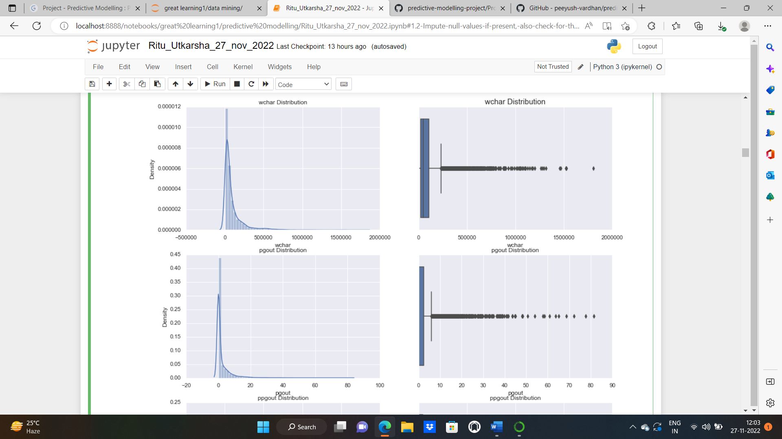

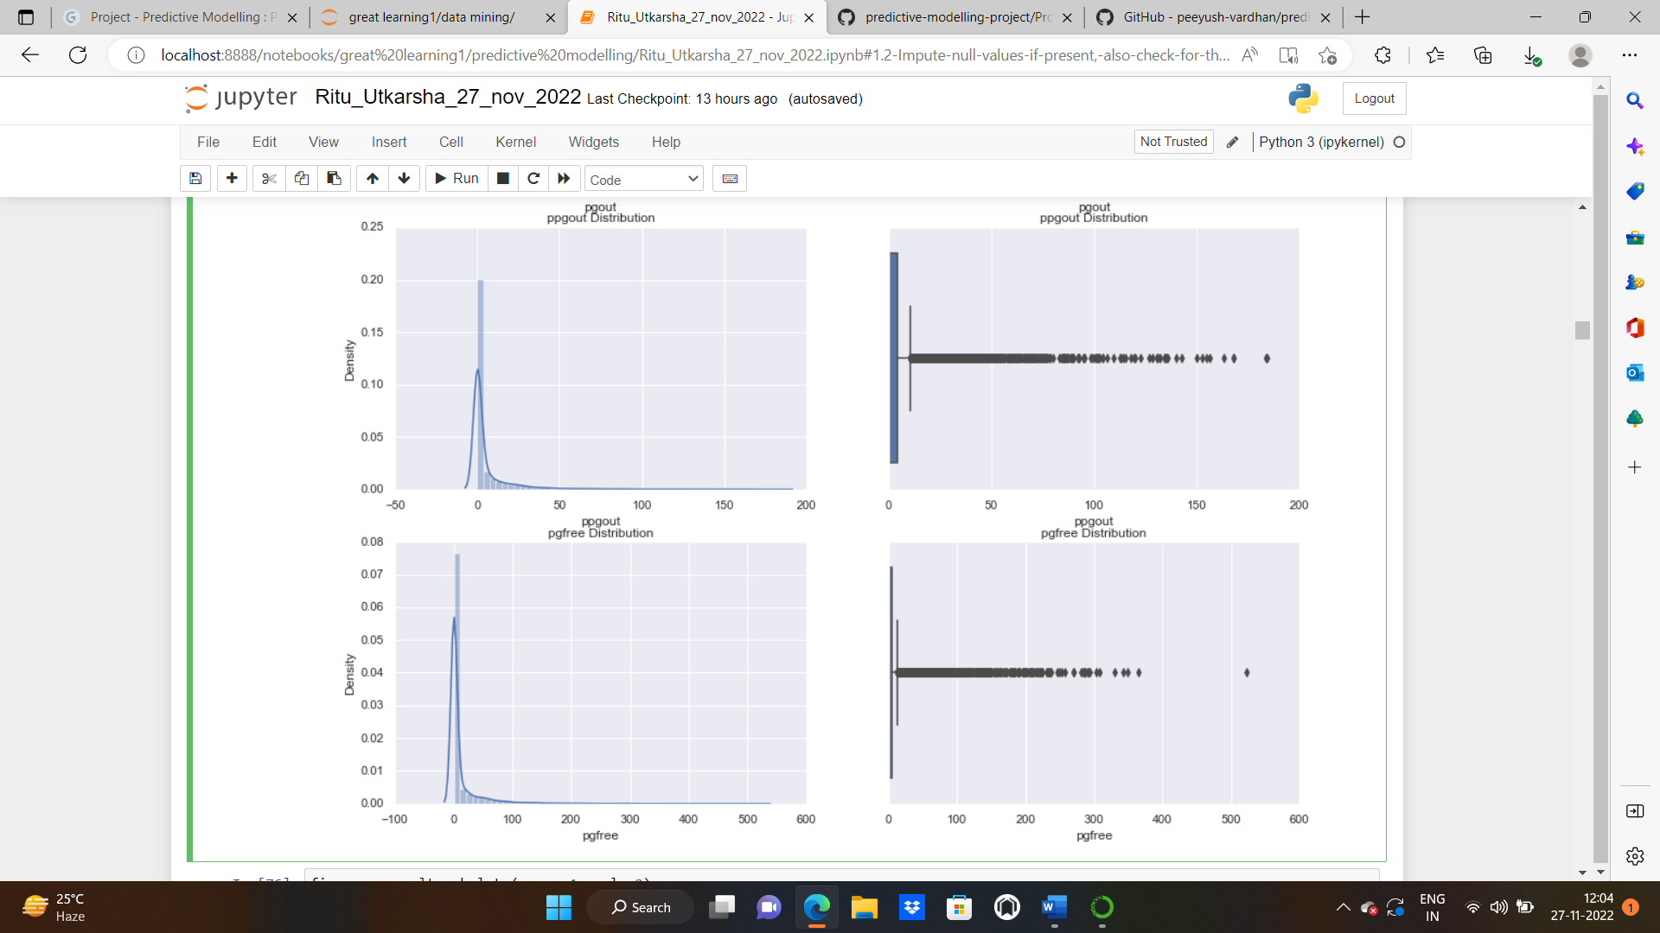

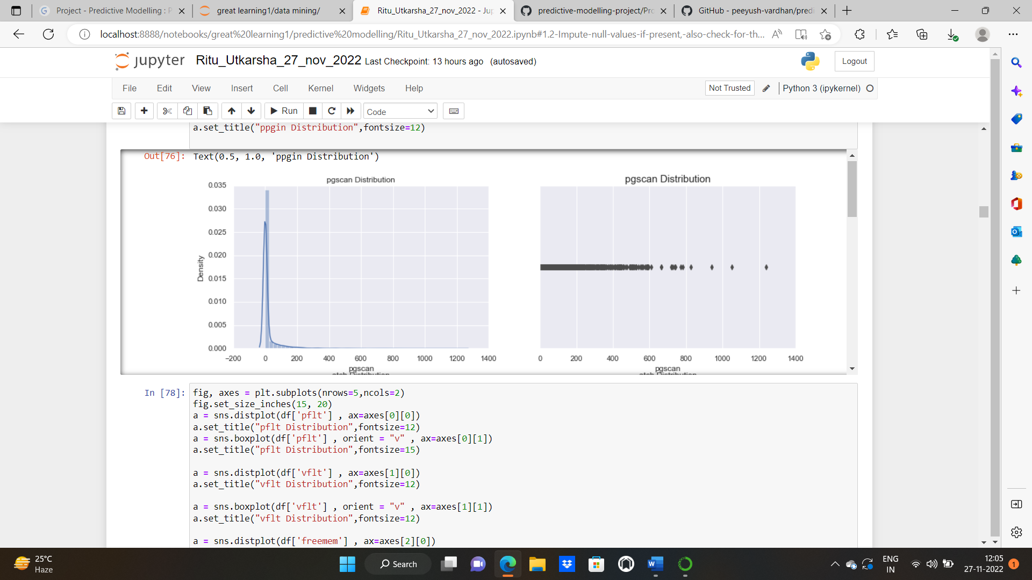

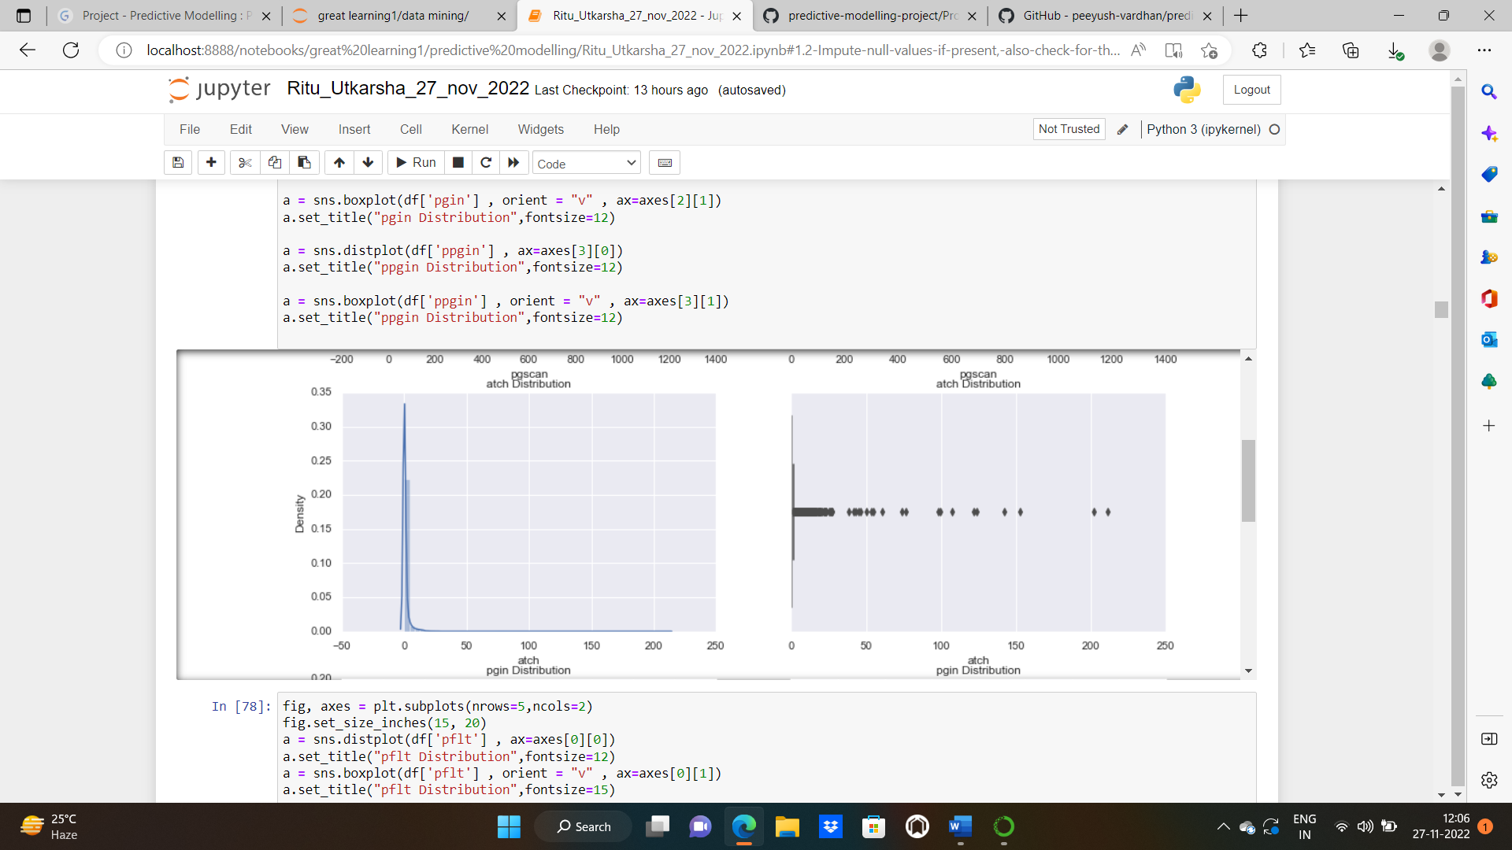

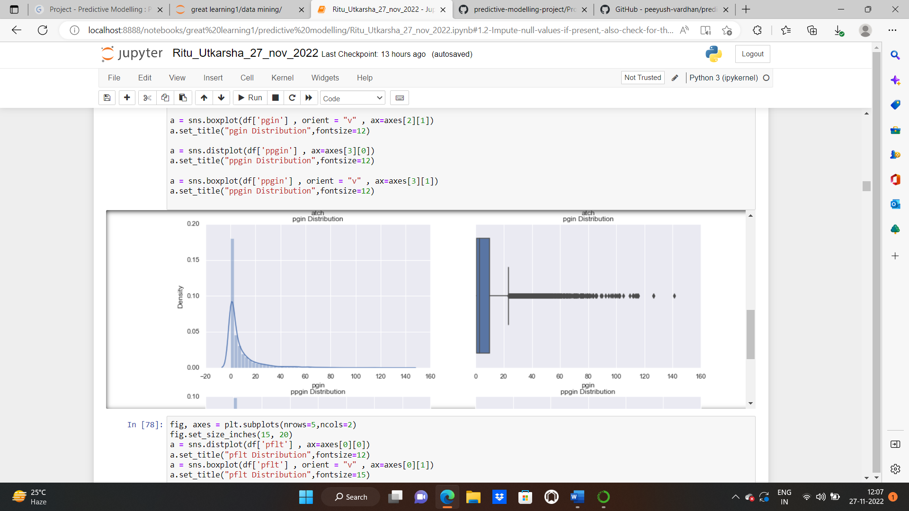

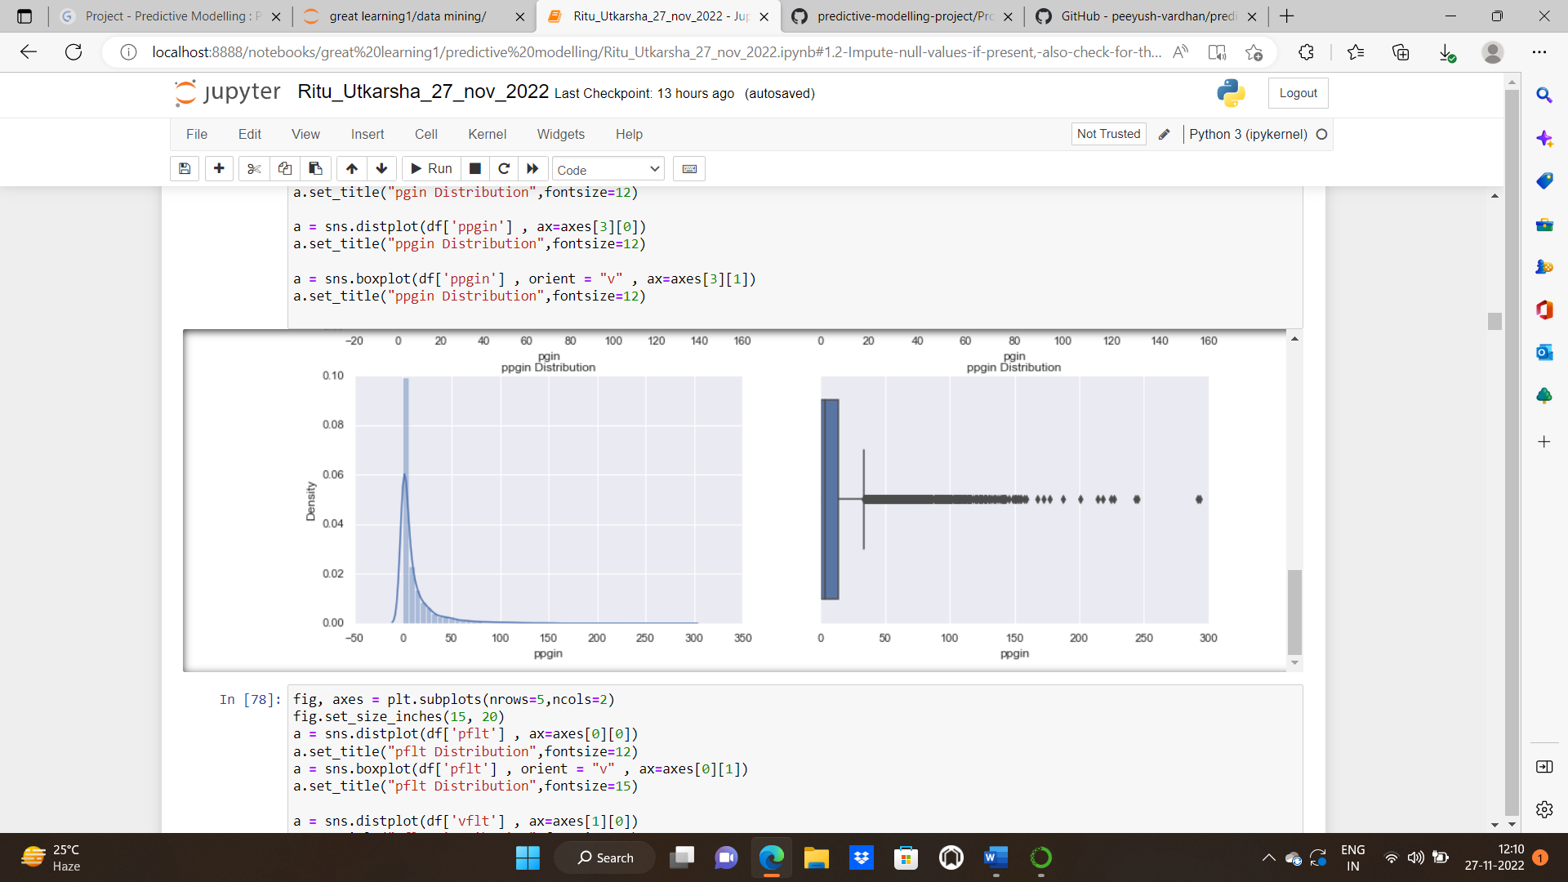

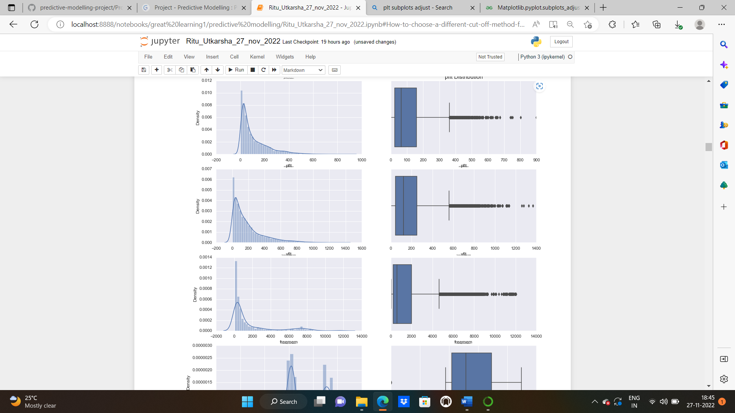

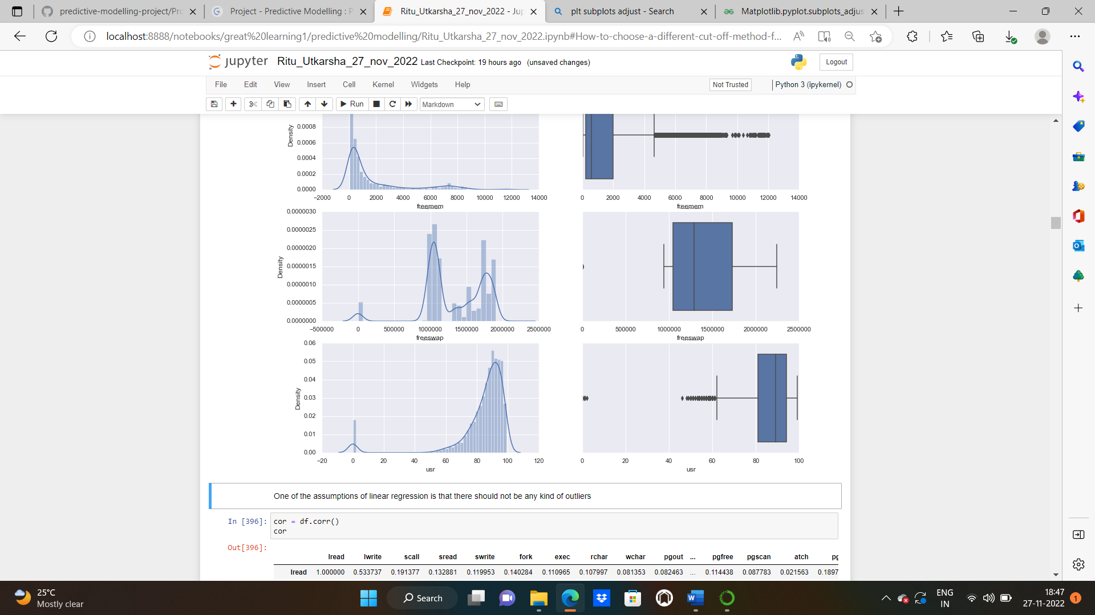

INSIGHTS: The distribution of data in freeswap and usr is negatively skewed, except them rest of the columns are positively skewed.

There seems to be outliers in almost every independent variable except “freeswap”

**MULTIVARIATE ANALYSIS:**

CORRELATION: data.corr() will give us the correlation matrix for the dataset. Correlation is a term that is a measure of the strength of a linear relationship between two quantitative variables .

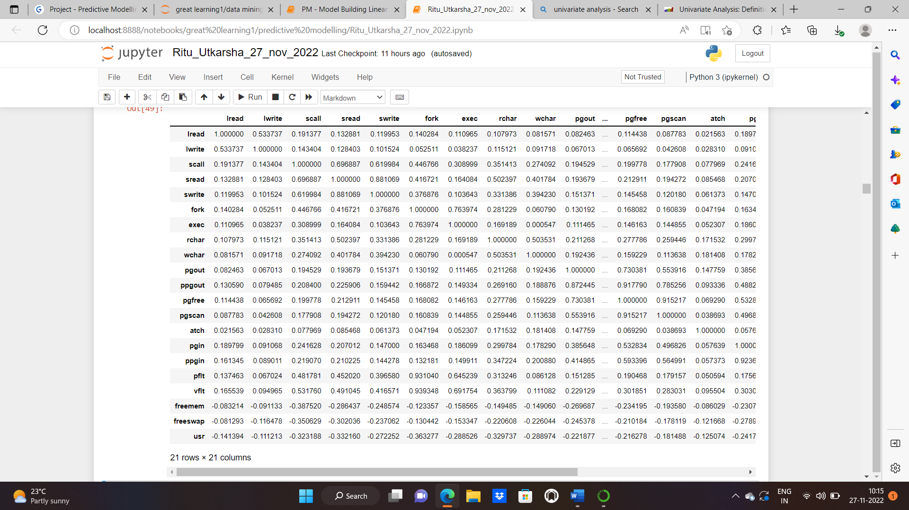

We can see strong positive correlation between pgout and lread,pflt and fork,pgfree and ppgout,vflt and fork and so on.

**HEATMAP:** A representation of data in the form of a map or diagram in which data values are represented as colours: A correlation coefficient quite close to 0, but either positive or negative, implies little or no relationship between the two variables. A correlation coefficient close to plus 1 means a positive relationship between the two variables, with increases in one of the variables being associated with increases in the other variable.

A correlation coefficient close to -1 indicates a negative relationship between two variables, with an increase in one of the variables being associated with a decrease in the other variable.

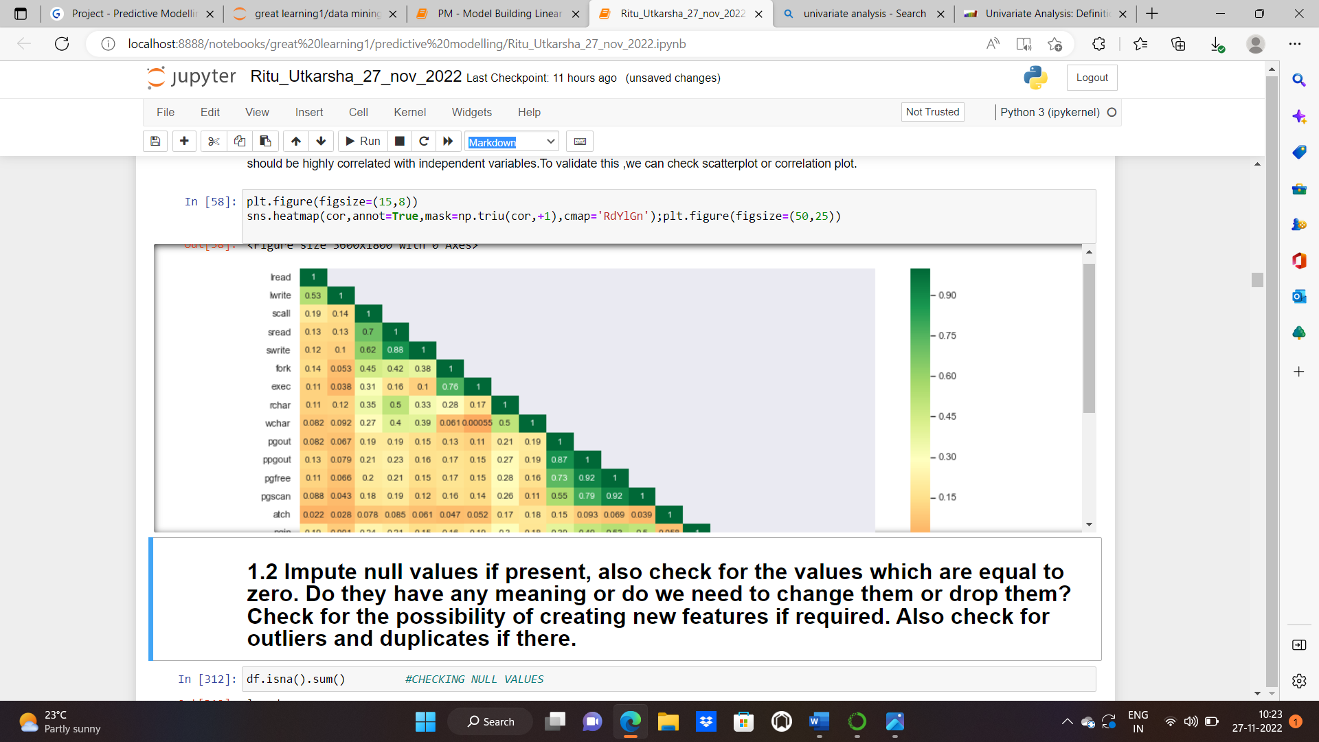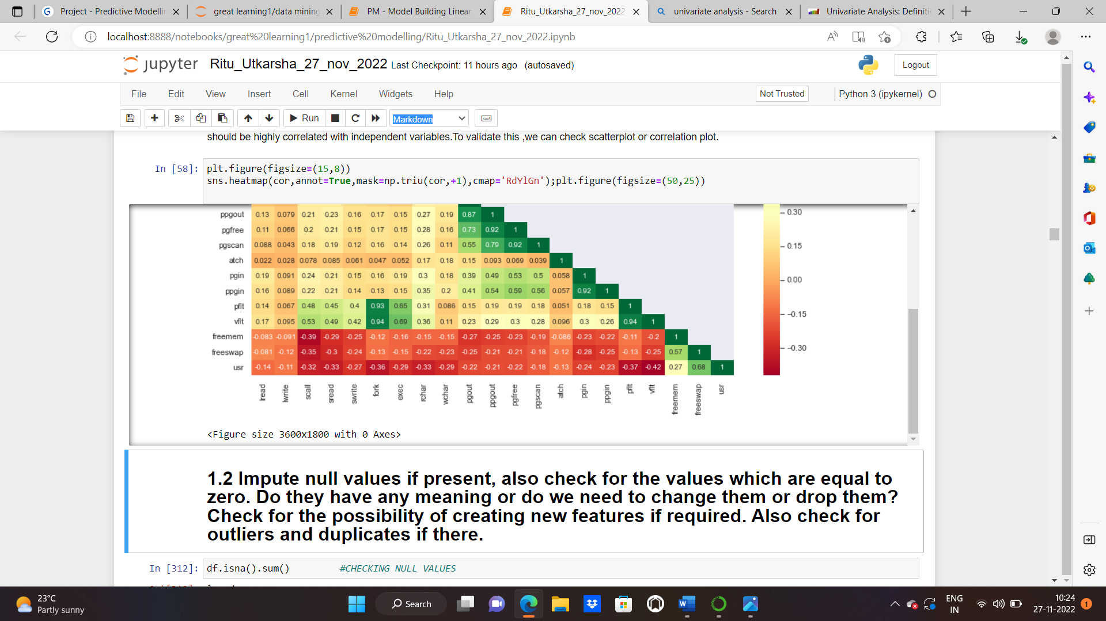

* 1. **Impute null values if present, also check for the values which are equal to zero. Do they have any meaning, or do we need to change them or drop them? Check for the possibility of creating new features if required. Also check for outliers and duplicates if there.**

Solution:

CHECKING NULL VALUES:

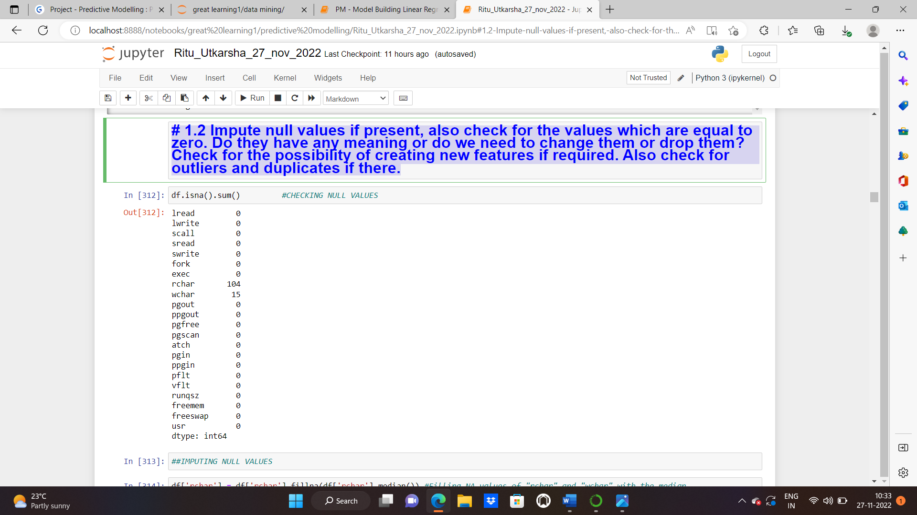

There are 104 null values in rchar and 15 null values in wchar columns.

We impute / replace Missing Values with Median. When the data is skewed, it is good to consider using the median value for replacing the missing values.

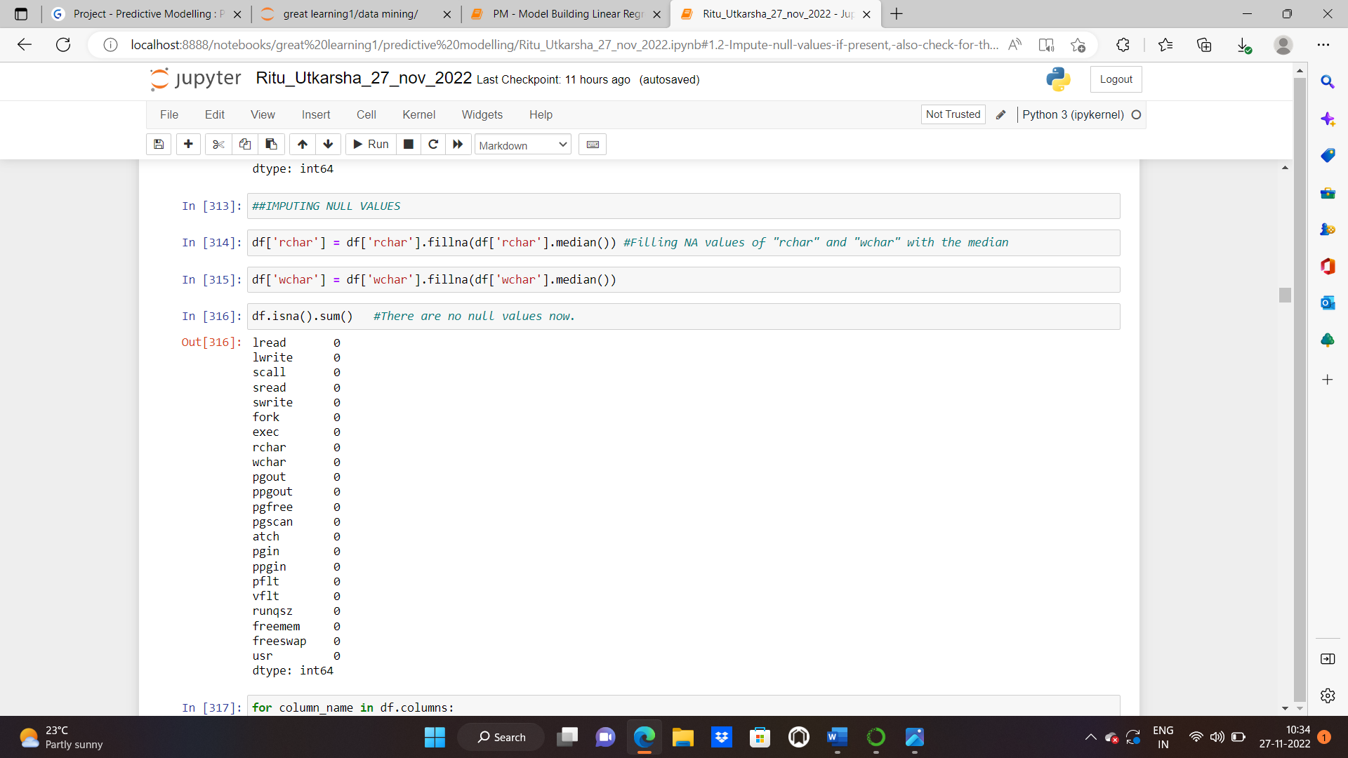

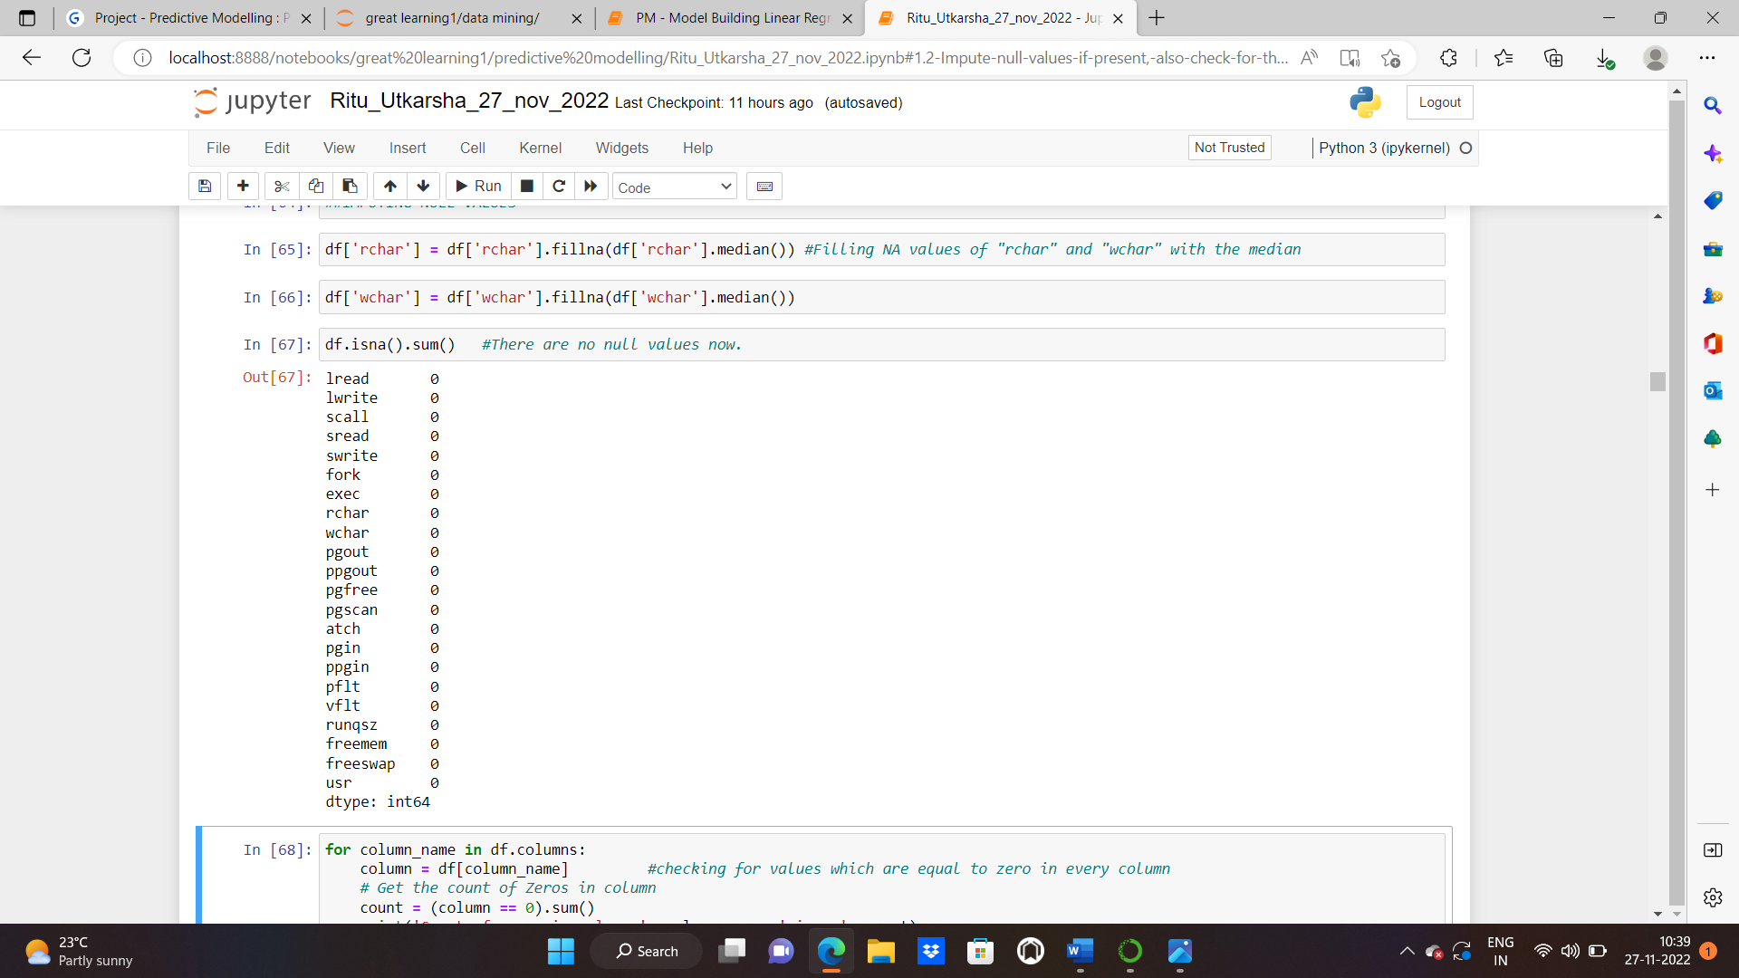

The null values have been removed now.

**CHECKING VALUES WHICH ARE EQUAL TO ZERO:**

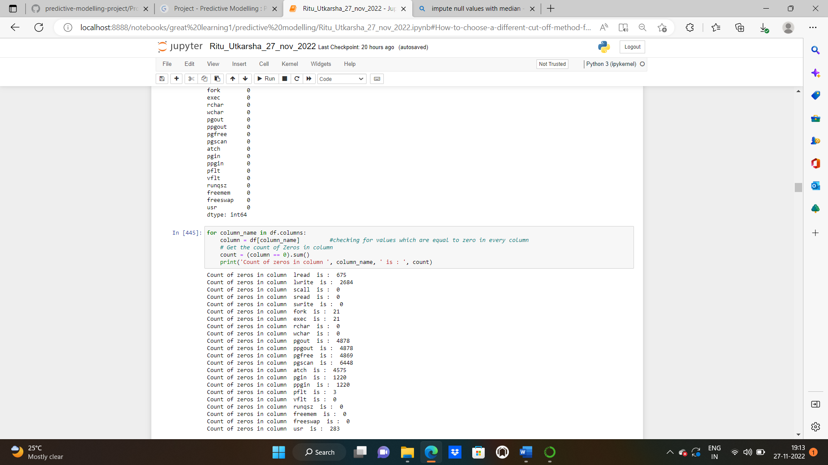

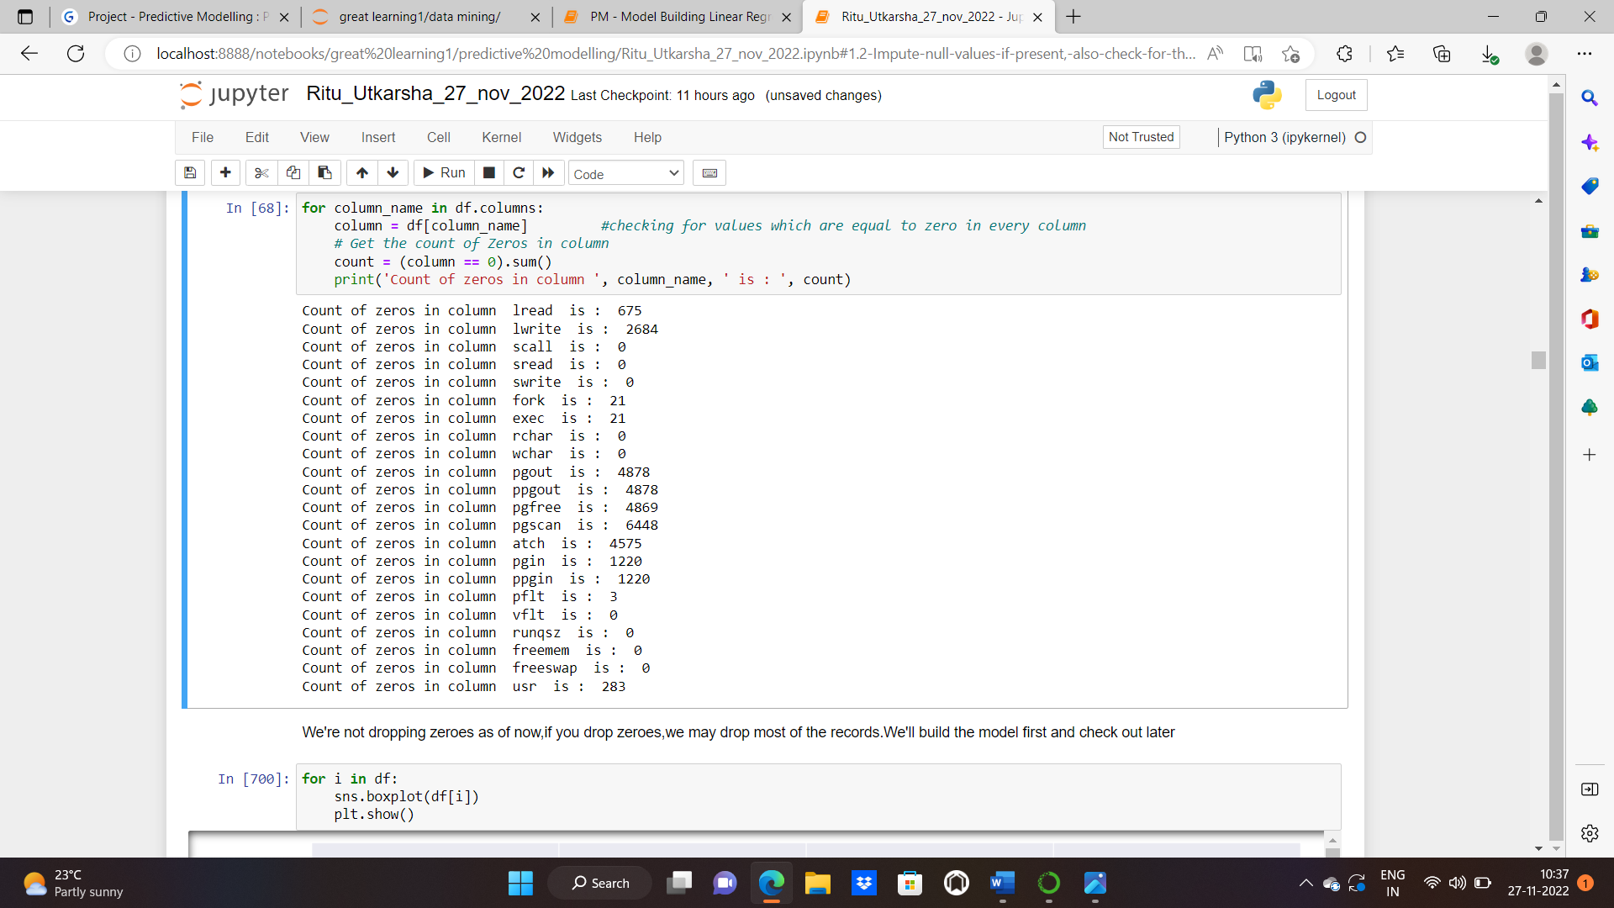

We're not dropping zeroes as of now, if you drop zeroes, we may drop most of the records. We’ll build the model first and check out later.

**CHECKING DUPLICATES:**

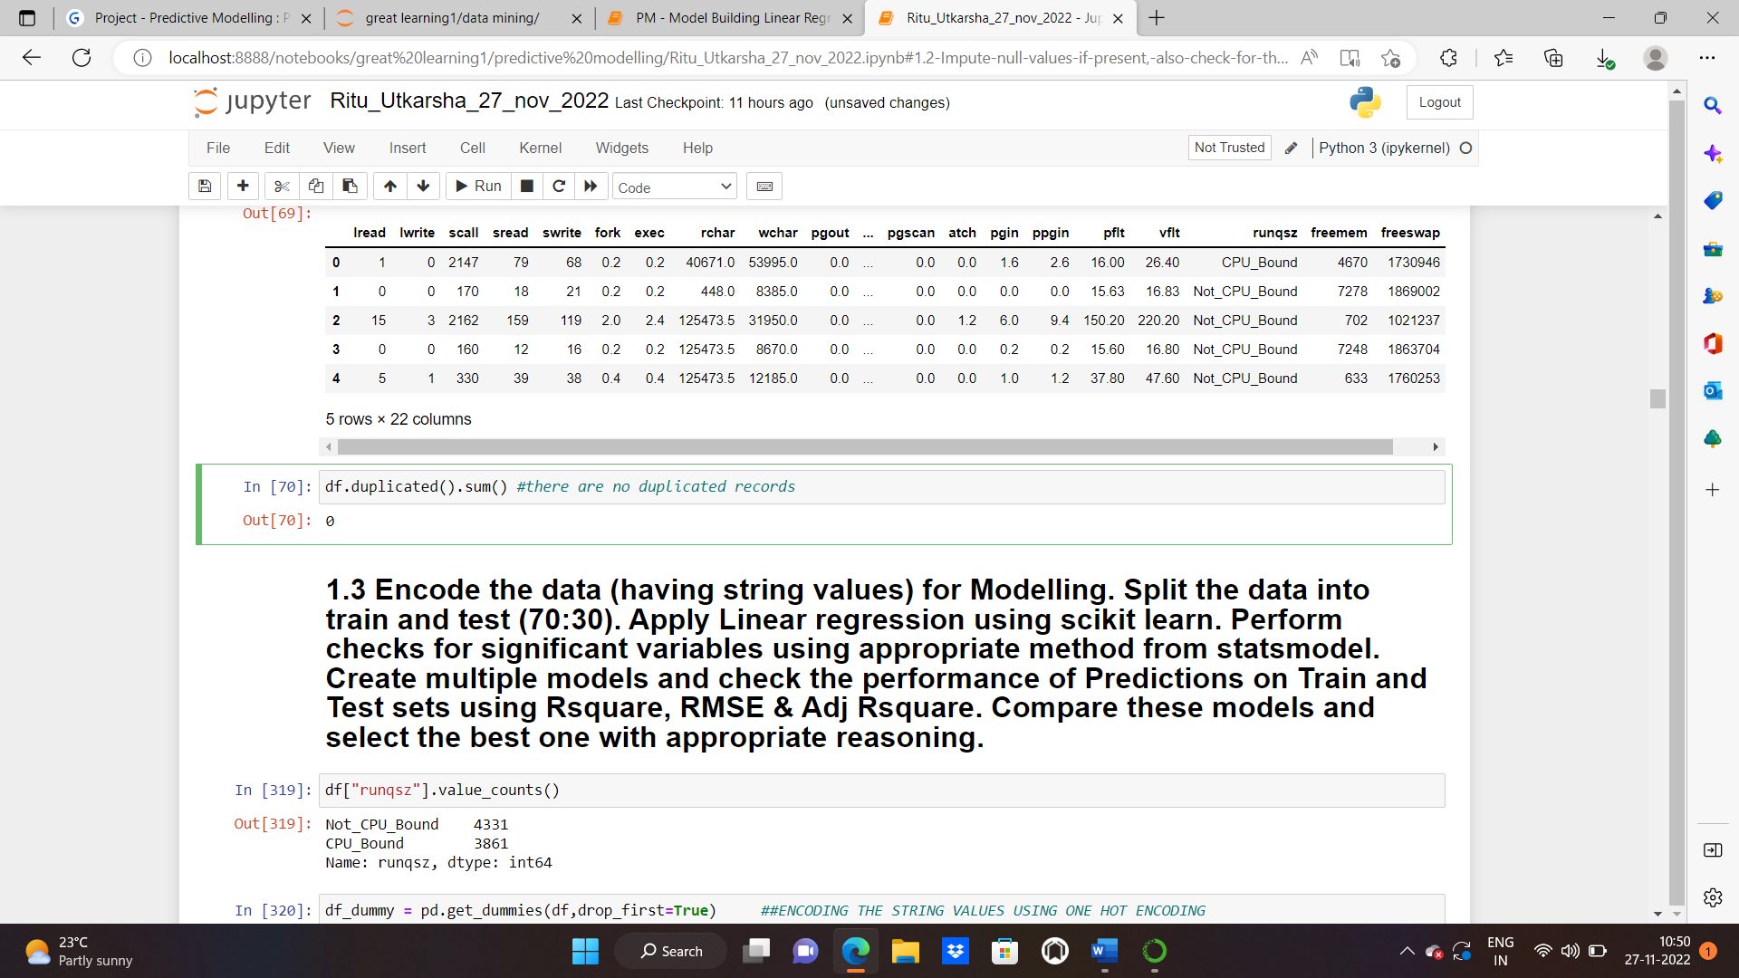

**CHECKING OUTLIERS:**

We’ve already plotted the boxplots of all the numerical variables in 1.1 and got the result that we’ve a lot of outliers in the data. Almost every column has outliers except “freeswap” column.

**1.3 Encode the data (having string values) for Modelling. Split the data into train and test (70:30). Apply Linear regression using scikit learn. Perform checks for significant variables using appropriate method from stats model. Create multiple models and check the performance of Predictions on Train and Test sets using R squared, RMSE & Adj R square. Compare these models and select the best one with appropriate reasoning.**

Solution: **STEP1: Convert categorical to dummy variables in the data:**

To encode the data (having string value), we’ll perform one hot encoding.

**One hot encoding** is one method of **converting data** to prepare it for an algorithm and get a better prediction. With one-hot, we convert each categorical value into a new categorical column and assign a binary value of 1 or 0 to those columns. Each integer value is represented as a binary vector. All the values are zero, and the index is marked with a 1.

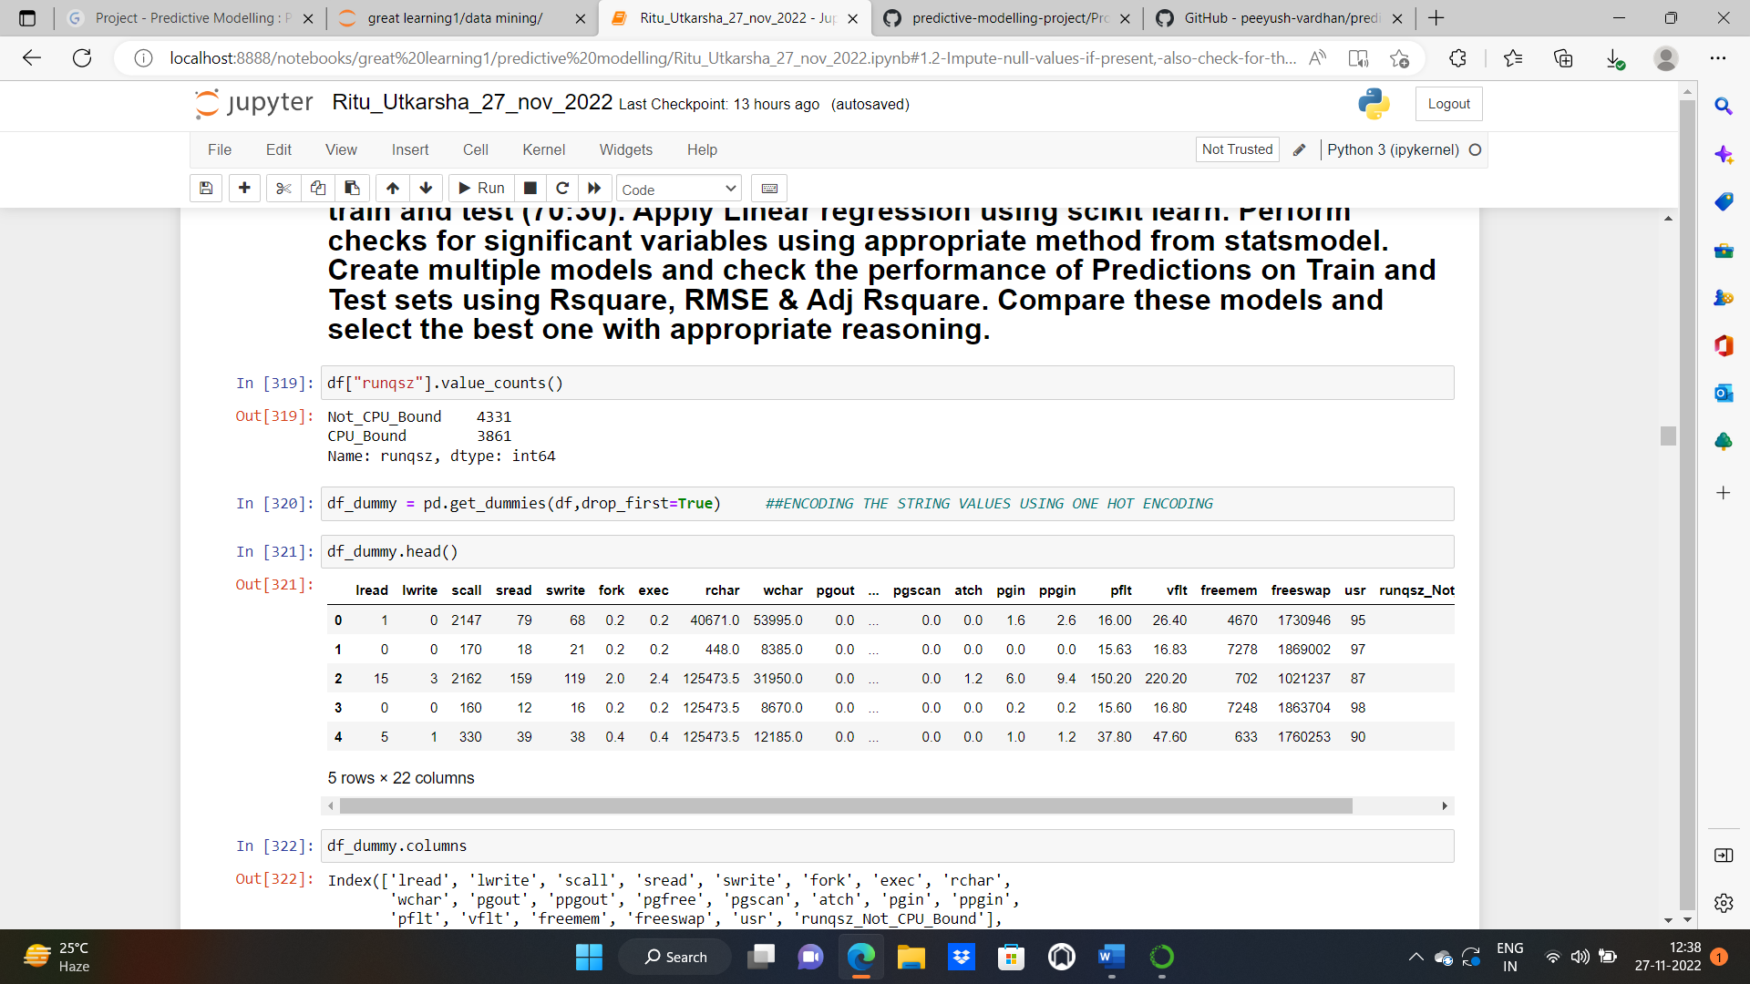We got our encoded data now.

**Step 2: Split the data into train and test (70:30)**

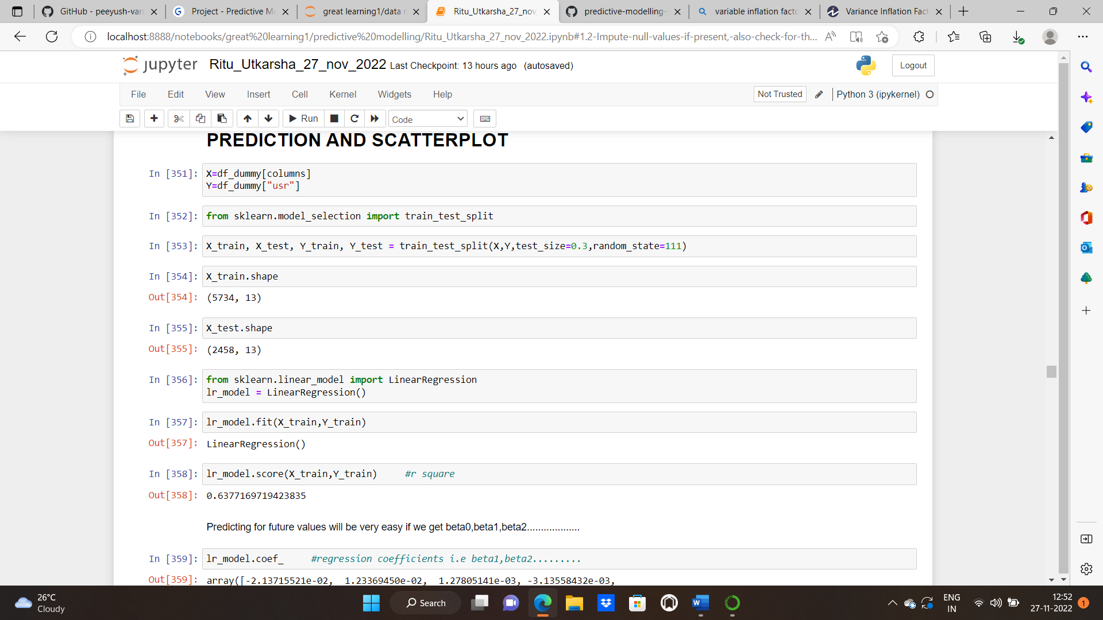

**Step3: Applying the linear regression model**

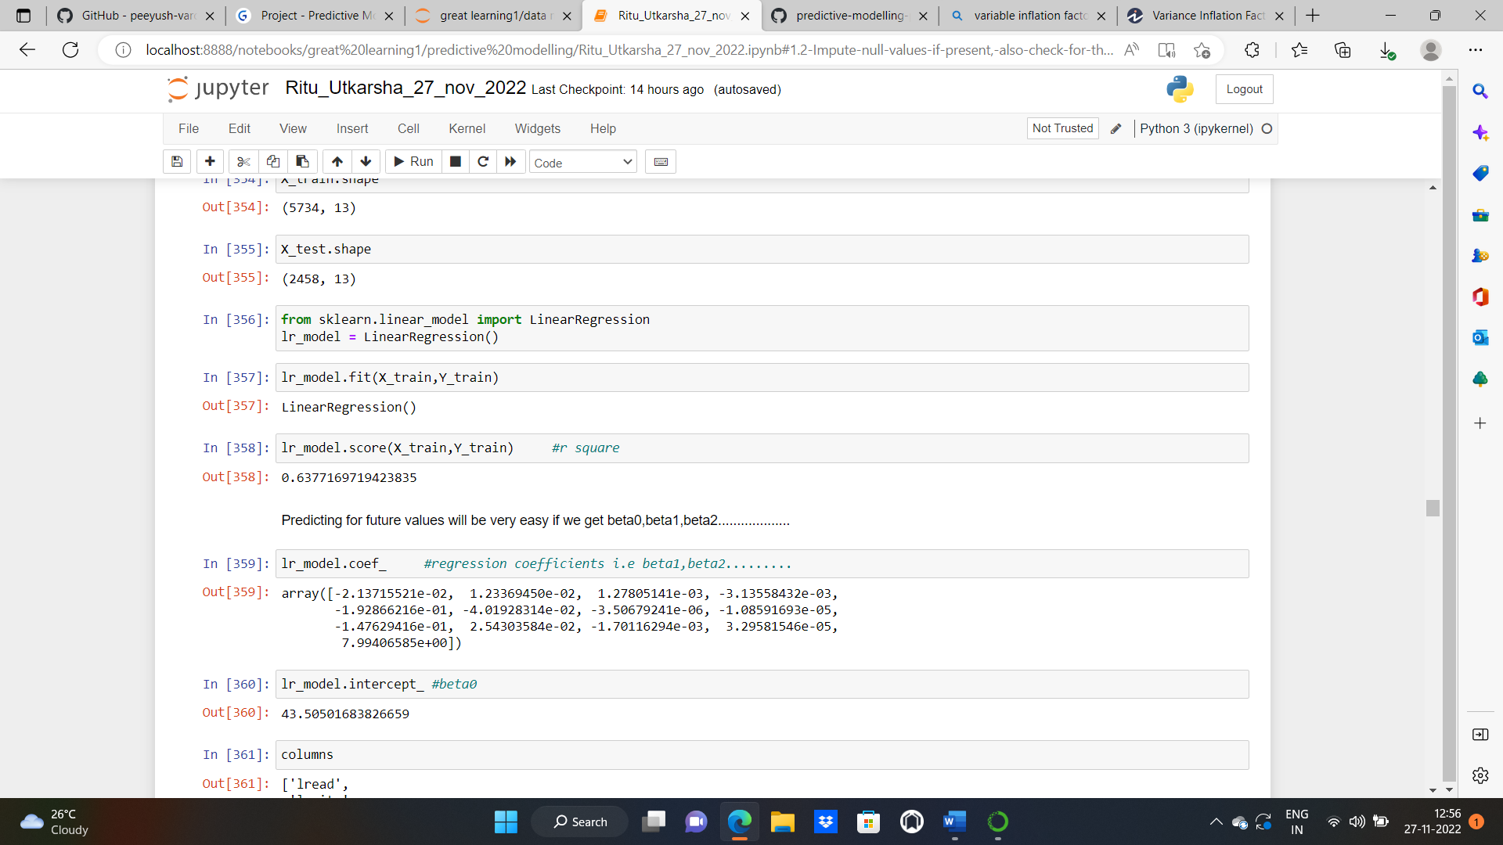

**Coefficients for each of the independent attributes and the intercept of the model:**

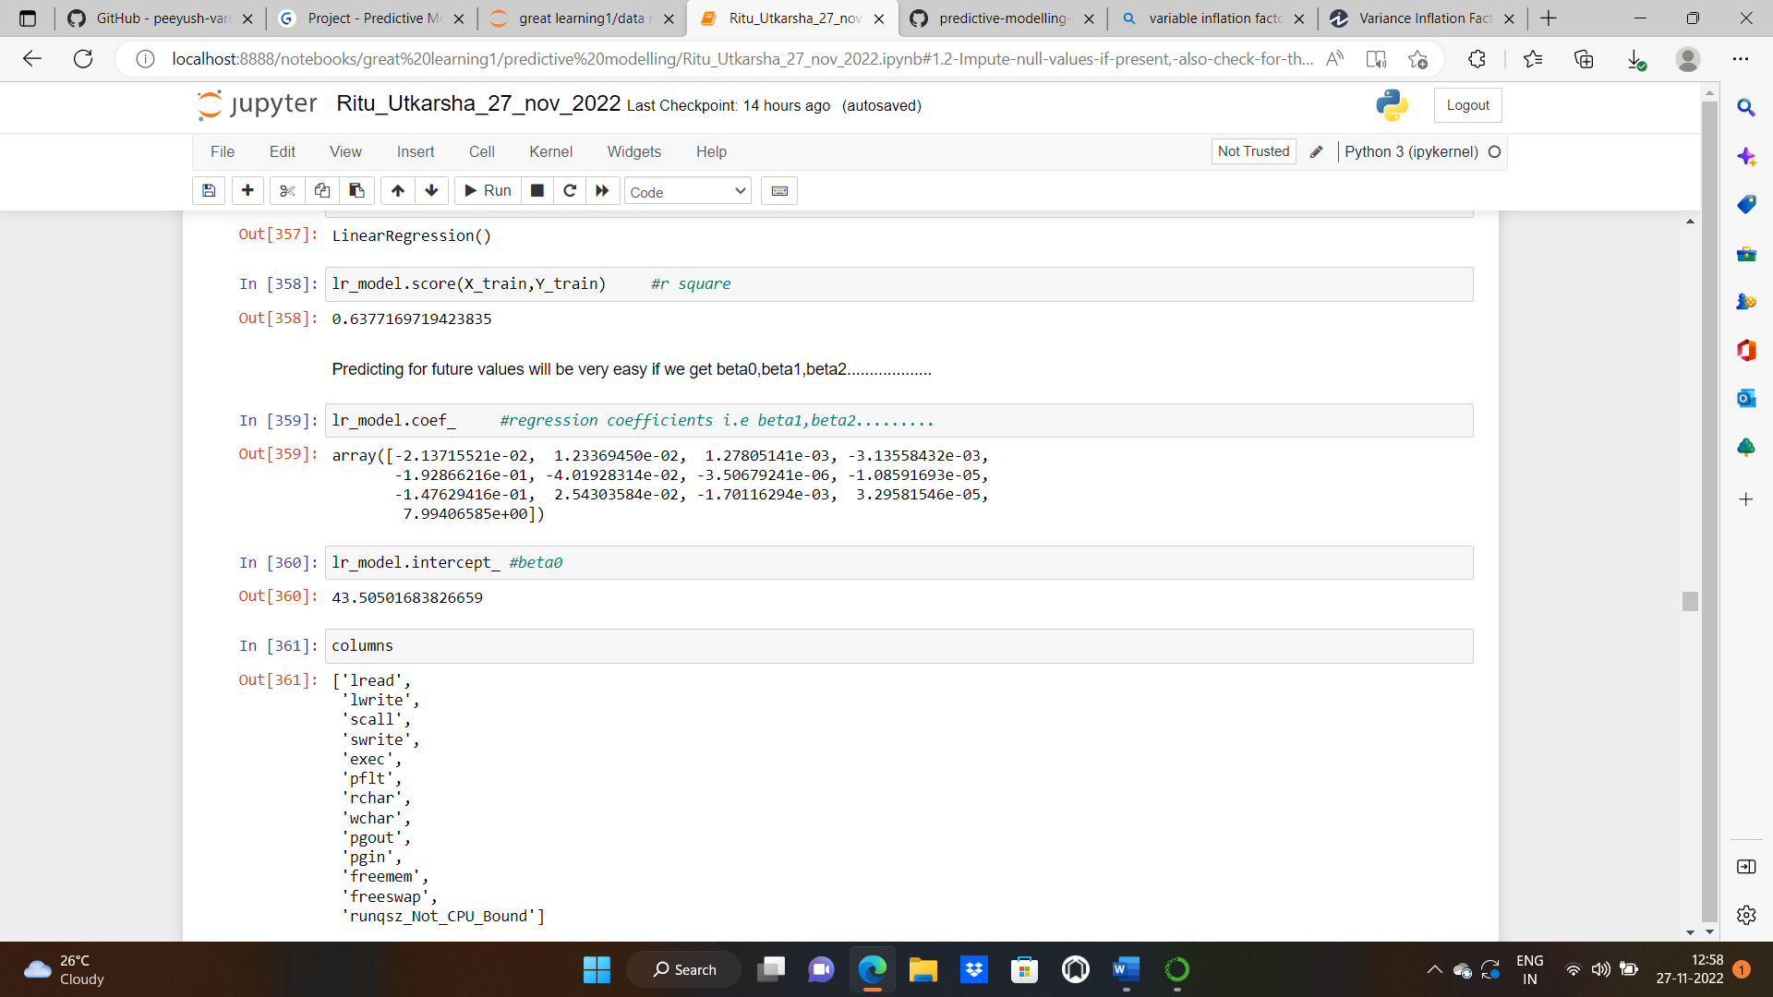

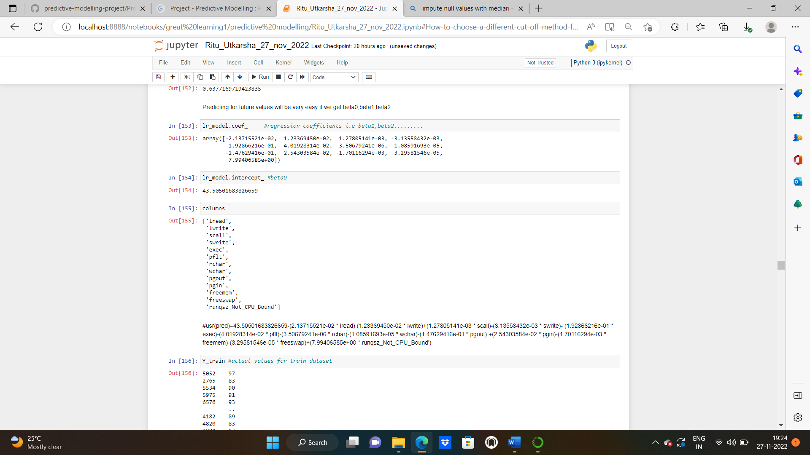

**The predicted equation:**

#usr(pred)=43.50501683826659-(2.13715521e-02 * lread) (1.23369450e-02 * lwrite) +(1.27805141e-03 * scall)-(3.13558432e-03 * swrite)-(1.92866216e-01 * exec) -(4.01928314e-02 * pflt)-(3.50679241e-06 * rchar)-(1.08591693e-05 * wchar)-(1.47629416e-01 * pgout)+(2.54303584e-02 * pgin) -(1.70116294e-03 * freemem)-(3.29581546e-05 * freeswap)+(7.99406585e+00 * runqsz_Not_CPU_Bound')

**R square for the training and test data:**

R-squared (R2) is popular as a statistical measure that represents the proportion of the variance for a [dependent variable](https://www.toppr.com/guides/physics/fundamentals/what-are-dependent-independent-and-controlled-variables/). While correlation explains the strength of the relationship between two variables independent and dependent variables, R-squared explains to what extent the variance of one variable explains the variance of the second one. So, if the R2 value of a model is 0.50, then approximately half of the observed variation will be explained by its inputs.

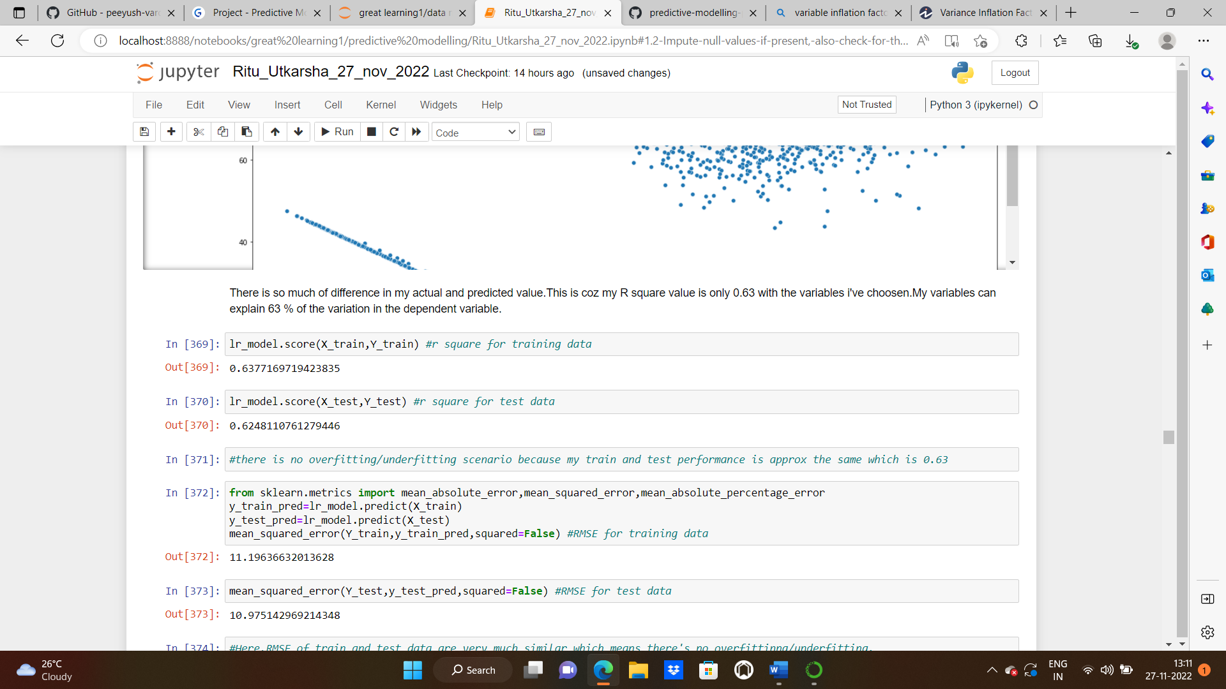

**RMSE for the training and test data:**

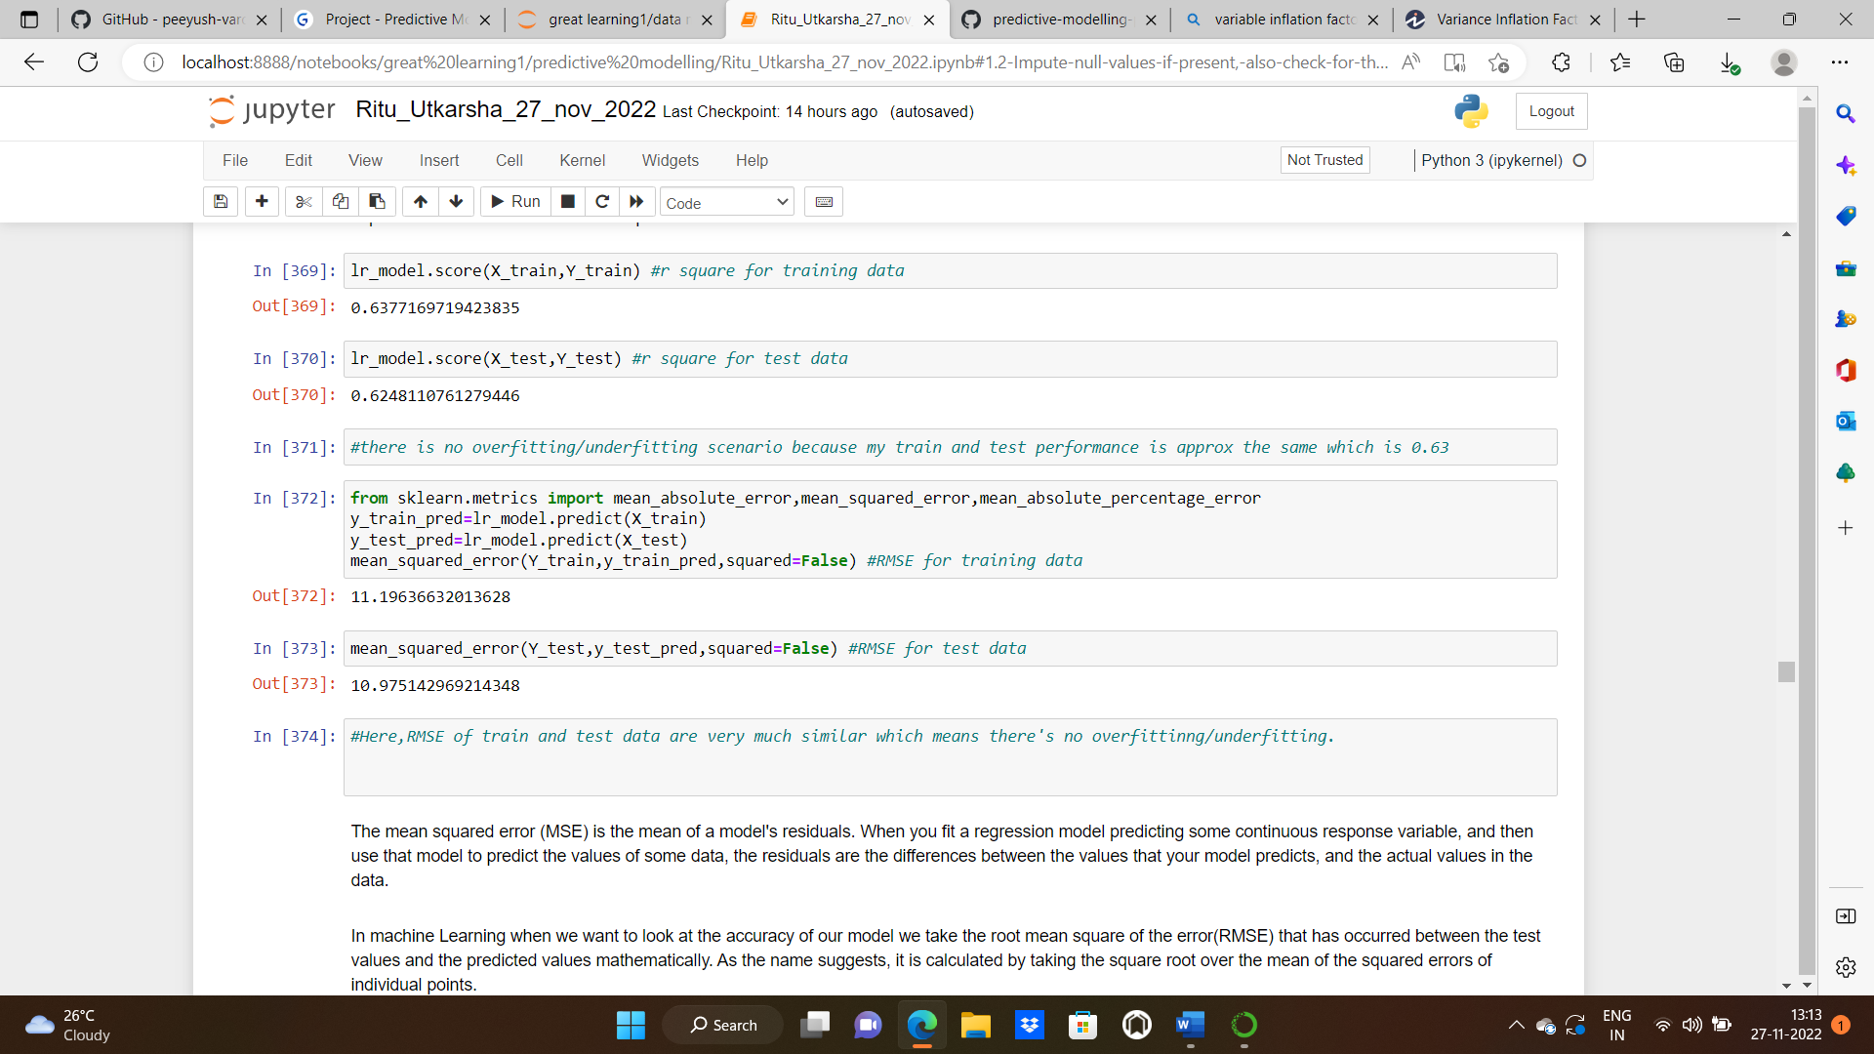

RMSE and R square of train and test data are very much similar which means there's no overfitting/underfitting.

The mean squared error (MSE) is the mean of a model's residuals. When you fit a regression model predicting some continuous response variable, and then use that model to predict the values of some data, the residuals are the differences between the values that your model predicts, and the actual values in the data.

In machine Learning when we want to look at the accuracy of our model we take the root mean square of the error(RMSE) that has occurred between the test values and the predicted values mathematically. As the name suggests, it is calculated by taking the square root over the mean of the squared errors of individual points.

**Mean Absolute error** of the train and test data: We know that an error basically is the absolute difference between the actual or true values and the values that are predicted. Absolute difference means that if the result has a negative sign, it is ignored.

Hence, **MAE = True values – Predicted values**

MAE takes the **average** of this error from every sample in a dataset and gives the output.

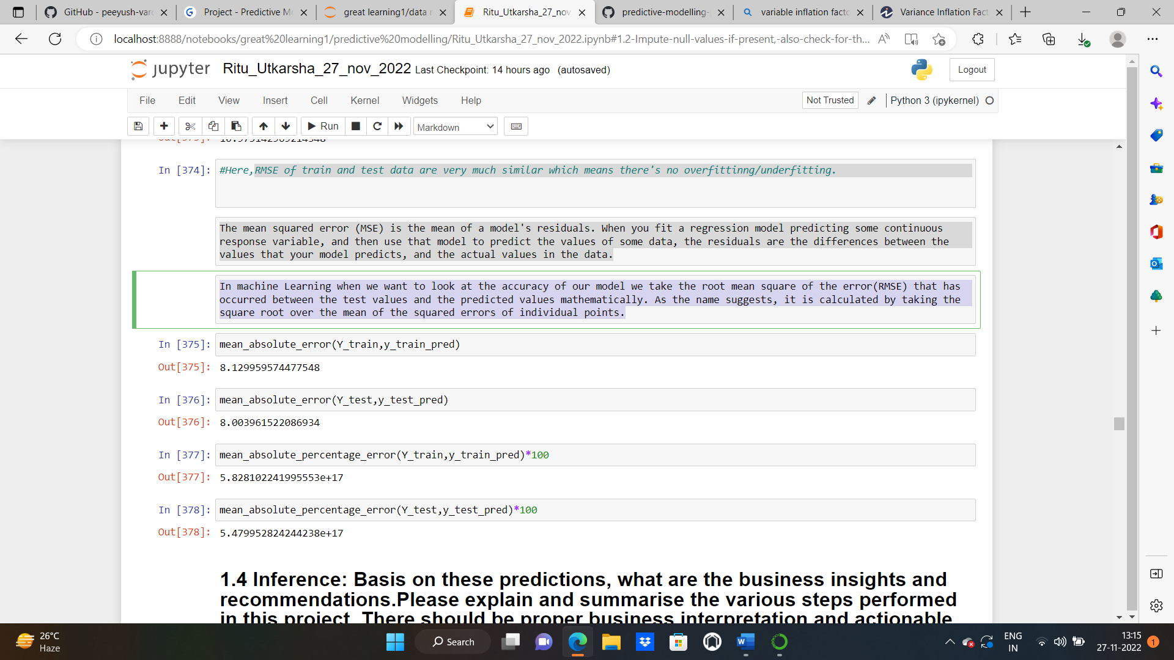

Mean Absolute percentage error of the training and test dataset:

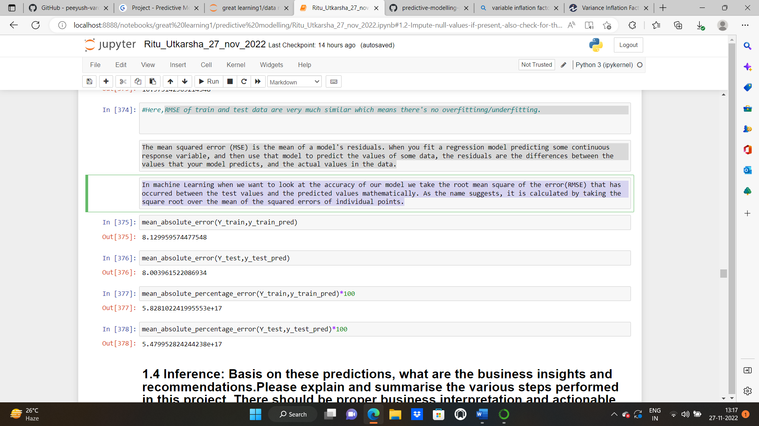

**Insights:**

**Please refer to the jupyter notebook to go through the codes.**

As we have seen from the VIF values that multicollinearity is present in our dataset. The exemplary interpretation of VIF is less than 5.

**Inferential statistical data :**

Building a base model with all the features:

**Multicollinearity** is the occurrence of high intercorrelations among two or more independent variables in a multiple regression model. Multicollinearity can lead to skewed or misleading results when a researcher or analyst attempts to determine how well each independent variable can be used most effectively to predict or understand the dependent variable in a statistical model.

To check multicollinearity, we’ll check VIF score for each of the columns. A variance inflation factor (VIF) is a measure of the amount of multicollinearity in regression analysis. [Multicollinearity](https://www.investopedia.com/terms/m/multicollinearity.asp) exists when there is a correlation between multiple independent variables in a multiple regression model. This can adversely affect the [regression](https://www.investopedia.com/terms/r/regression.asp) results. Thus, the variance inflation factor can estimate how much the variance of a regression coefficient is inflated due to multicollinearity.

Now, we will calculate the Variance Inflation Factor (VIF). We will calculate the Variance Inflation Factor by a user defined function.

VIF regresses the dependent variables amongst themselves and then calculates the VIF values based on the 𝑅 Square of each such regression.

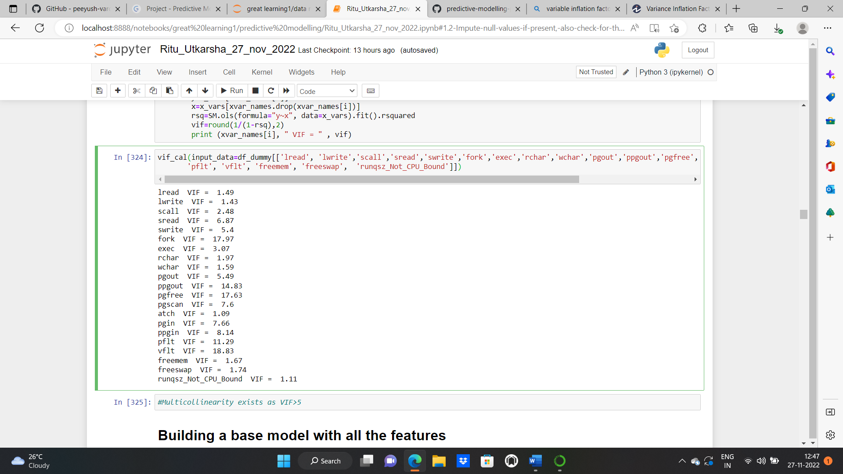

We can see multicollinearity exists as the VIF for a few columns is greater than 5. We’ll treat multicollinearity first as correlation exists among most of the variables.

Looking at the VIF and the pvalues both,we’ll go on removing the insignificant columns till we achieve columns with the appropriate columns and pvalues<0.5.

**BUILDING BASE MODEL USING ALL THE INDEPENDENT VARIABLES:**

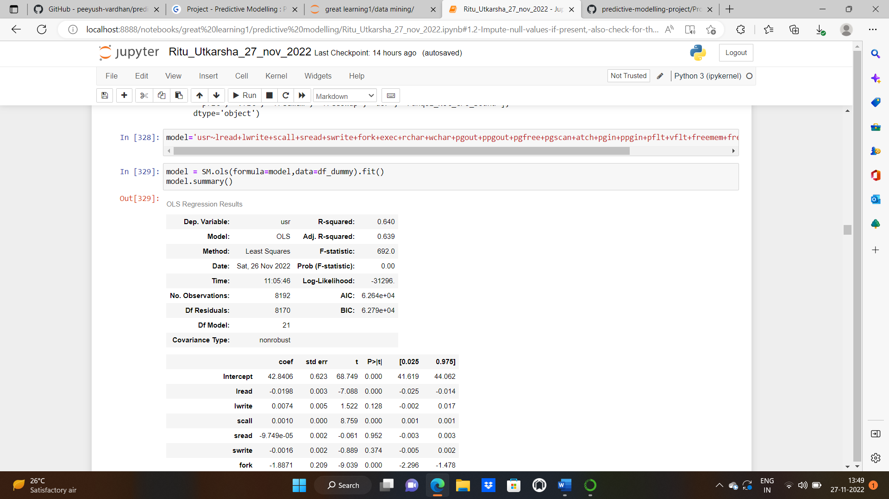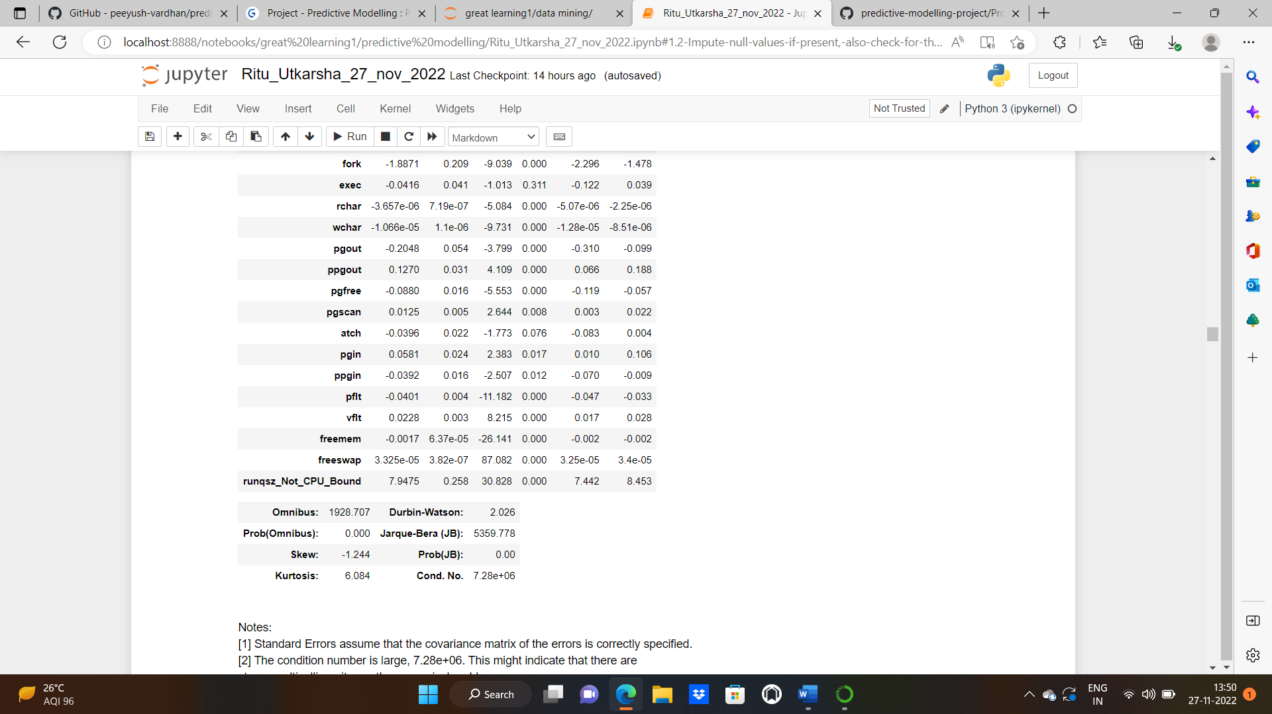

[1] Standard Errors assume that the covariance matrix of the errors is correctly specified.  
[2] The condition number is large, 7.28e+06. This might indicate that there are  
strong multicollinearity or other numerical problems.

**prob F-stat:**

.

*null hypothesis:*

none of the independent variables have a relation with the dependent variable (all betas are zero)

*alternate hypothesis:* at least one of the independent variables is having relation with dependent variable.

(any one of the betas is non zero)

Here, pvalue i.e prob F-stat<0.05.we'll reject null hypothesis.It means at least one of the independent variables is having relation with dependent variable

**ttest**: TO check which variable is having higher relation with your target variable

null: beta=0

alternate: beta<>0

From P>|t| column, we can say lwrite,sread,exec, swrite,atch,are not significant to the model as their p values are greater than 0.05."Intercept" is also not significant.these are statistically insignificant variables. even if we remove them, the model performance will not be affected.

Looking at the VIF and the pvalues both, we’ll go on removing the insignificant columns till we achieve columns with the appropriate columns and pvalues<0.5.

**FINAL Model 8 :**

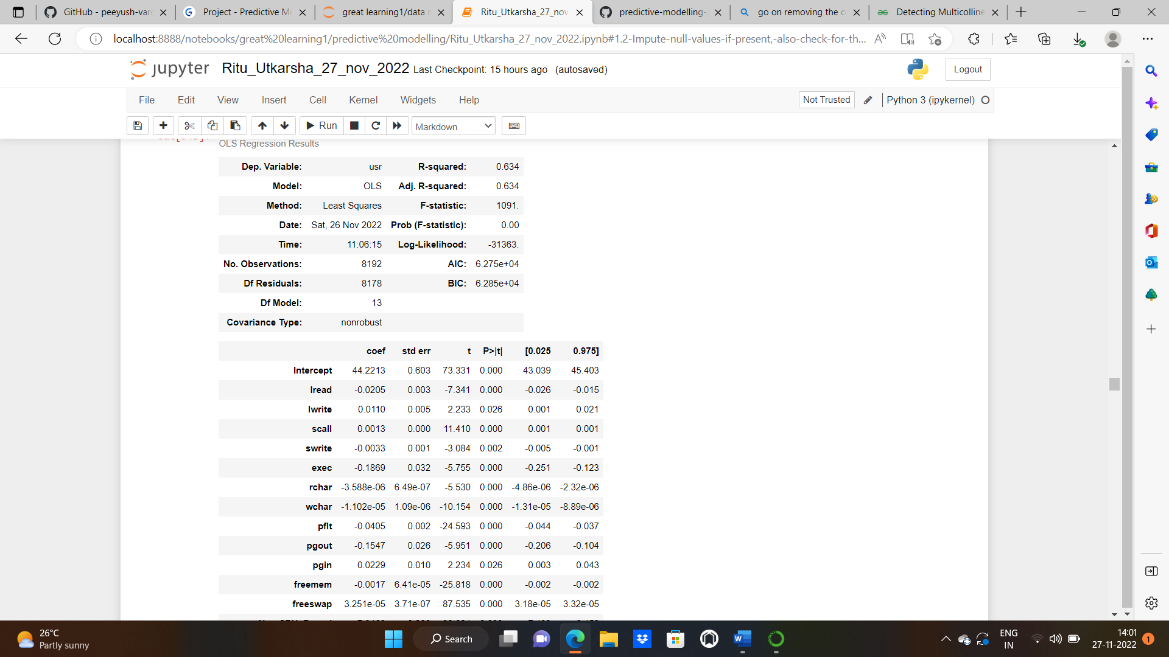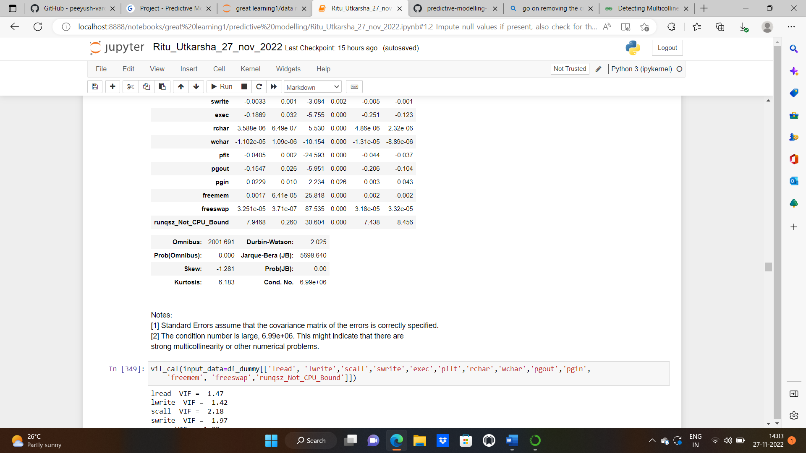

VIF for all the significant columns taken into model:

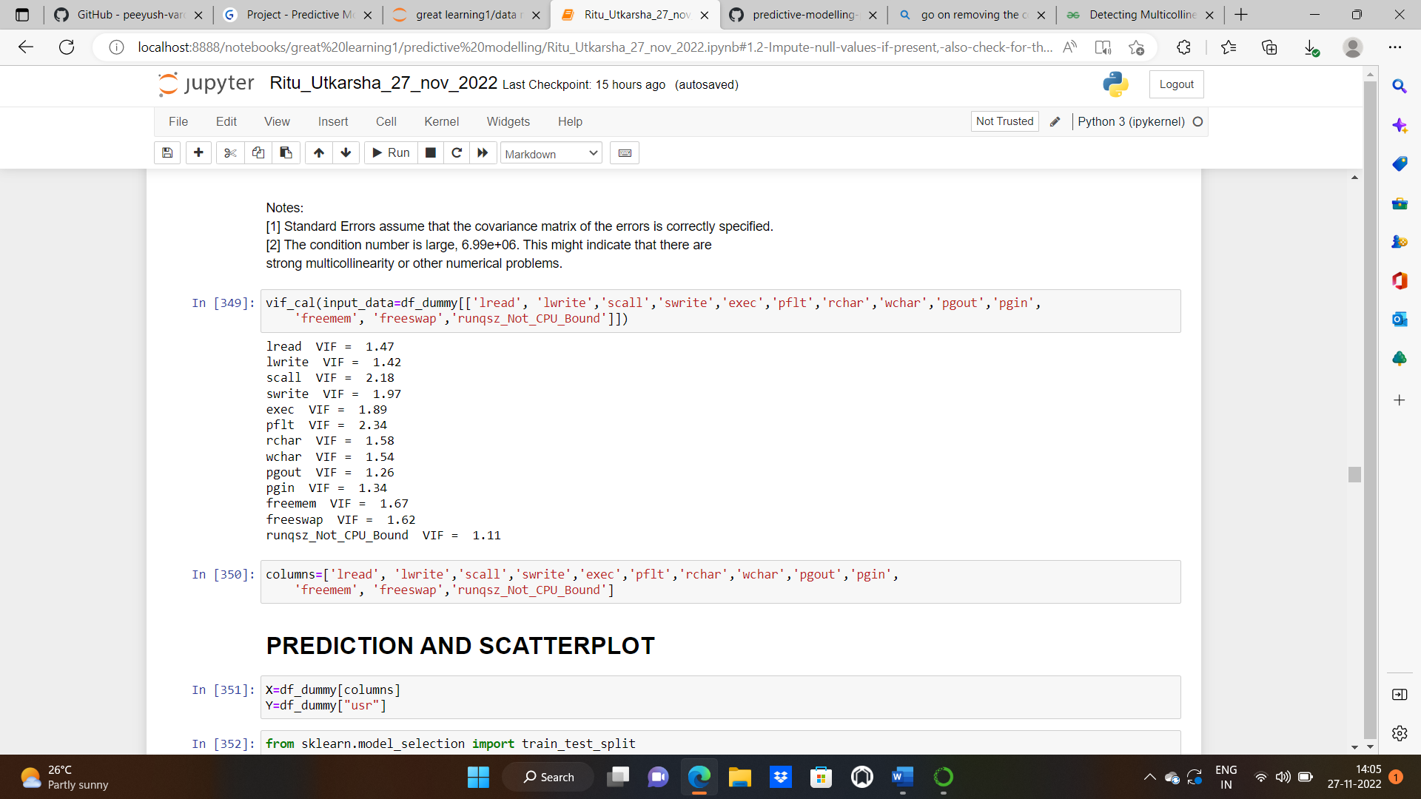

Now the VIF for all the columns is less than 2. Multicollinearity is treated now. p values for all the columns is less than 5% ,which means all the columns we selected for our model are significant now.

**PREDICTED VALUES:**

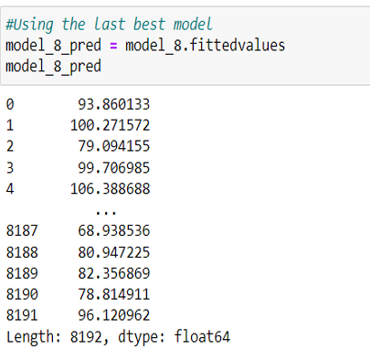

**DENSITY PLOT OF ACTUAL VALUES AND PREDICTED VALUES:**

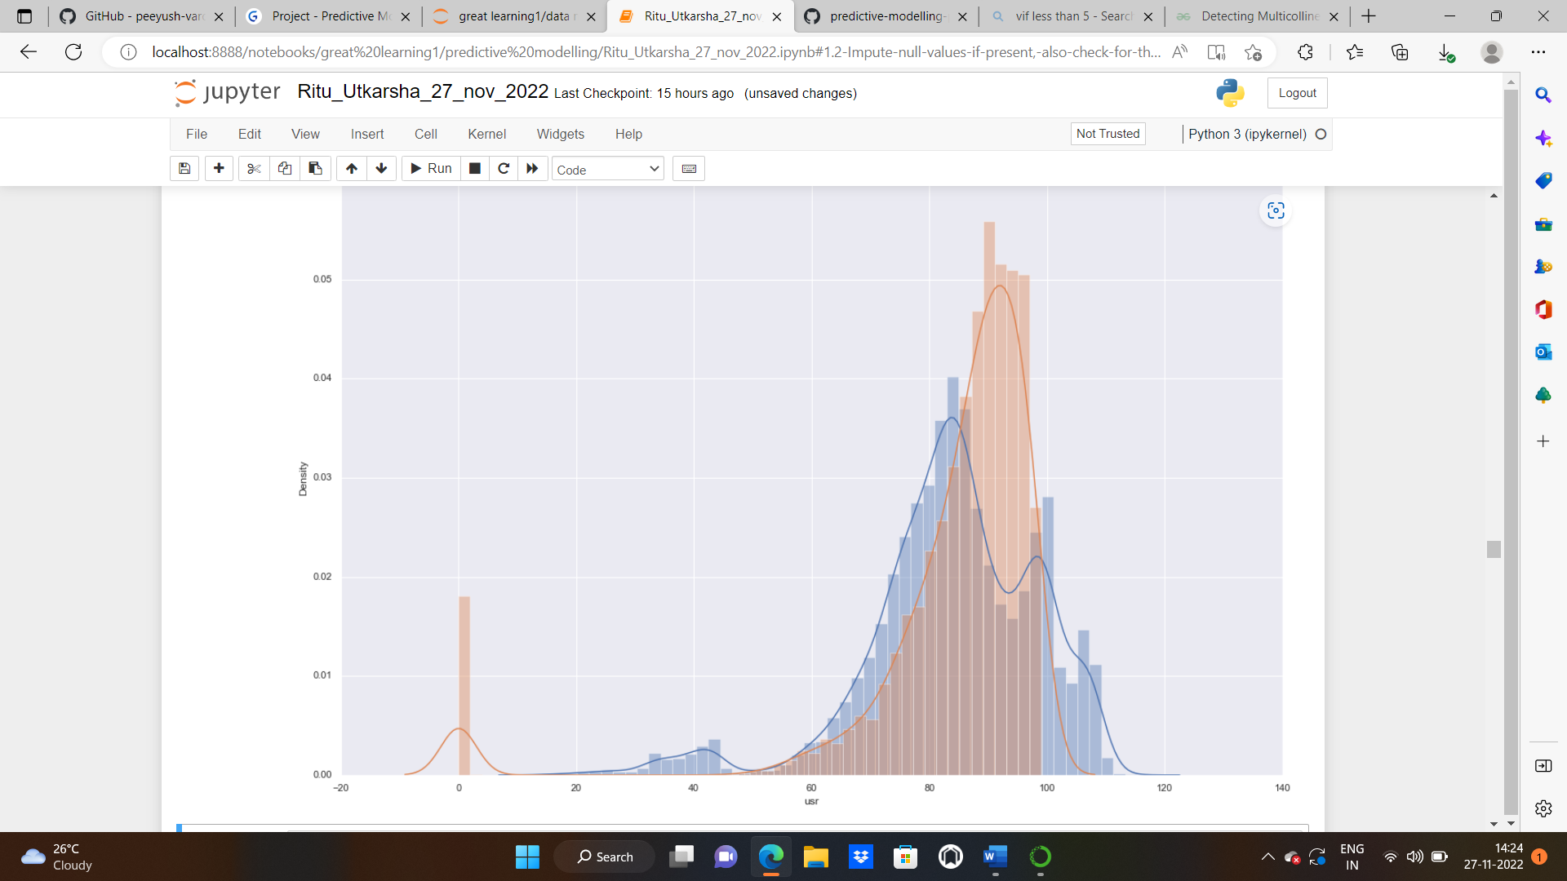

**1.4.Inference: Basis on these predictions, what are the business insights and recommendations. Please explain and summarise the various steps performed in this project. There should be proper business interpretation and actionable insights present.**

**Solution:**

**## CONCLUSIONS FROM 8th Iteration that is the BEST MODEL**

**usr(pred)=43.50501683826659-(2.13715521e-02 * lread) +(1.23369450e-02 * lwrite) +(1.27805141e-03 * scall)-(3.13558432e-03 * swrite)-**

**(1.92866216e-01 * exec) -(4.01928314e-02 * pflt) -(3.50679241e-06 * rchar) -(1.08591693e-05 * wchar)-(1.47629416e-01 * pgout)**

**+(2.54303584e-02 * pgin) -(1.70116294e-03 * freemem) -(3.29581546e-05 * freeswap) +(7.99406585e+00 * runqsz_Not_CPU_Bound')**

**if lread increases by 1 unit, predicted usr will gown by 0.021 unit.**

**if lwrite increases by 1 unit, predicted usr will go up by 0.0123 unit.**

**if scall increases by 1 unit, predicted usr will go up by 0.0001 unit**

**if swrite increases by 1 unit, predicted usr decrease by 0.003 unit**

**if exec increases by 1 unit, predicted usr decrease by 0.019 unit**

**if pflt increases by 1 unit, predicted usr decrease by 0.04 unit**

**if rchar increases by 1 unit, predicted usr decrease by 3.29581546e-05 unit**

**if wchar increases by 1 unit, predicted usr decrease by 0.019 unit**

**if pgout increases by 1 unit, predicted usr decrease by 1.47629416e-01 unit**

**if pgin increases by 1 unit, predicted usr increase by 2.54303584e-02 unit**

**if freemen increase by 1 unit, predicted usr decrease by 1.70116294e-03 unit**

**if freewap increases by 1 unit, predicted usr decrease by 3.29581546e-05 unit**

**if runqsz_Not_CPU_Bound' increases by 1 unit, predicted usr increase by 7.9940658 unit**

**Comparing the model scores from the linear regression models, model 8 seems to be the best model. R square for my train and test data is approx. 63 percent which means 63 percent of the variance in the target variable is explained by the predictors (independent variables).Also for better accuracy ,we dropped the columns "fork","pgfree","ppgout","sread","ppgin","pgscan","atch" as some of them have vif much greater than 5 and some have pvalues>0.5.From the linear equation model, we can see runqsz_Not_CPU_Bound is the highest coefficient in predicting usr. The top attributes in influencing the usr are "runqsz_Not_CPU_Bound',exec, pgin ,lwrite etc.**

**Problem 2: Logistic Regression**

**You are a statistician at the Republic of Indonesia Ministry of Health and you are provided with a data of 1473 females collected from a Contraceptive Prevalence Survey. The samples are married women who were either not pregnant or do not know if they were at the time of the survey.**

**The problem is to predict do/don't they use a contraceptive method of choice based on their demographic and socio-economic characteristics.**

**Dataset for Problem 2:**[**Contraceptive_method_dataset.xlsx**](https://olympus.mygreatlearning.com/courses/75698/files/6789330/download?verifier=QEYwfgNKgynAOA7x7rlzJXVAUdzsRBZBuw8vBMn5&wrap=1)

**Data Dictionary:**

1. Wife's age (numerical)  
2. Wife's education (categorical) 1=uneducated, 2, 3, 4=tertiary  
3. Husband's education (categorical) 1=uneducated, 2, 3, 4=tertiary  
4. Number of children ever born (numerical)  
5. Wife's religion (binary) Non-Scientology, Scientology  
6. Wife's now working? (binary) Yes, No  
7. Husband's occupation (categorical) 1, 2, 3, 4(random)  
8. Standard-of-living index (categorical) 1=verlow, 2, 3, 4=high  
9. Media exposure (binary) Good, Not good  
10. Contraceptive method used (class attribute) No,Yes

**2.1 Data Ingestion: Read the dataset. Do the descriptive statistics and do null value condition check, check for duplicates and outliers and write an inference on it. Perform Univariate and Bivariate Analysis and Multivariate Analysis.**

**Solution:**

**Getting the basic info of the dataset: Head and tail of the dataset**

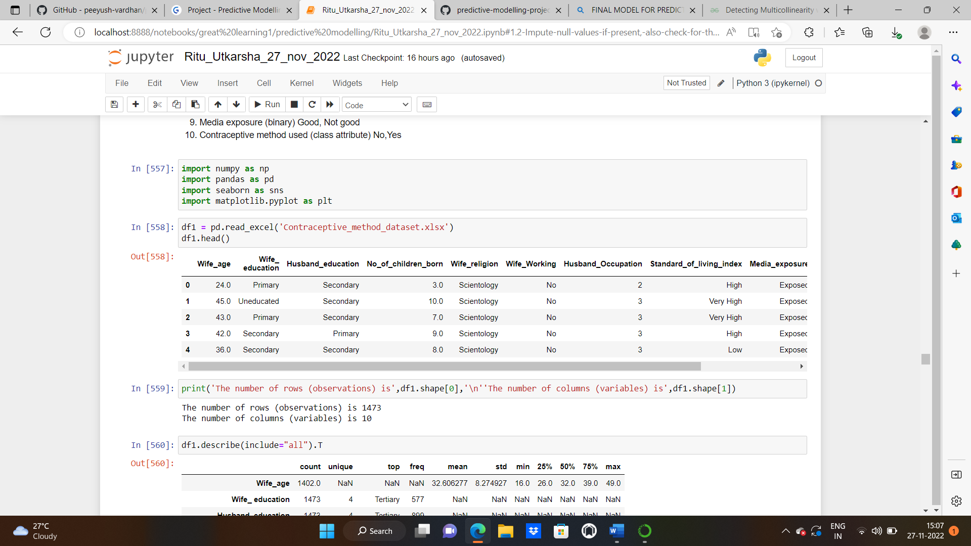

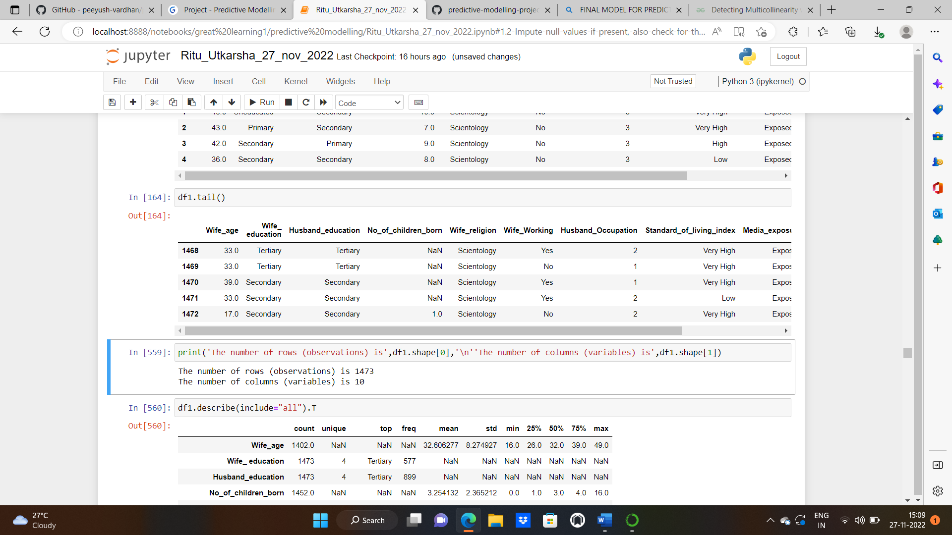

**SHAPE:**

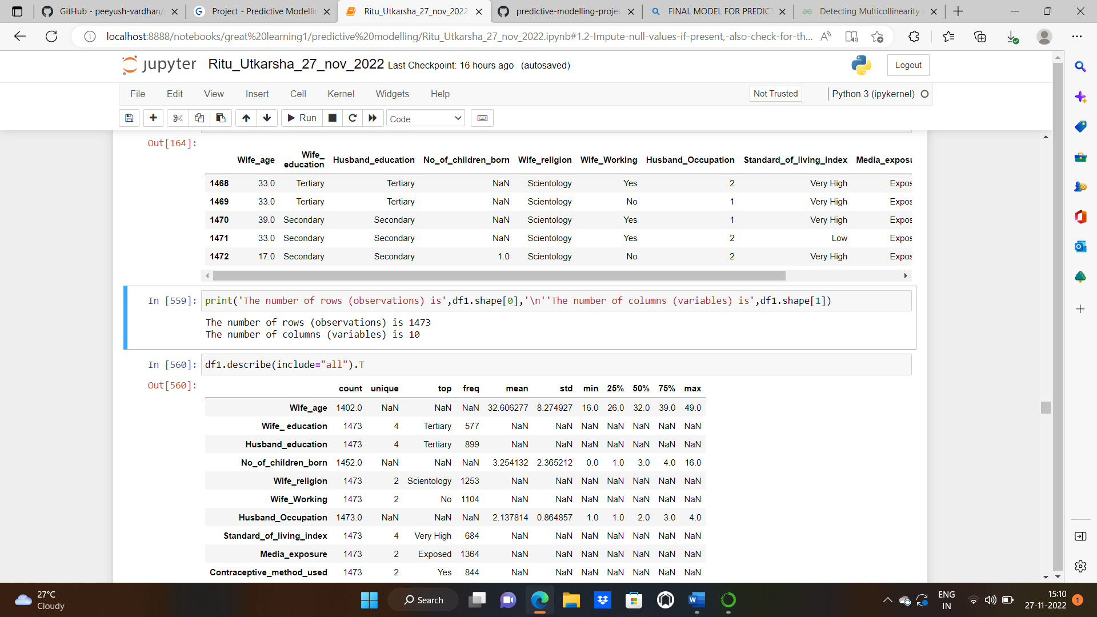

**DESCRIPTIVE ANALYSIS:**

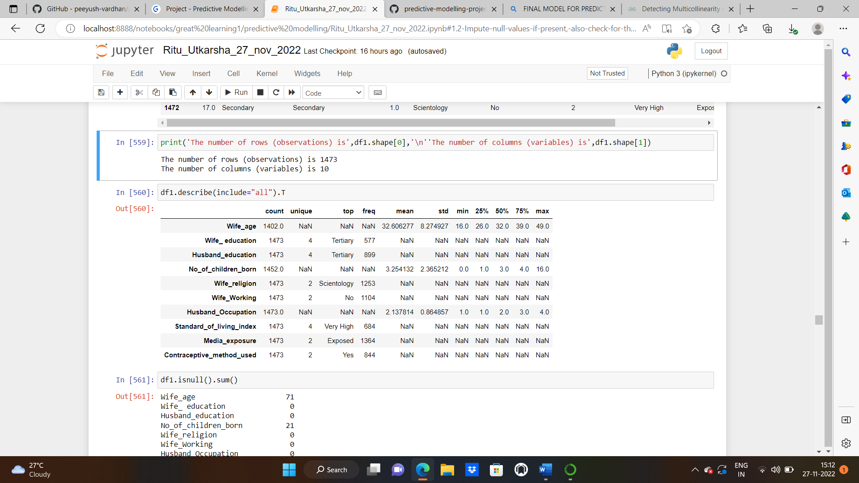

**NULL VALUES:**

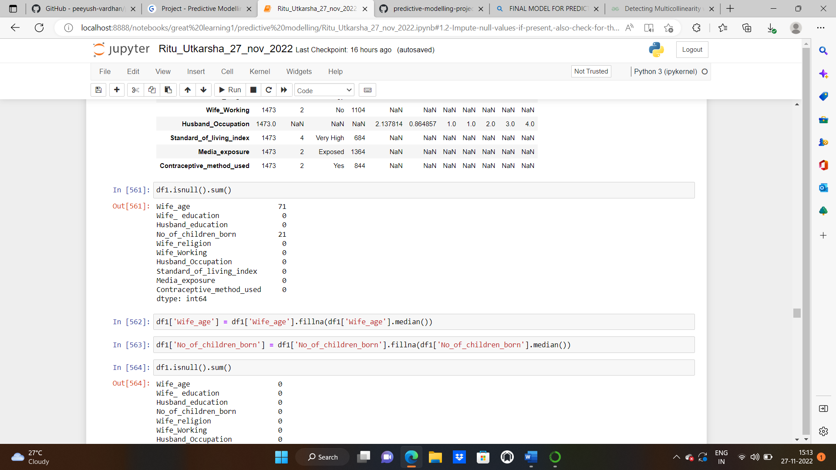

**IMPUTING NULL VALUES WITH THE MEDIAN VALUES:**

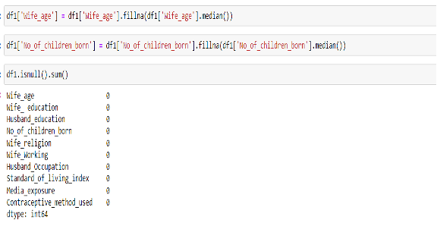

**CHECKING DUPLICATED RECORDS AND DROPPING THEM:**

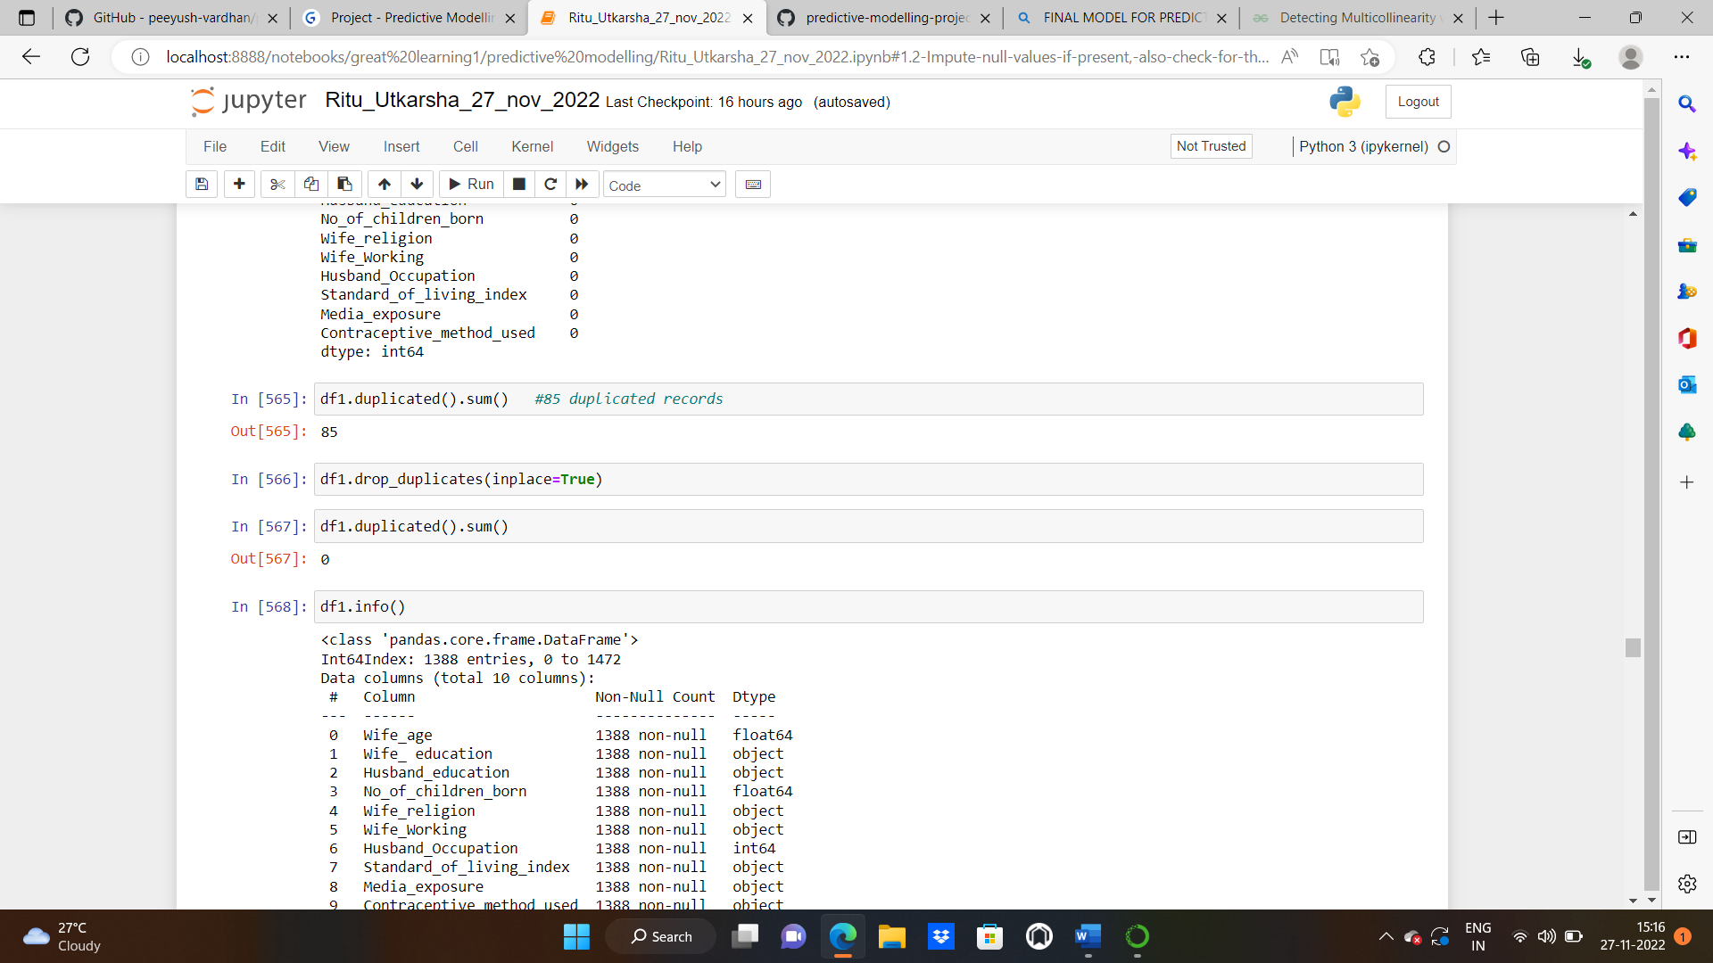

**INFO OF THE DATASET:**

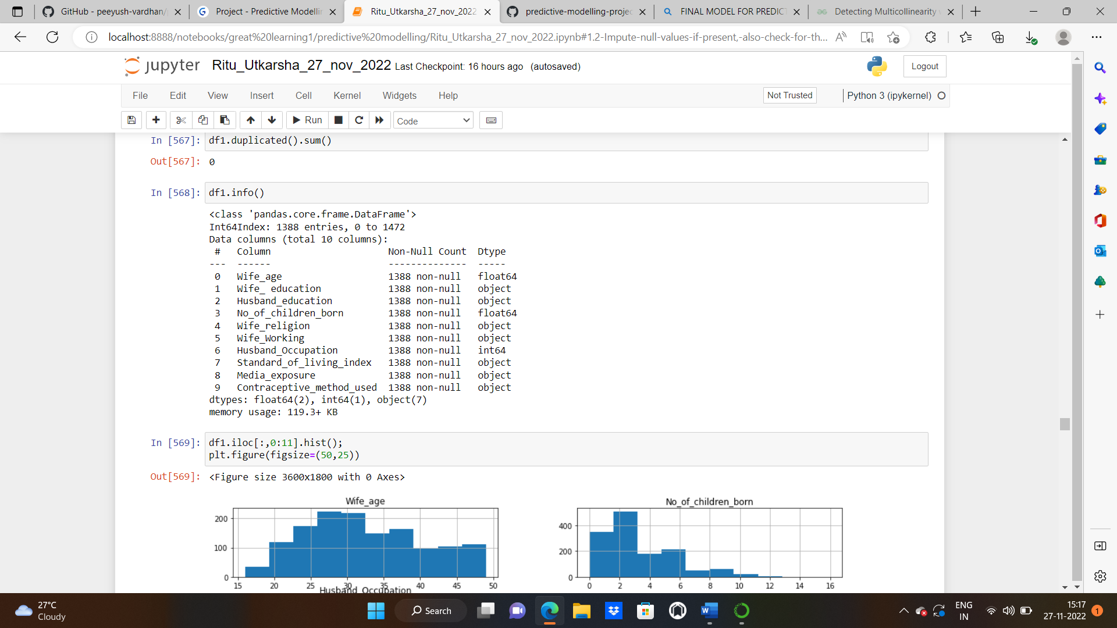

**UNIVARIATE AND BIVARIATE ANALYSIS:**

**HISTOGRAM**

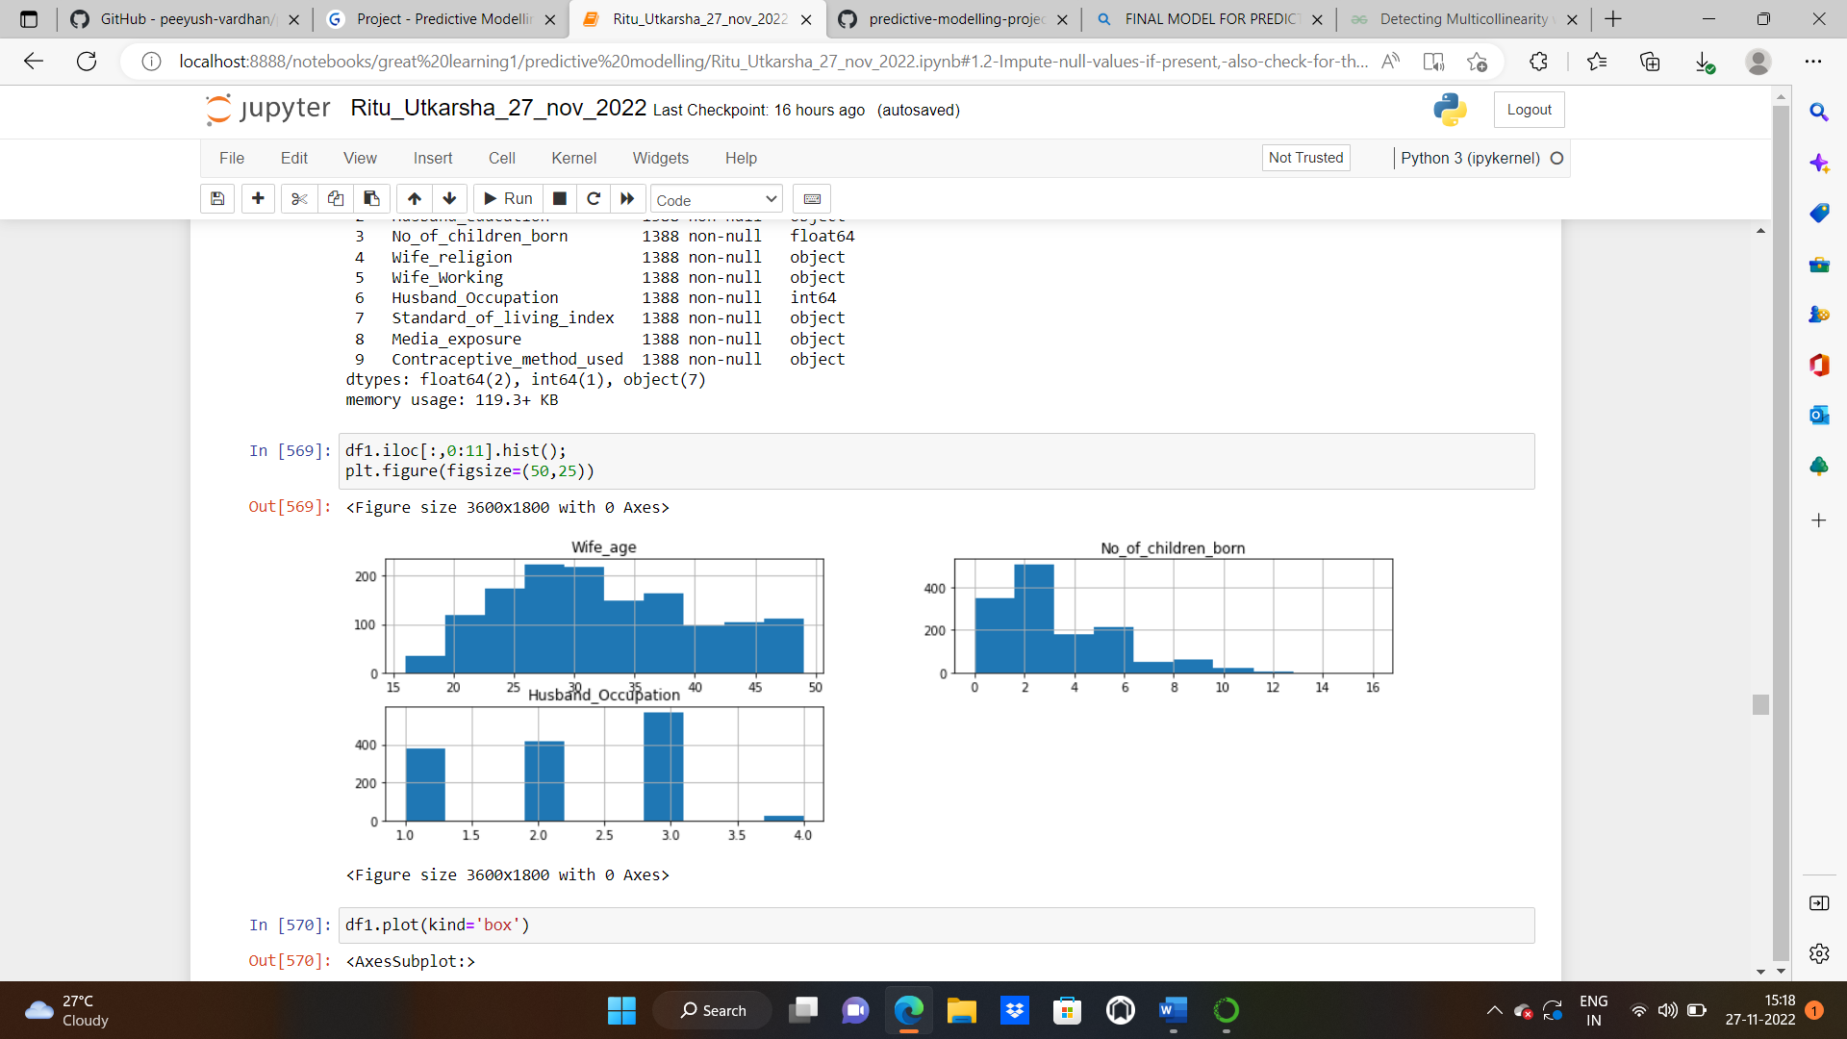

**BOXPLOT:**

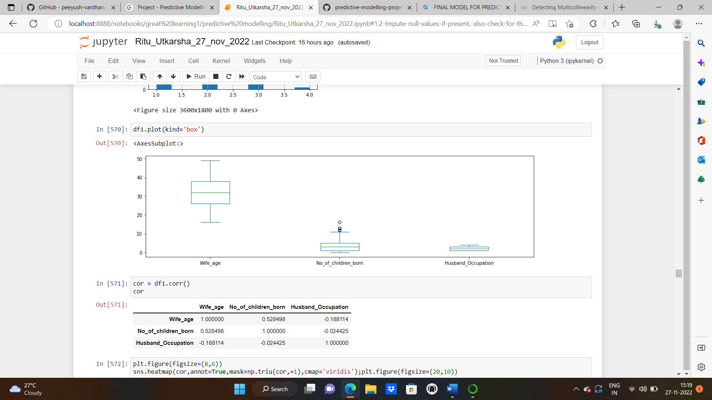

We have outliers in “No_of_children_born” column.

**CHECKING CORRELATION BETWEEN THE VARIABLES:**

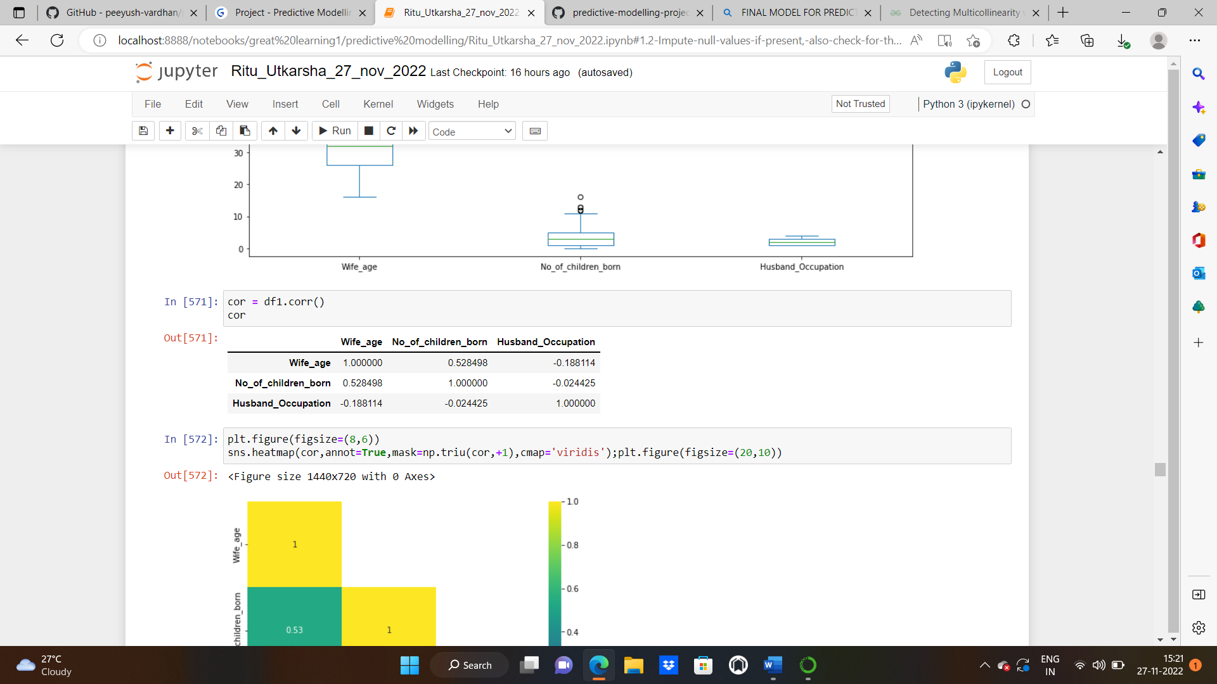

**HEATMAP**: A heat map (or heatmap) is**a data visualization technique that shows magnitude of a phenomenon as colour in two dimensions.** The variation in colour may be by hue or intensity, giving obvious visual cues to the reader about how the phenomenon is clustered or varies over space.

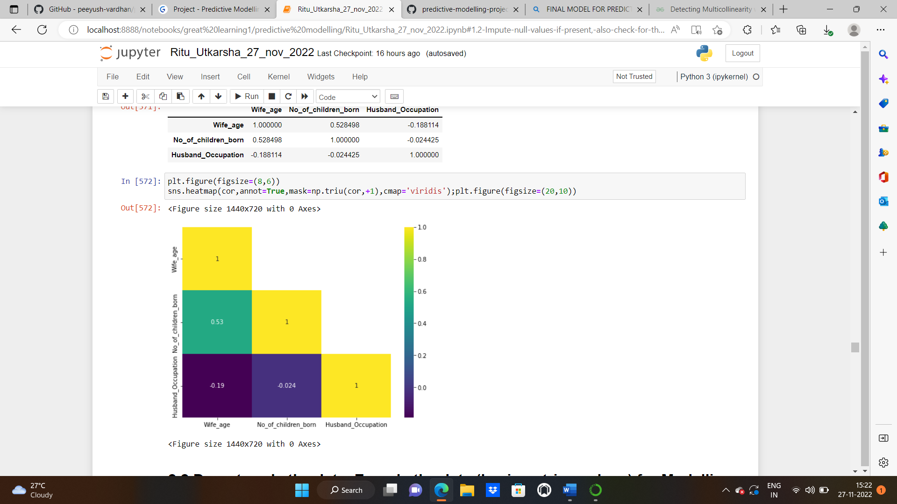

Wife _age and no_of_children_born have positive correlation.Whereas wife_age and husband_occupation ,no_of_children_born and wife_age have negative correlation**.**

**PAIRPLOT:** A pair plot is a**data visualization** that plots pair-wise relationships between all the variables of a dataset. This allows us to better understand the relationships visually.

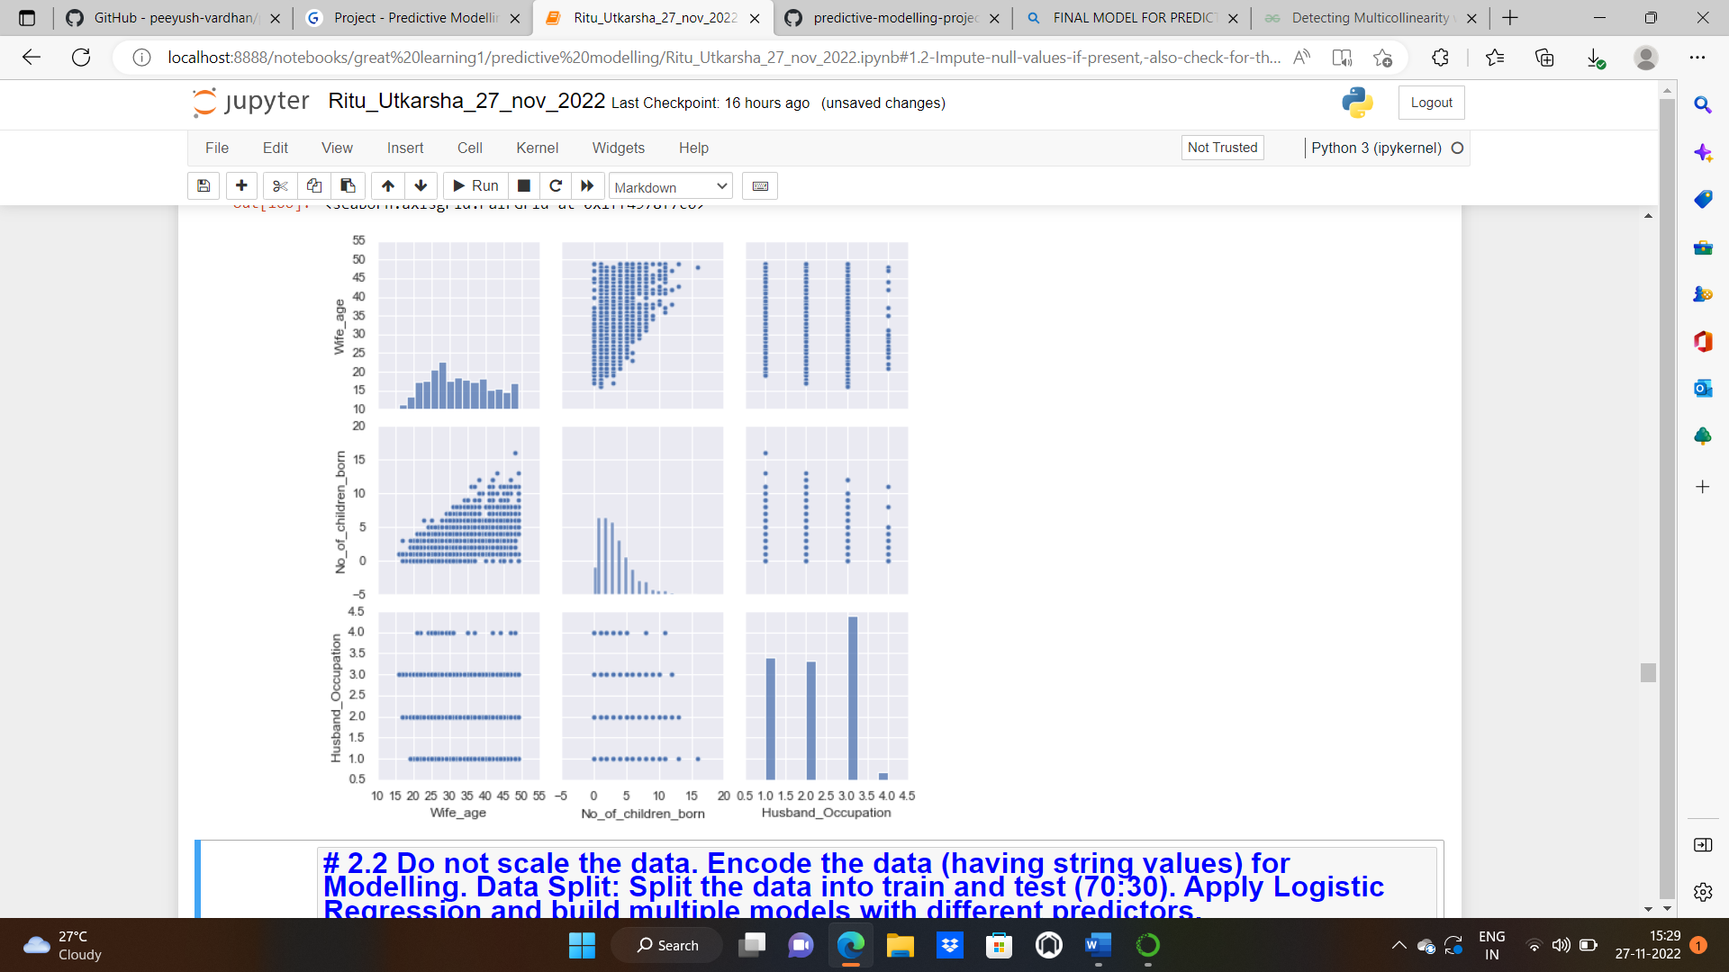

**2.2 Do not scale the data. Encode the data (having string values) for Modelling. Data Split: Split the data into train and test (70:30). Apply Logistic Regression and build multiple models with different predictors.**

**Solution:** We’ll do both the label encoding and one hot encoding since we’ve both the nominal and ordinal types of variables present in our dataset.

**Value counts of all the categorical variables:**

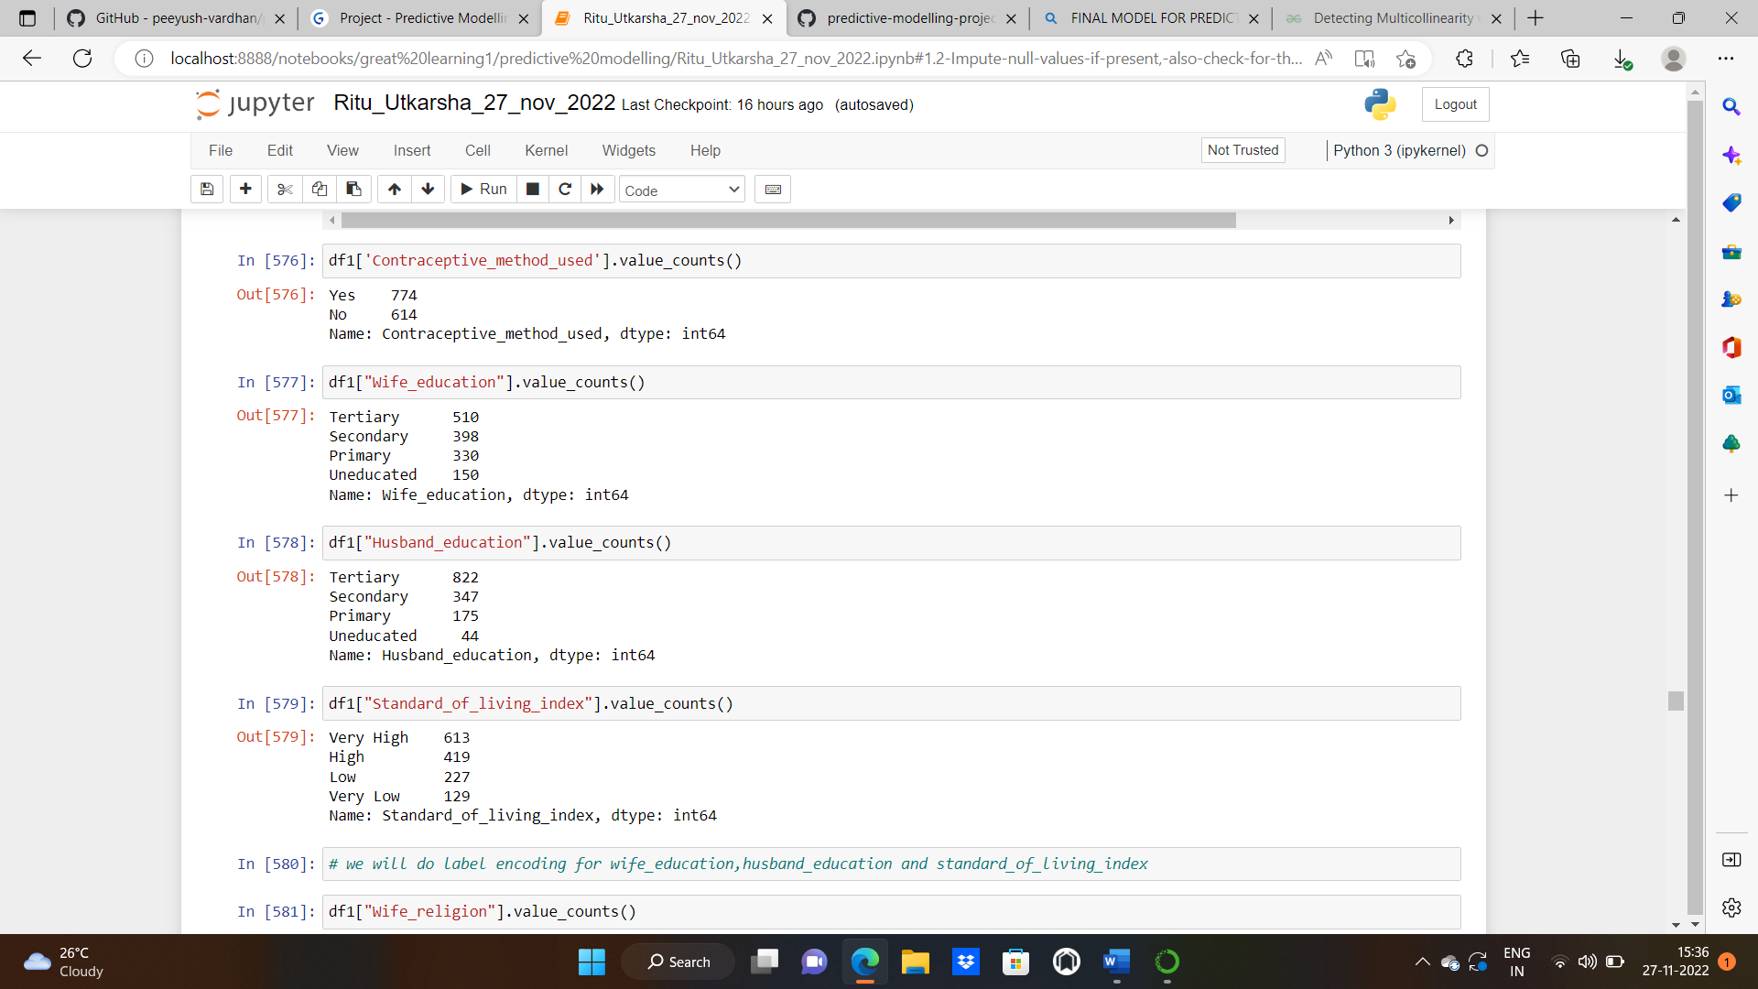

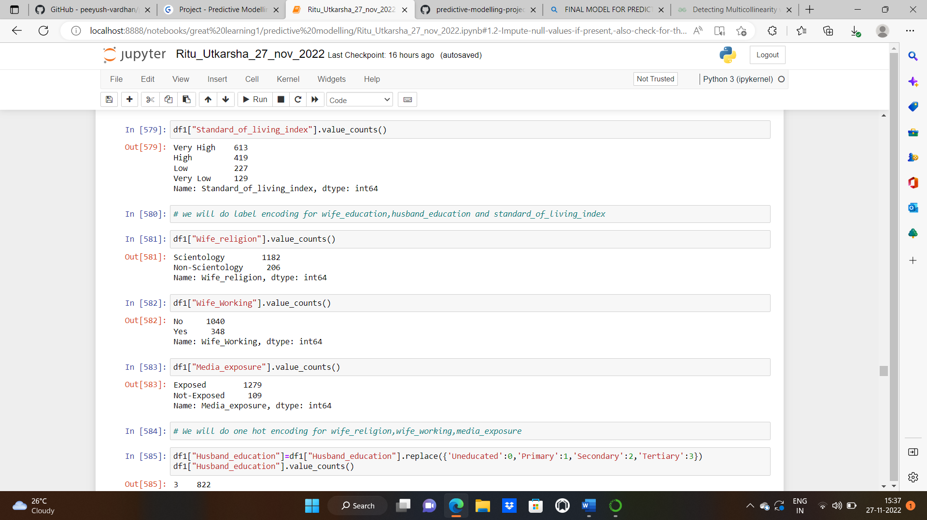

**Label Encoding** refers to converting the labels into a numeric form to convert them into the machine-readable form. Machine learning algorithms can then decide in a better way how those labels. must be operated. It assigns each categorical value an integer value based on the alphabetical order.

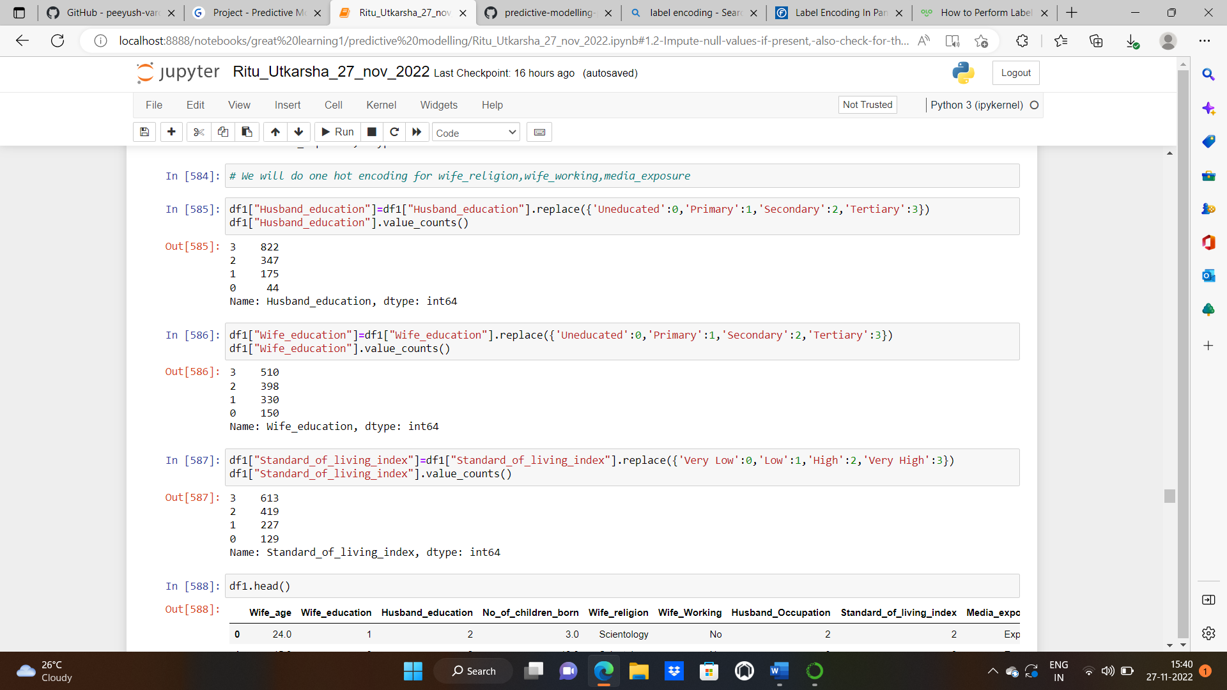

**One hot encoding:** One hot encoding is one method of **converting data** to prepare it for an algorithm and get a better prediction. With one-hot, we convert each categorical value into a new categorical column and assign a binary value of 1 or 0 to those columns. Each integer value is represented as a binary vector. All the values are zero, and the index is marked with a 1.

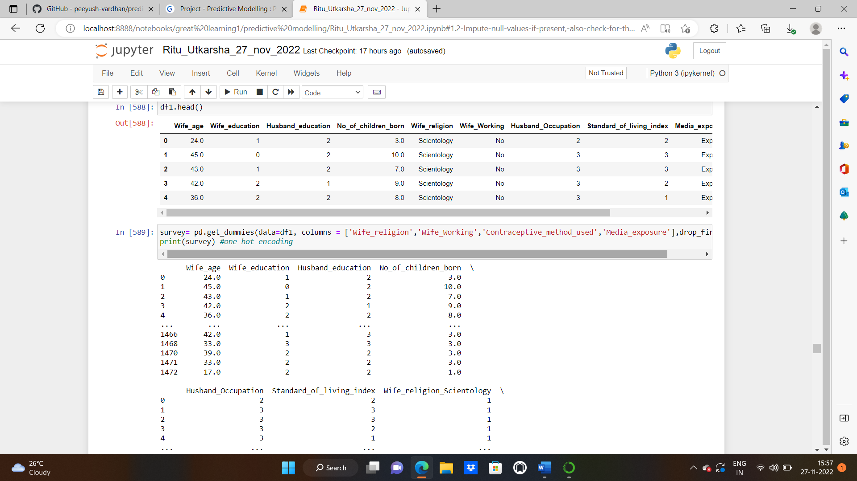

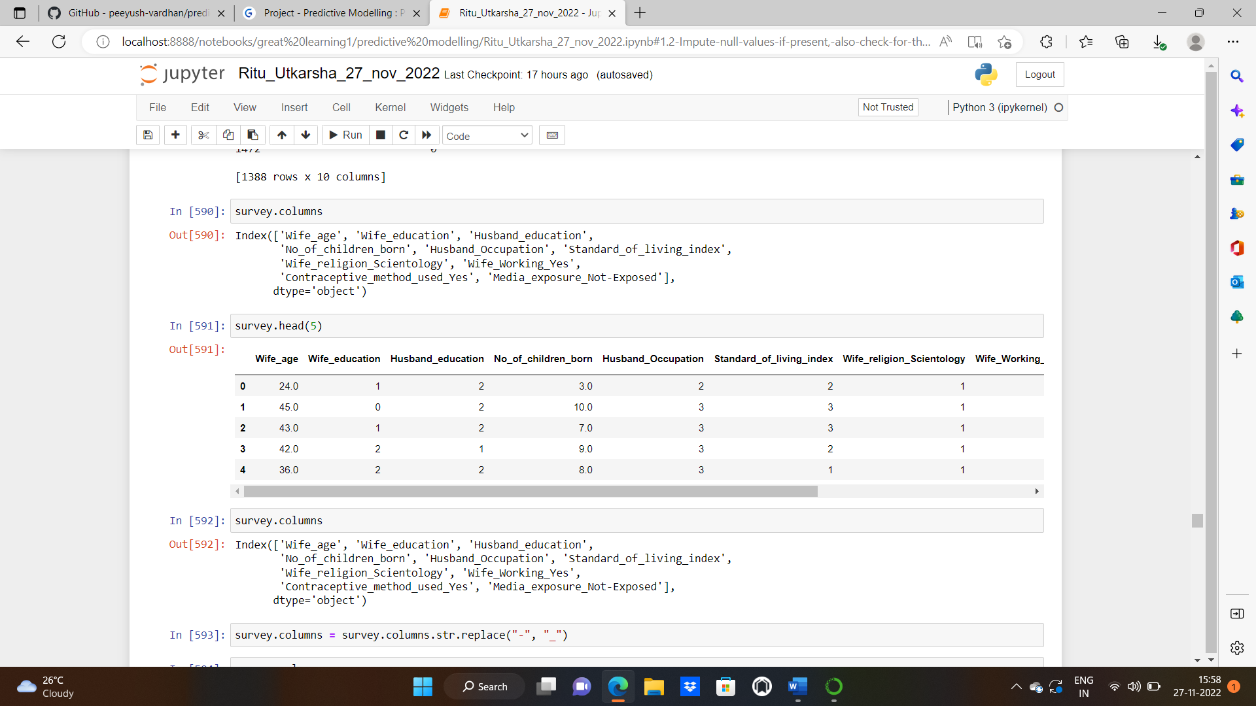

**Columns after both the encoding:**

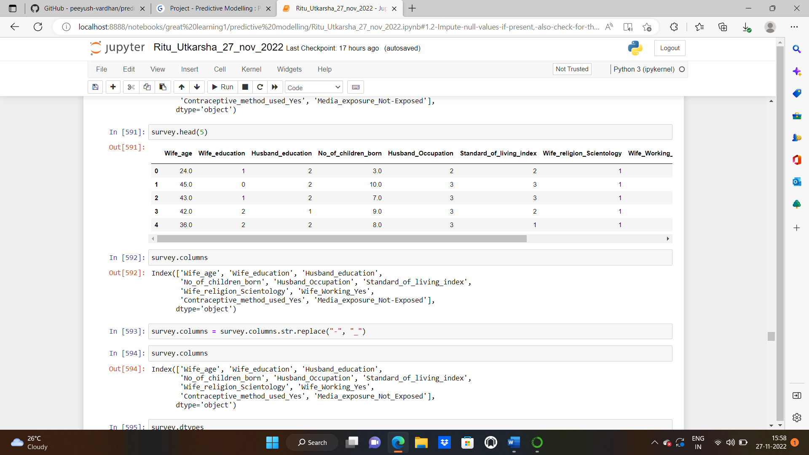

**SPLITTING THE DATA INTO TRAIN AND TEST:**

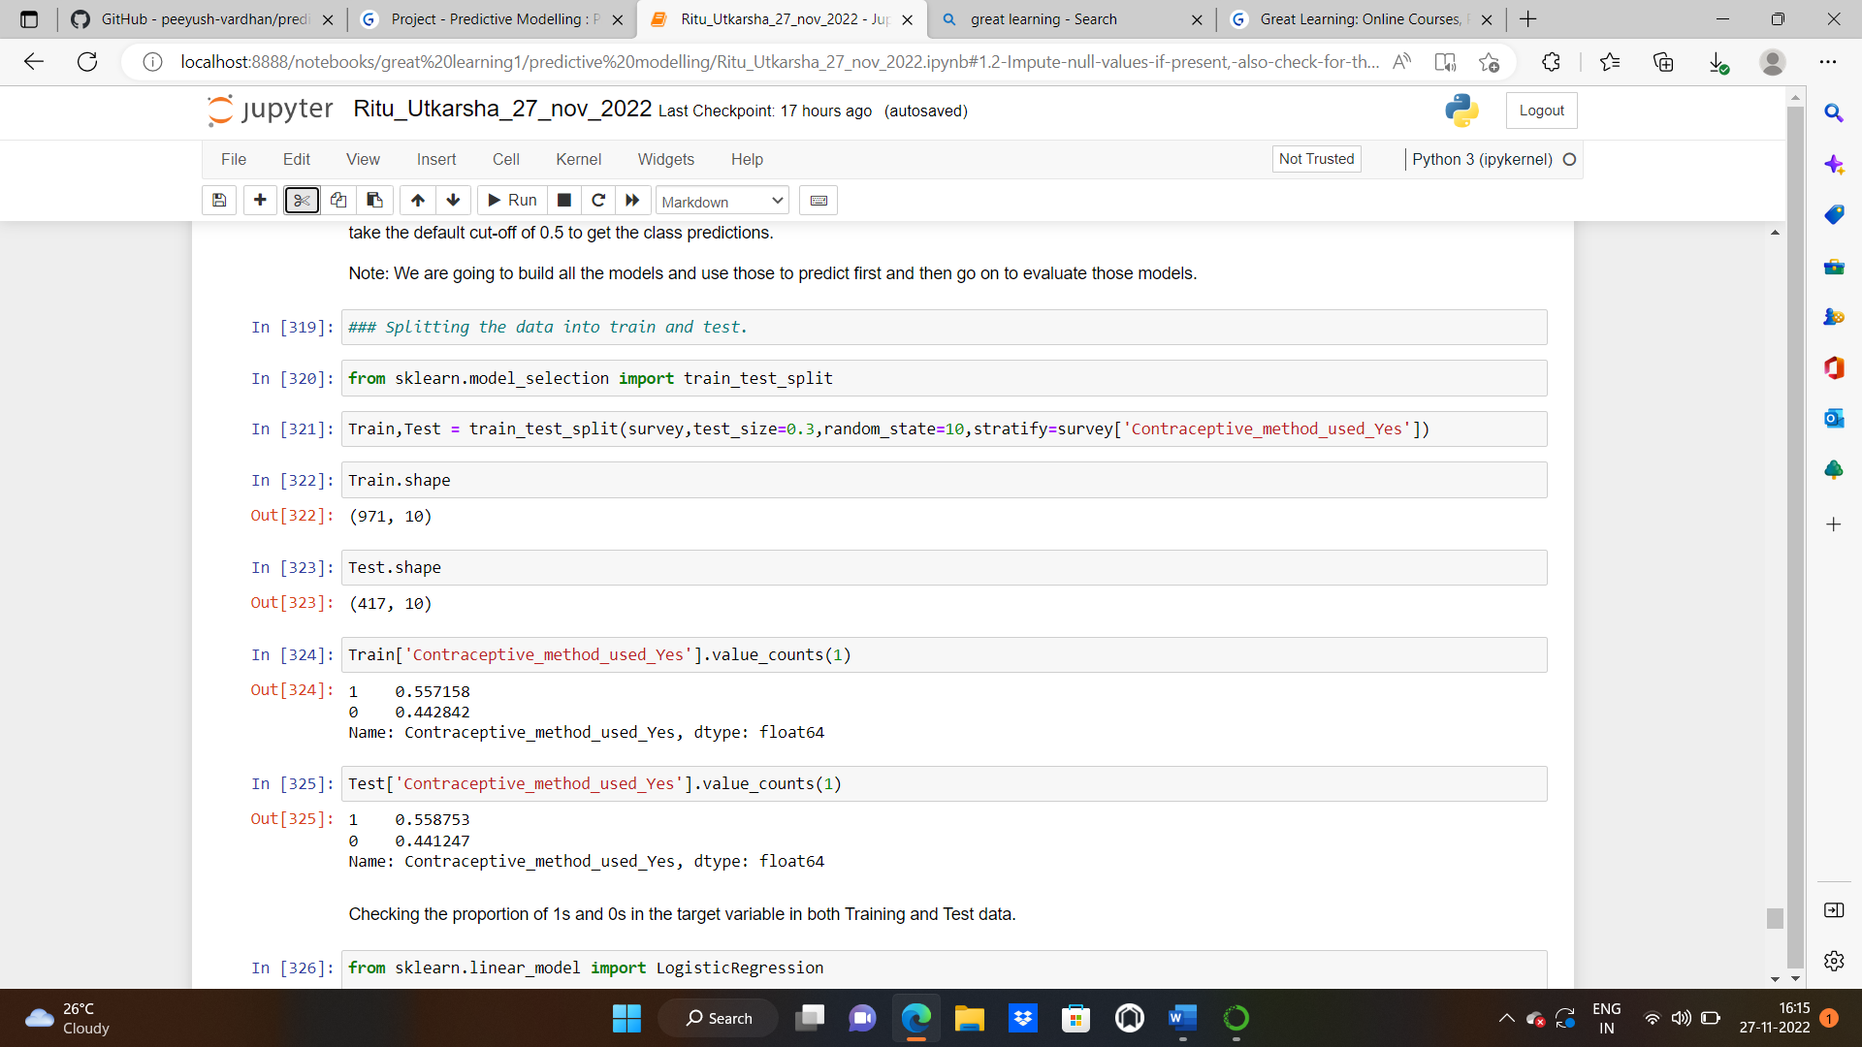

**Shape of the train and test data:**

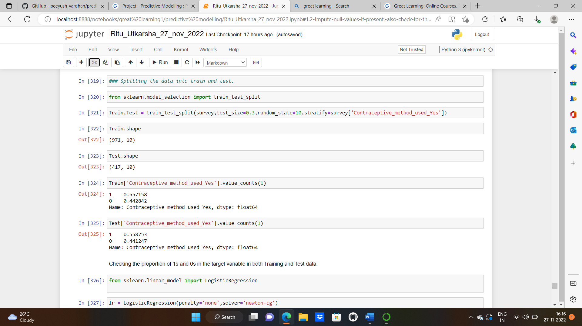

**Value counts of train and test data:**



**Applying logistic regression model:**

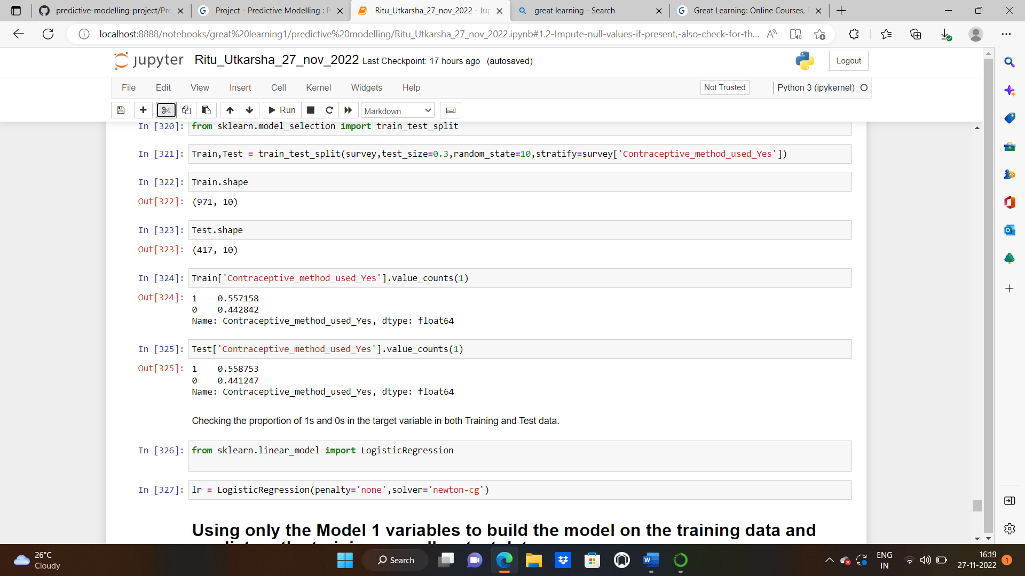

**BUILDING BASE MODEL USING ALL THE INDEPENDENT VARIABLES:**

We’ve to predict if do/don't they use a contraceptive method of choice based on their demographic and socio-economic characteristics.

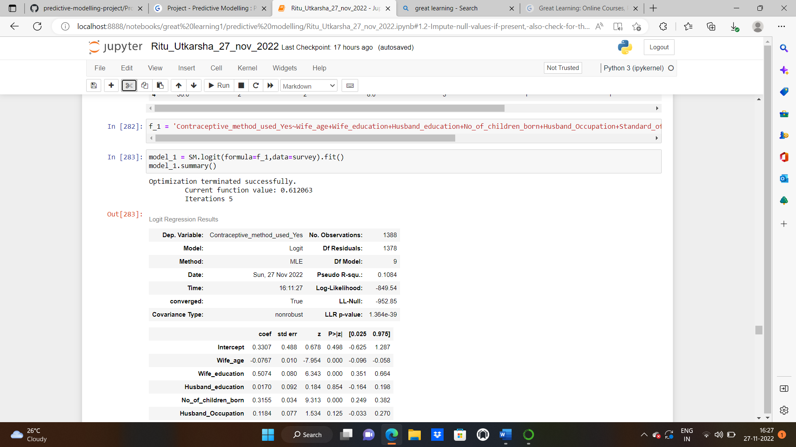

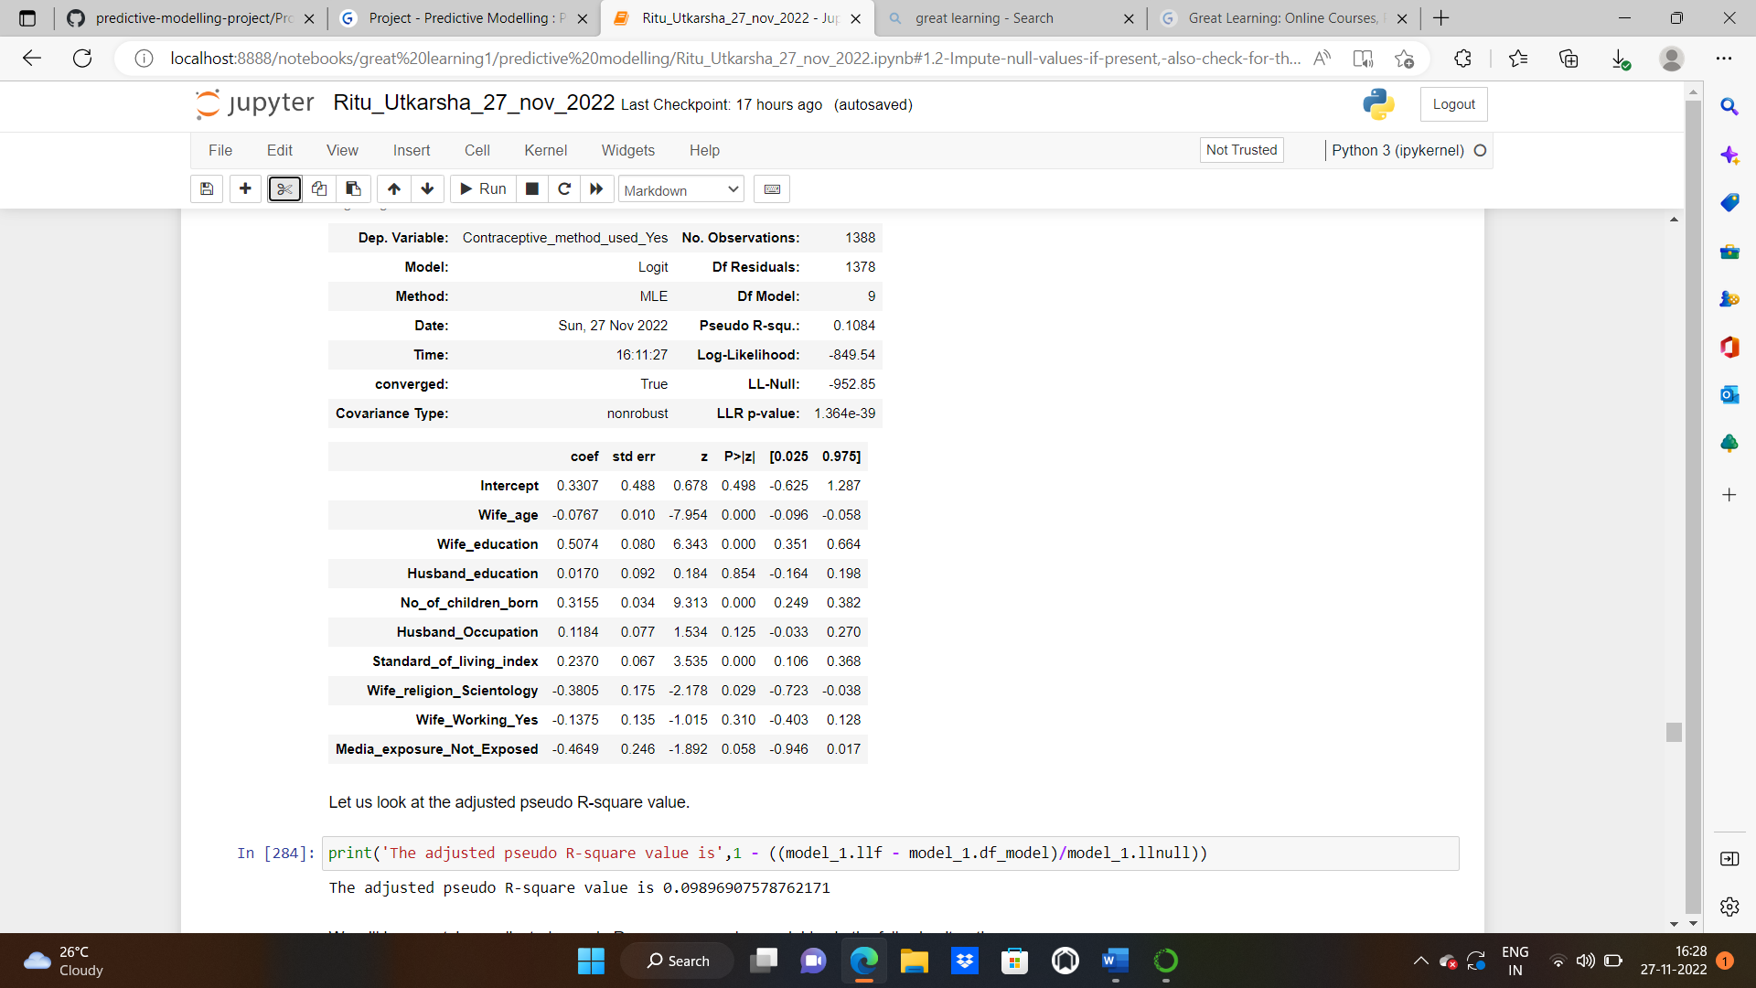

**ADJUSTED R square for the base model f_1:**

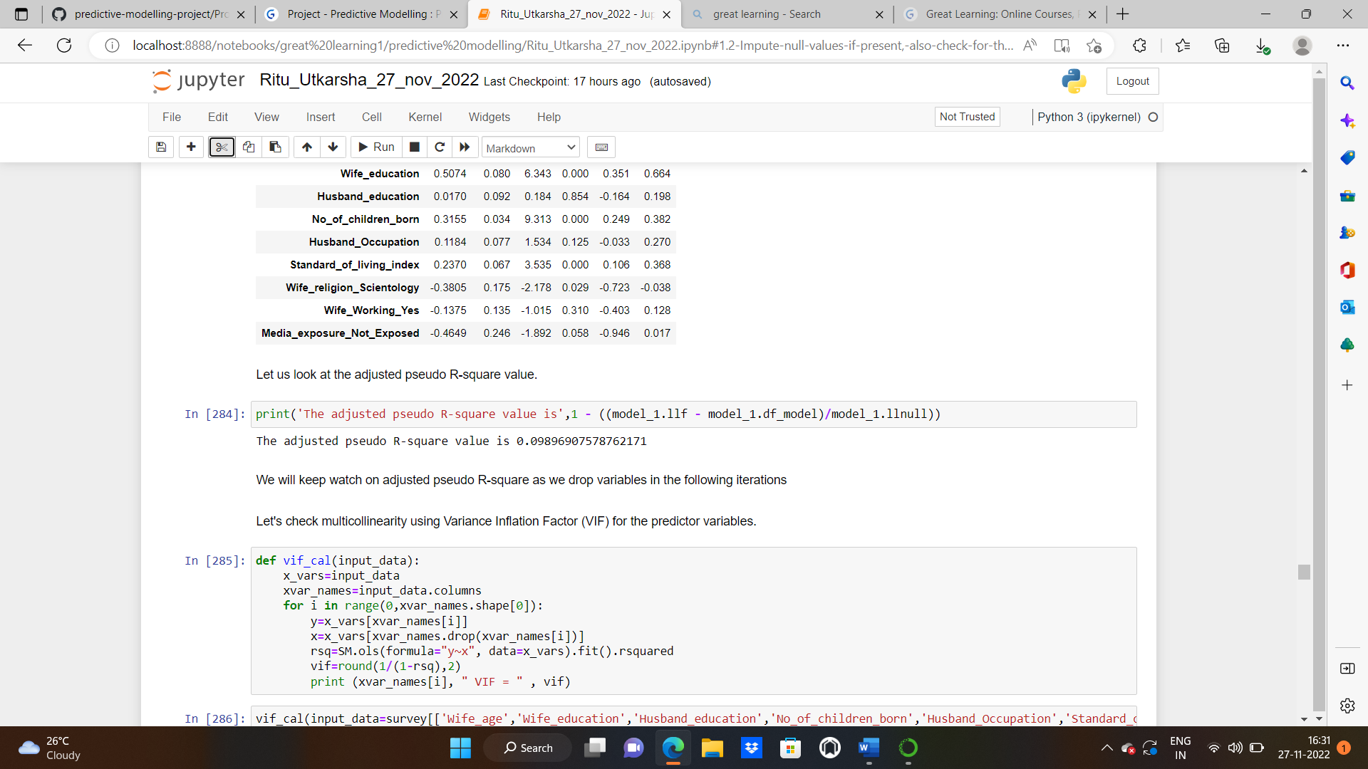

We will keep watch on adjusted pseudo-R-square as we drop variables in the following iterations. Like its ordinary least squares analog, the adjusted McFadden Pseudo R2R2 penalizes the McFadden pseudo-R square as more terms are added to the model. More the value of adjusted pseudo-R square, the better the model is.

**CHECKING VIF:**

. 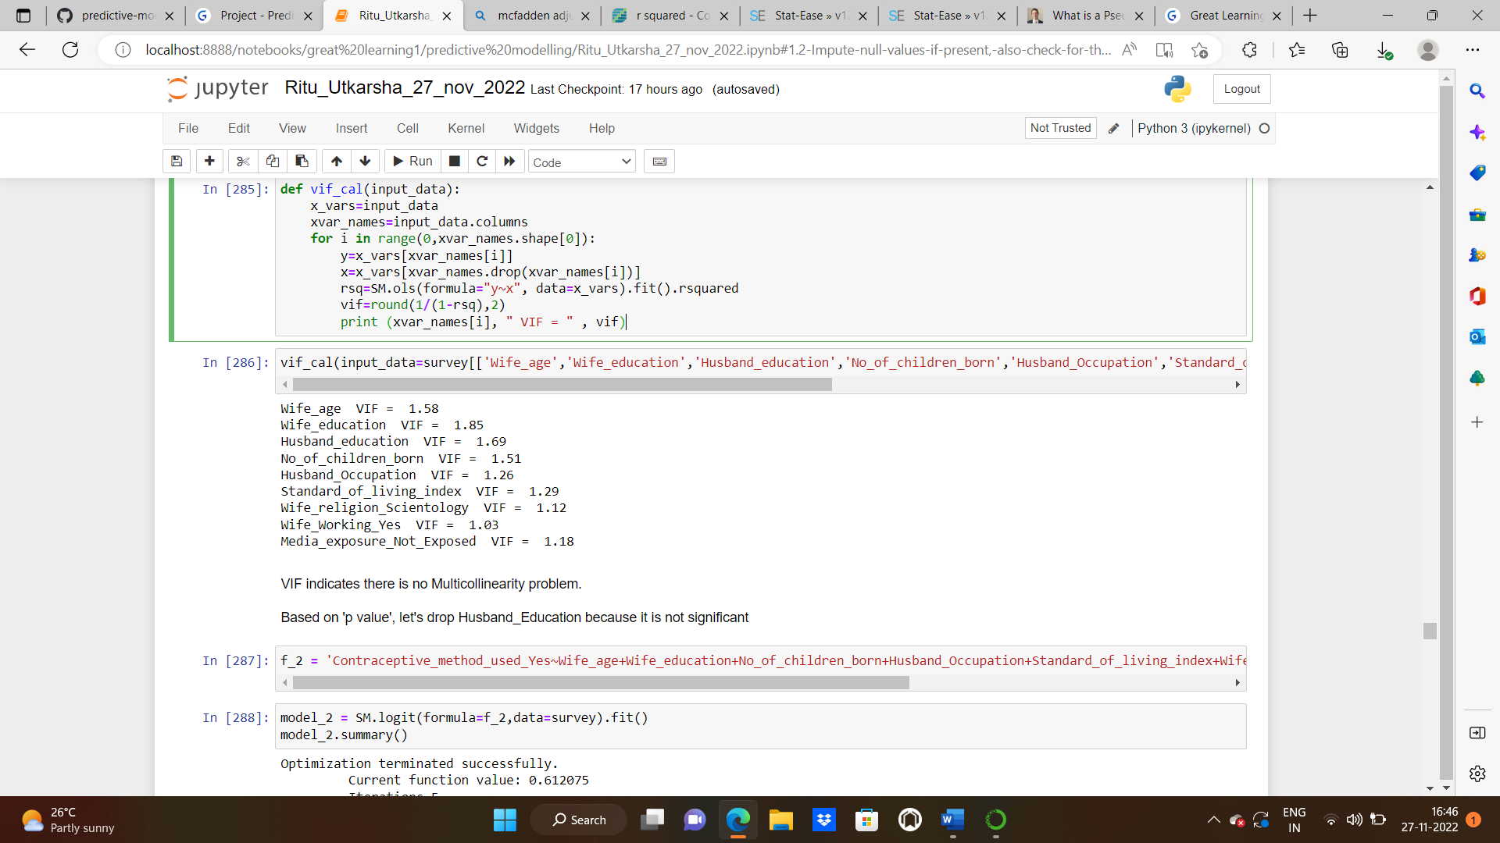

The Variance Inflation Factor (VIF) measures the severity of multicollinearity in [regression analysis](https://corporatefinanceinstitute.com/resources/knowledge/finance/regression-analysis/). It is a statistical concept that indicates the increase in the variance of a regression coefficient as a result of collinearity. In ordinary least square (OLS) regression analysis, multicollinearity exists when two or more of the [independent variables](https://corporatefinanceinstitute.com/resources/knowledge/modeling/independent-variable/) demonstrate a linear relationship between them.

VIF indicates there is no Multicollinearity problem.

Based on 'p value', let's drop Husband_Education because it is not significant.

In the same way, we’ll build multiple and keep a check on VIF and pvalue. Refer to the jupyter notebook for the codes

**FINAL MODEL BUILT:**

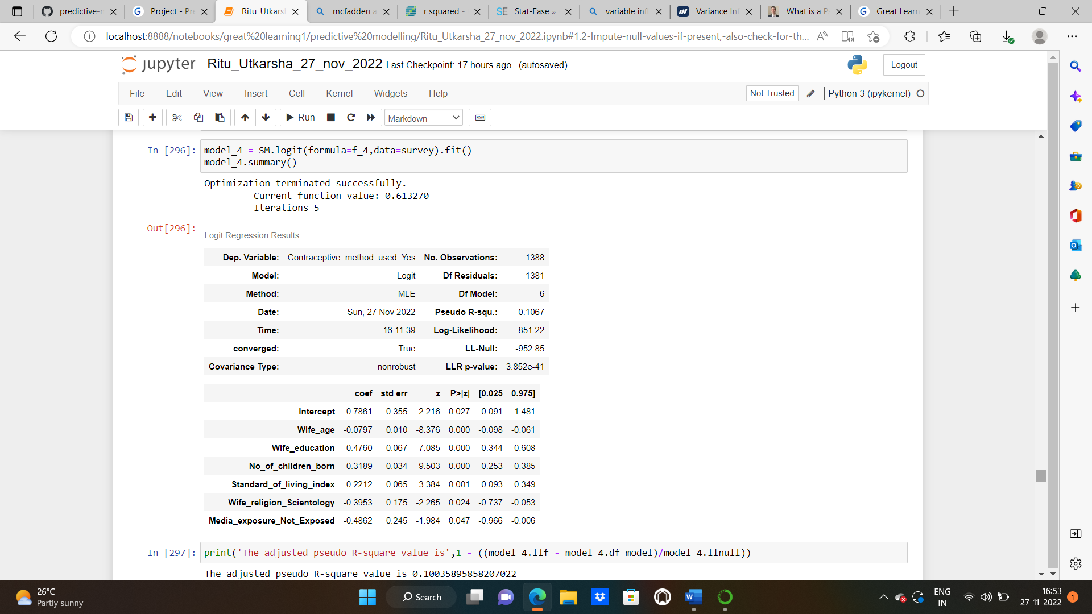

As we can see from the pvalues now that all the independent variables are significant. Also, the VIF is less than 2 for all the columns.

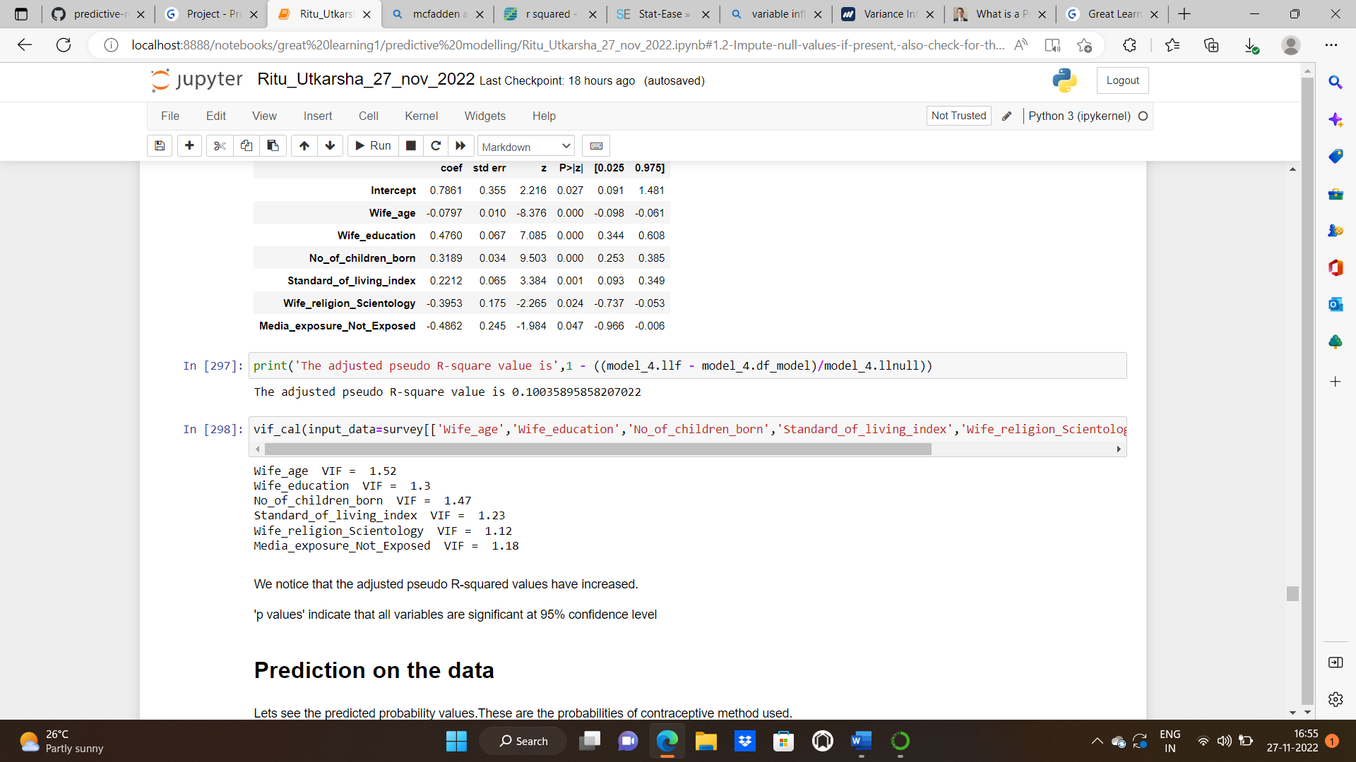

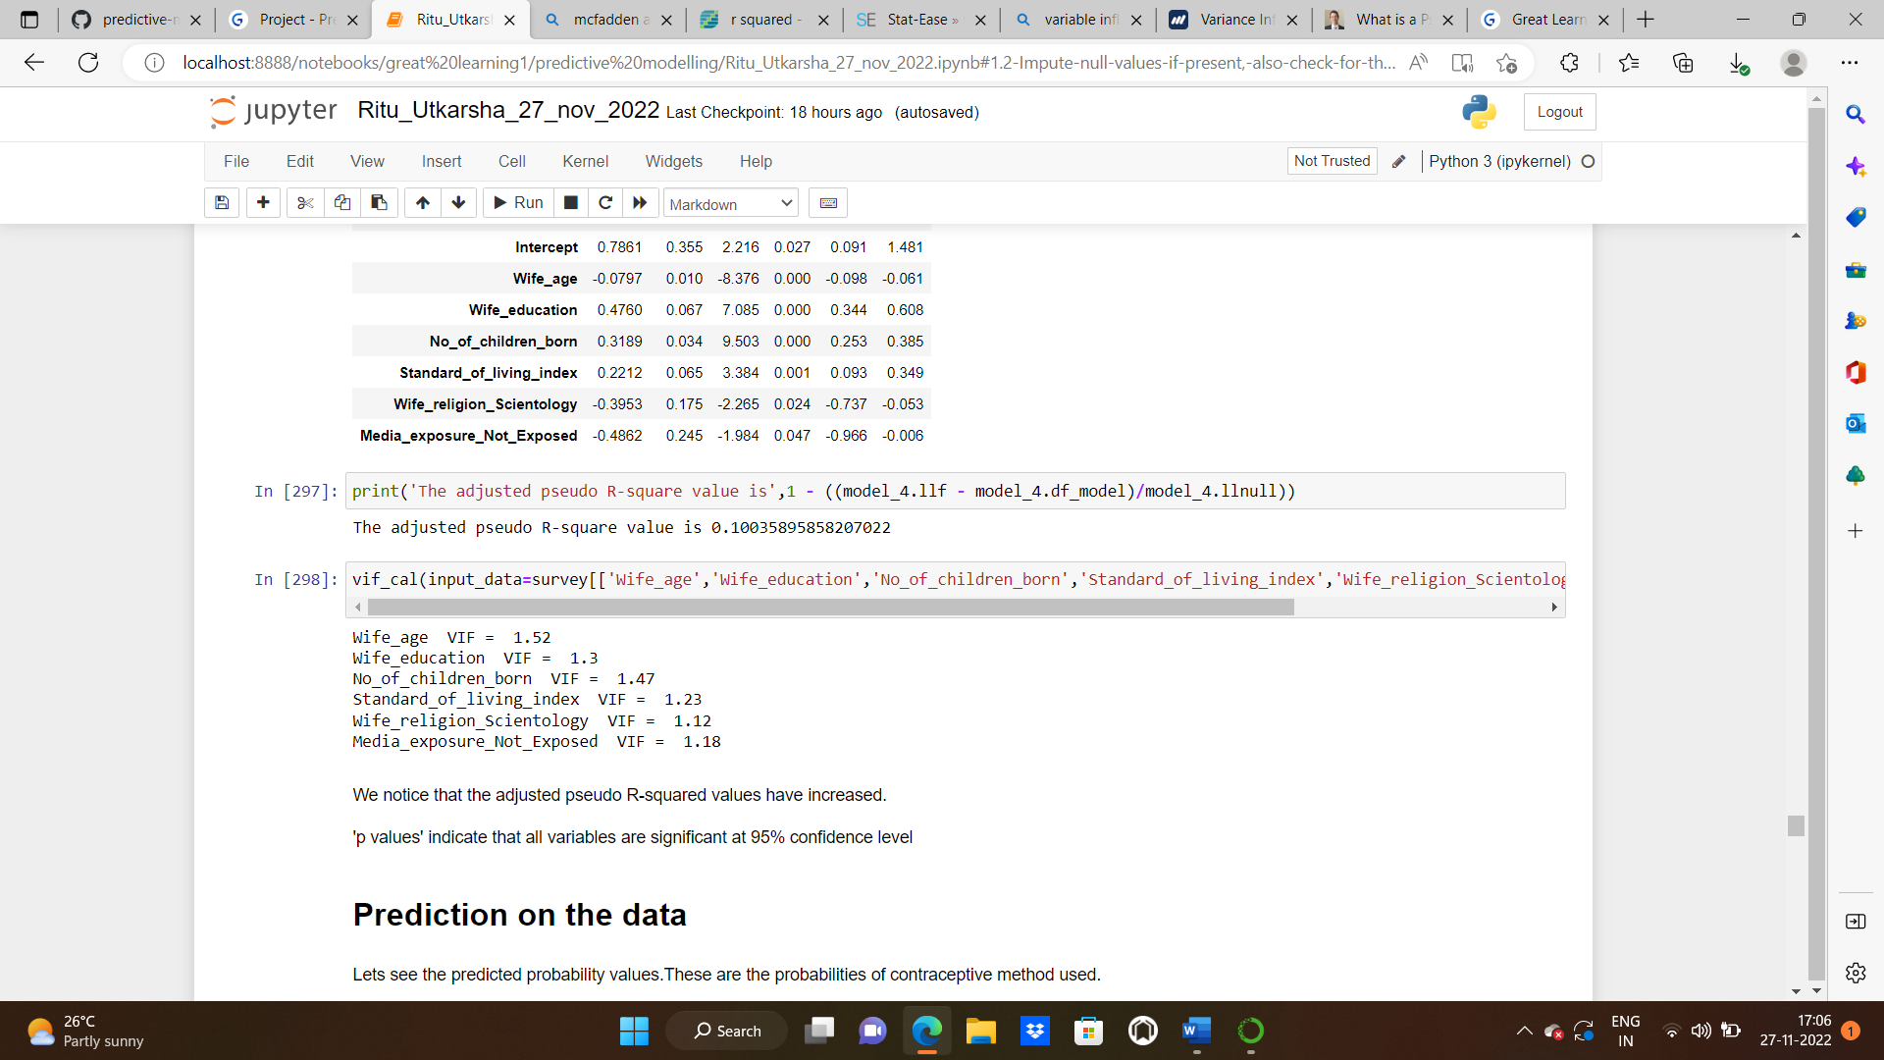

We notice that the adjusted pseudo-R-squared values have increased. Pvalues indicate that all variables are significant at 95% confidence level.

PREDICTION ON THE DATA:

Let’s see the predicted probability values. These are the probabilities of contraceptive method used.

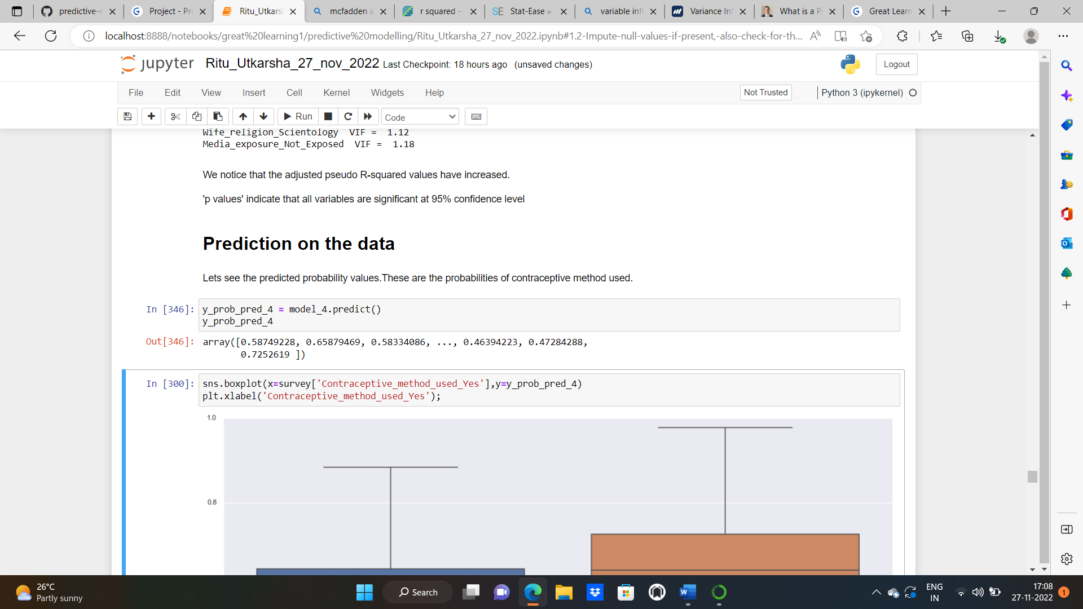

BOXPLOT OF PREDICTED VALUES:

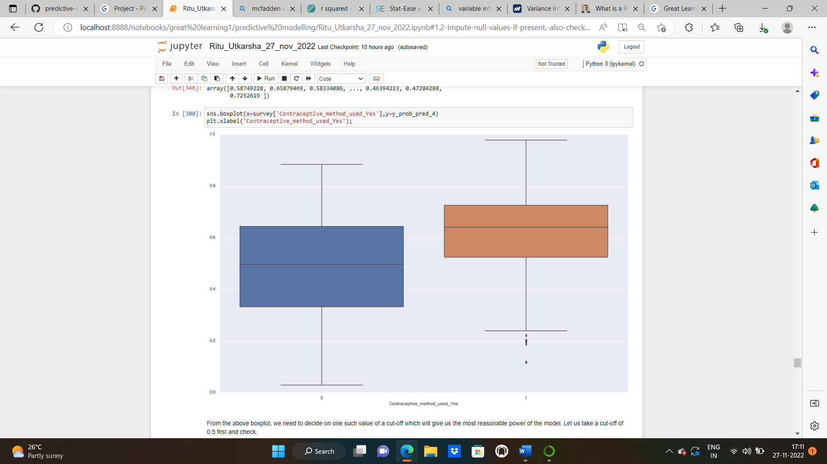

From the above boxplot, we need to decide on one such value of a cut-off which will give us the most reasonable power of the model. Let us first take a cut-off of 0.5 and check. Let us now see the predicted classes of the model.

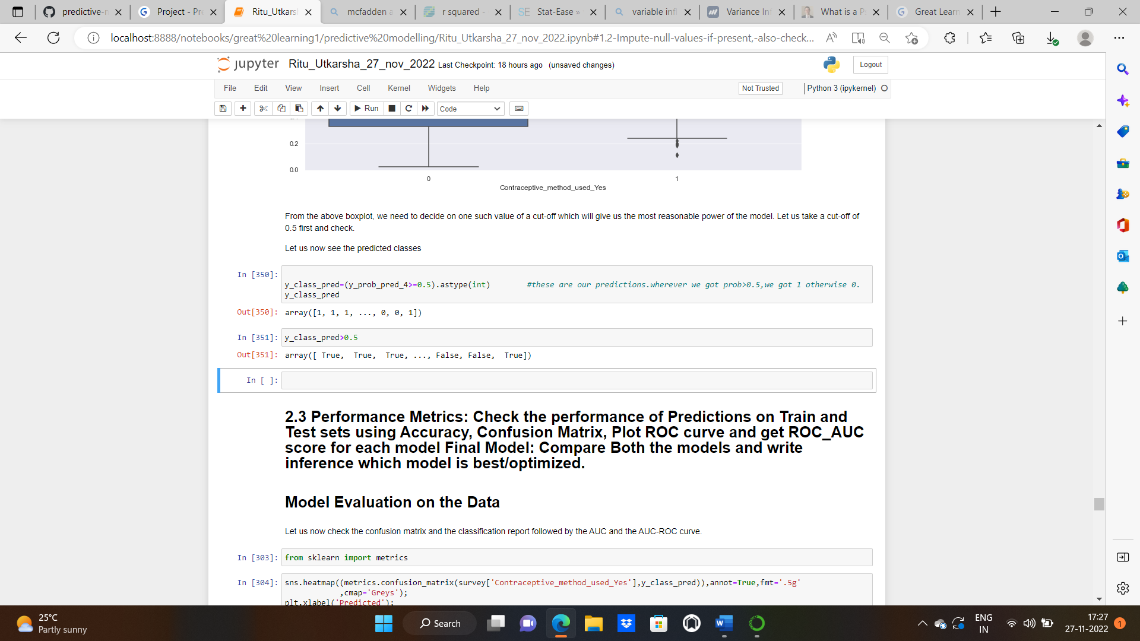

**2.3 Performance Metrics: Check the performance of Predictions on Train and Test sets using Accuracy, Confusion Matrix, Plot ROC curve and get ROC_AUC score for each model Final Model: Compare Both the models and write inference which model is best/optimized.**

**Solution:**

**MODEL EVALUATION ON THE DATA:**

**Let us now check the confusion matrix and the classification report followed by the AUC and the AUC-ROC curve.**

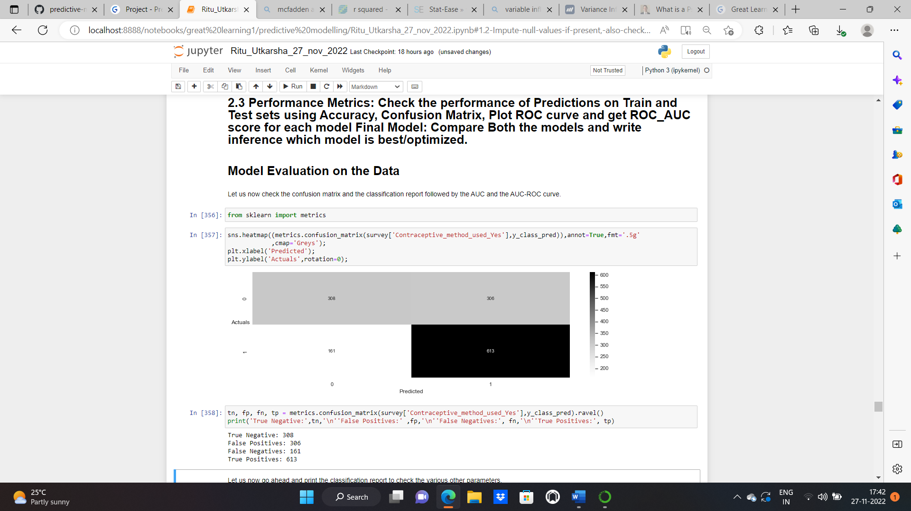

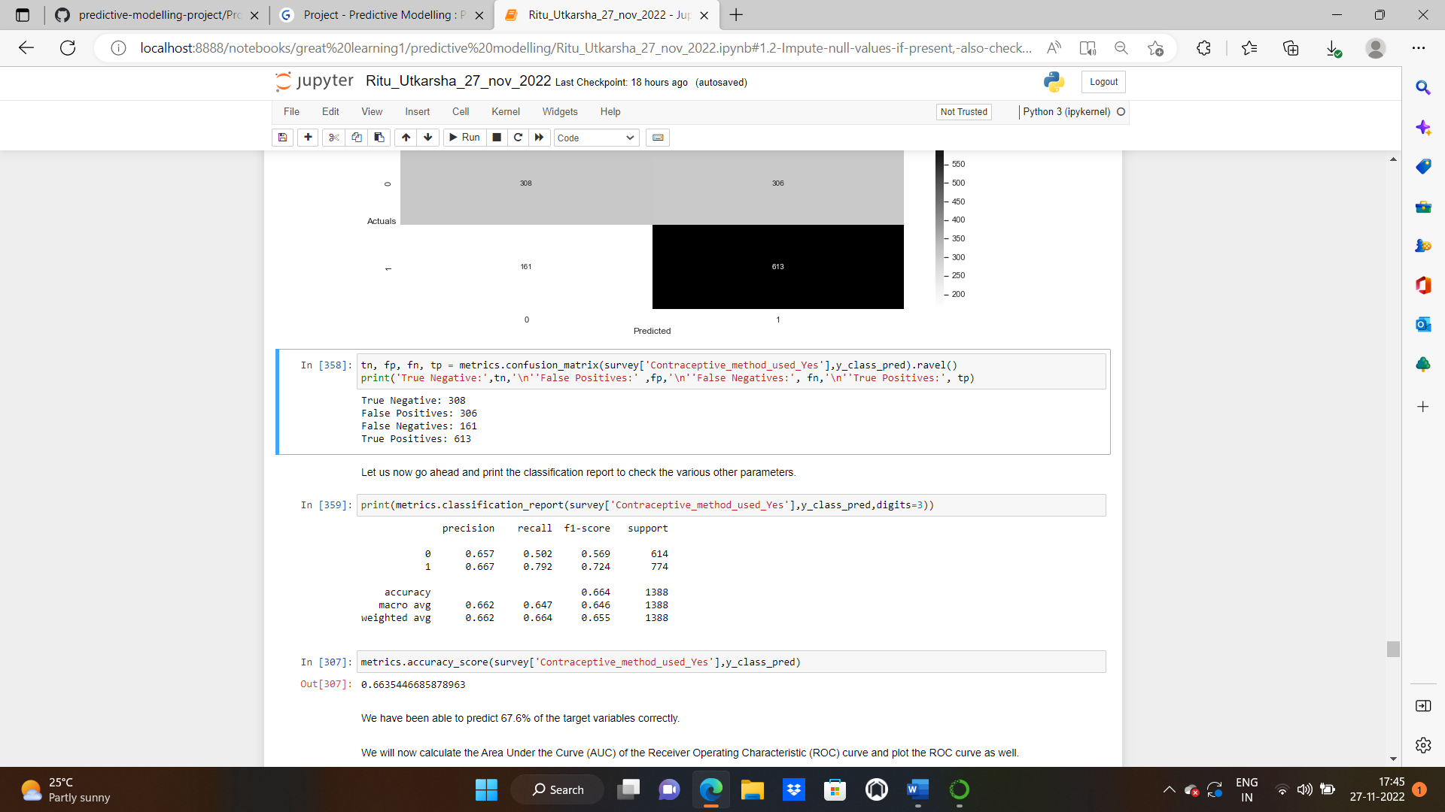

Let us now go ahead and print the classification report to check the various other parameters.

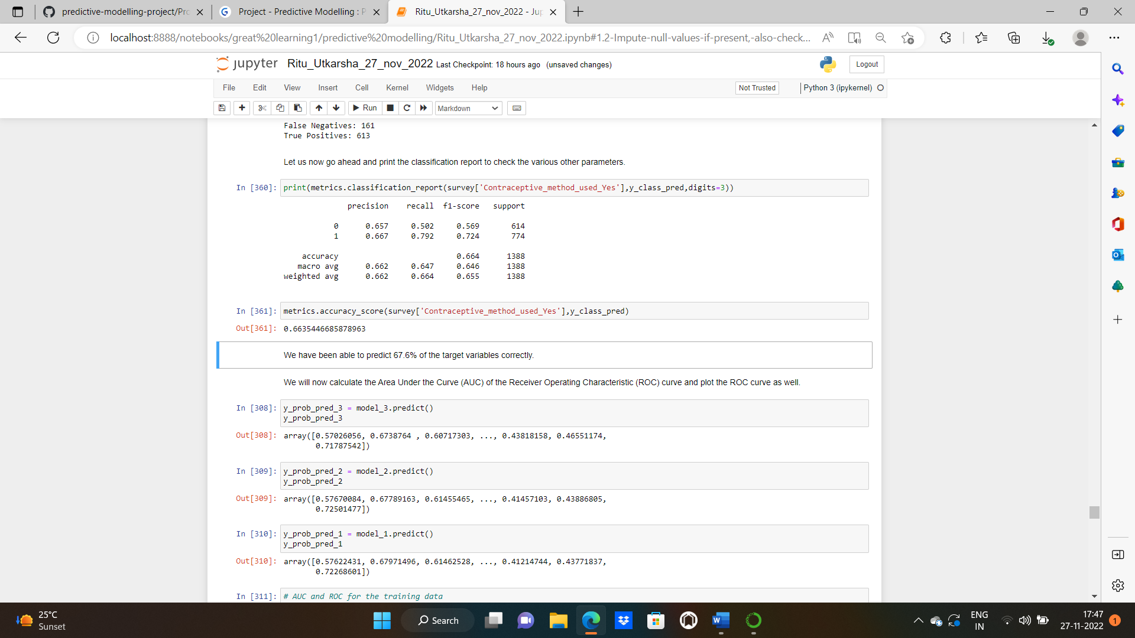

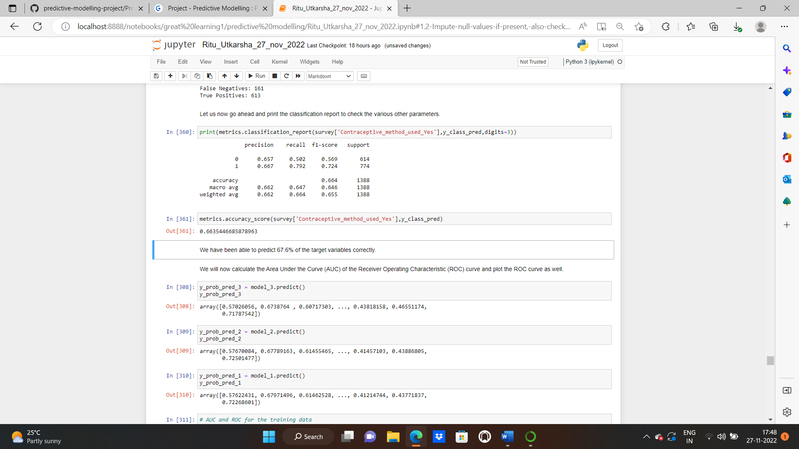

We have been able to predict 67.6% of the target variables correctly.

**Predicted values of model 1,2,3,4:**

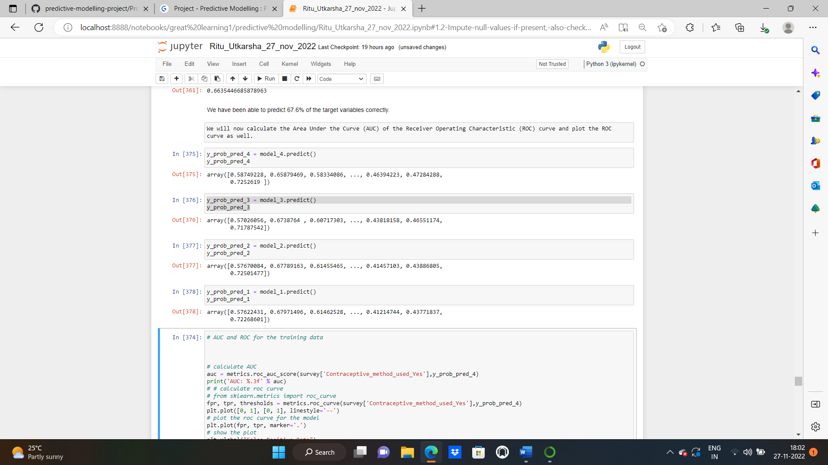

We will now calculate the Area Under the Curve (AUC) of the Receiver Operating Characteristic (ROC) curve and plot the ROC curve as well.

**MODEL_4**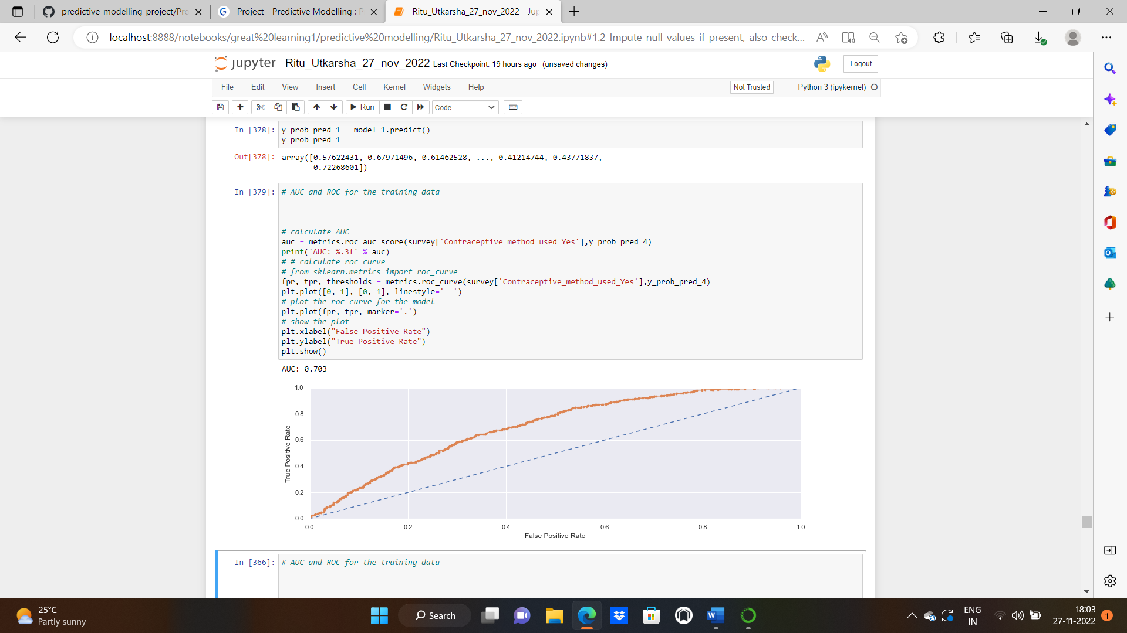

**MODEL_3**

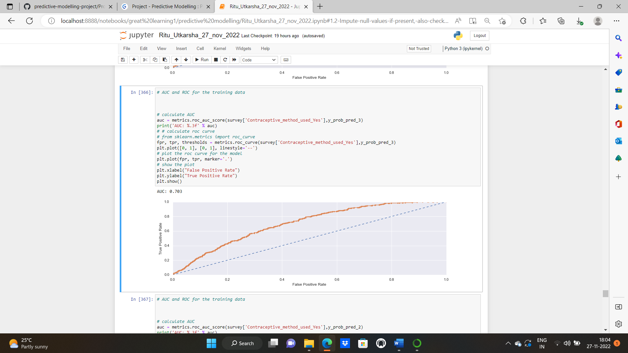

**MODEL_2**

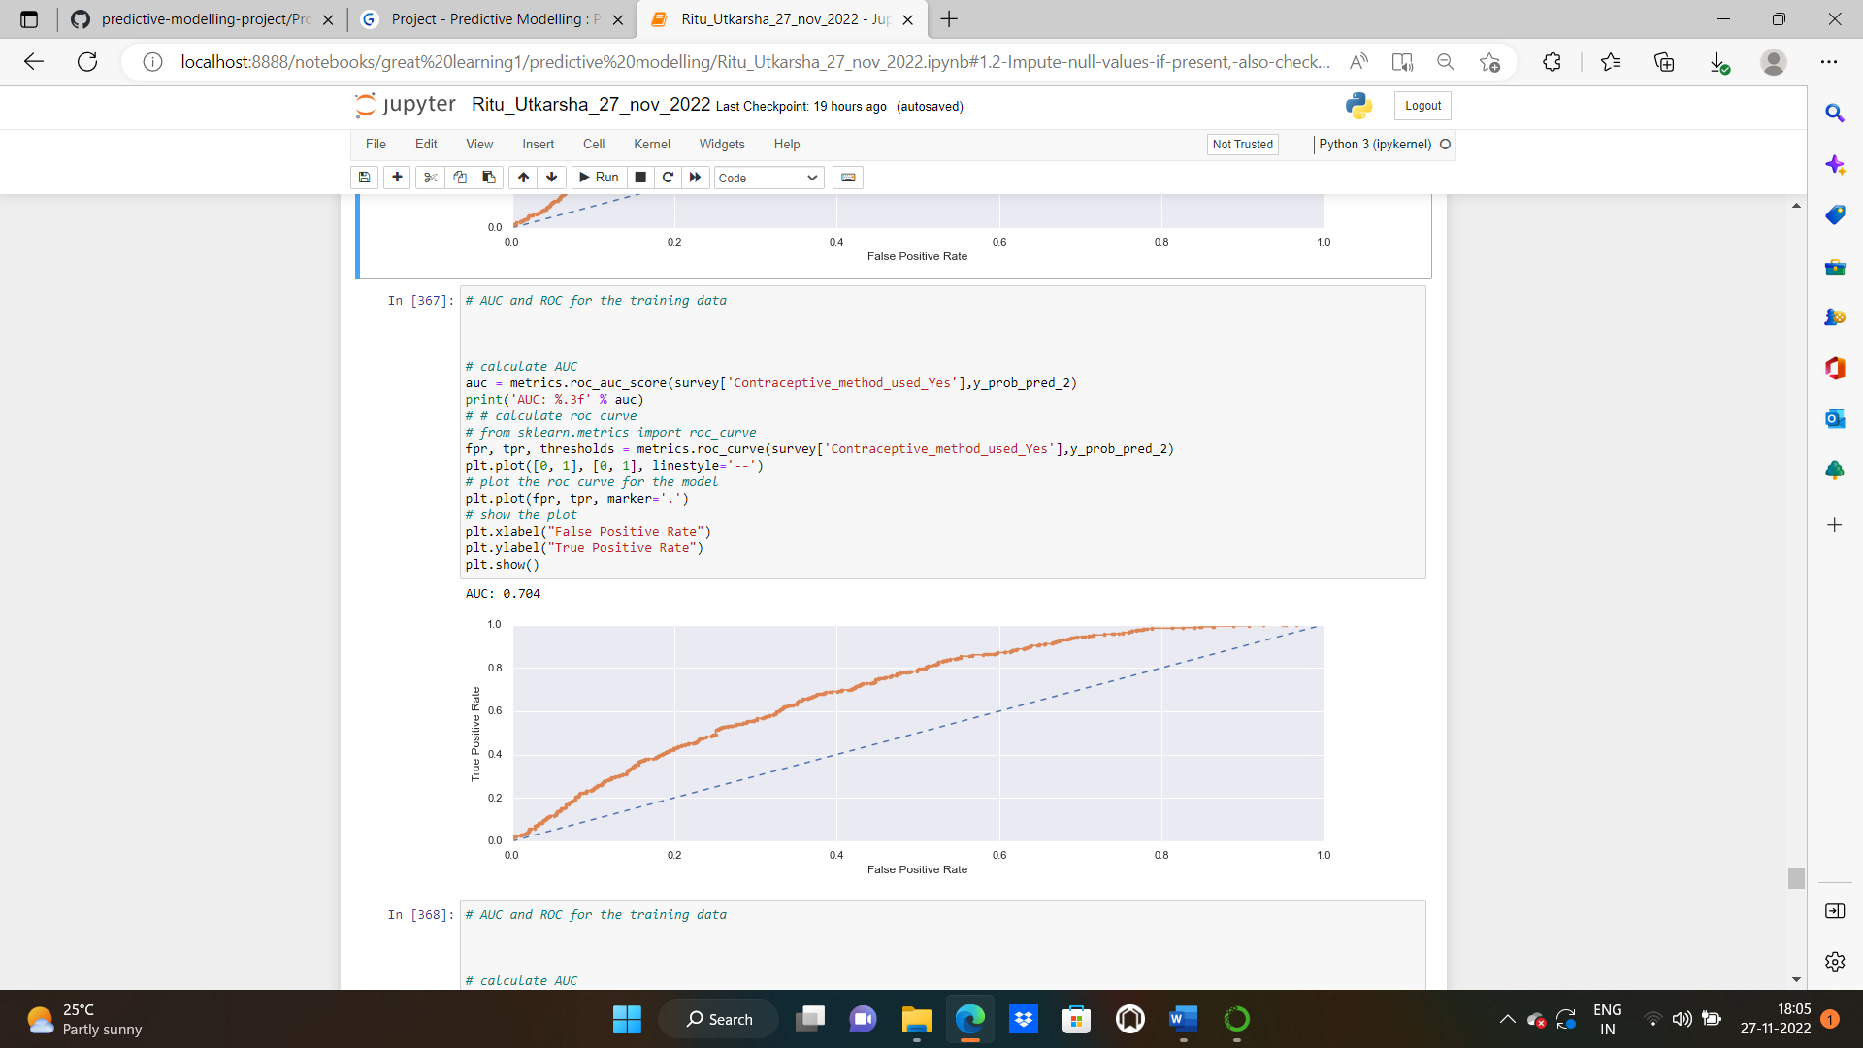

**MODEL_1**

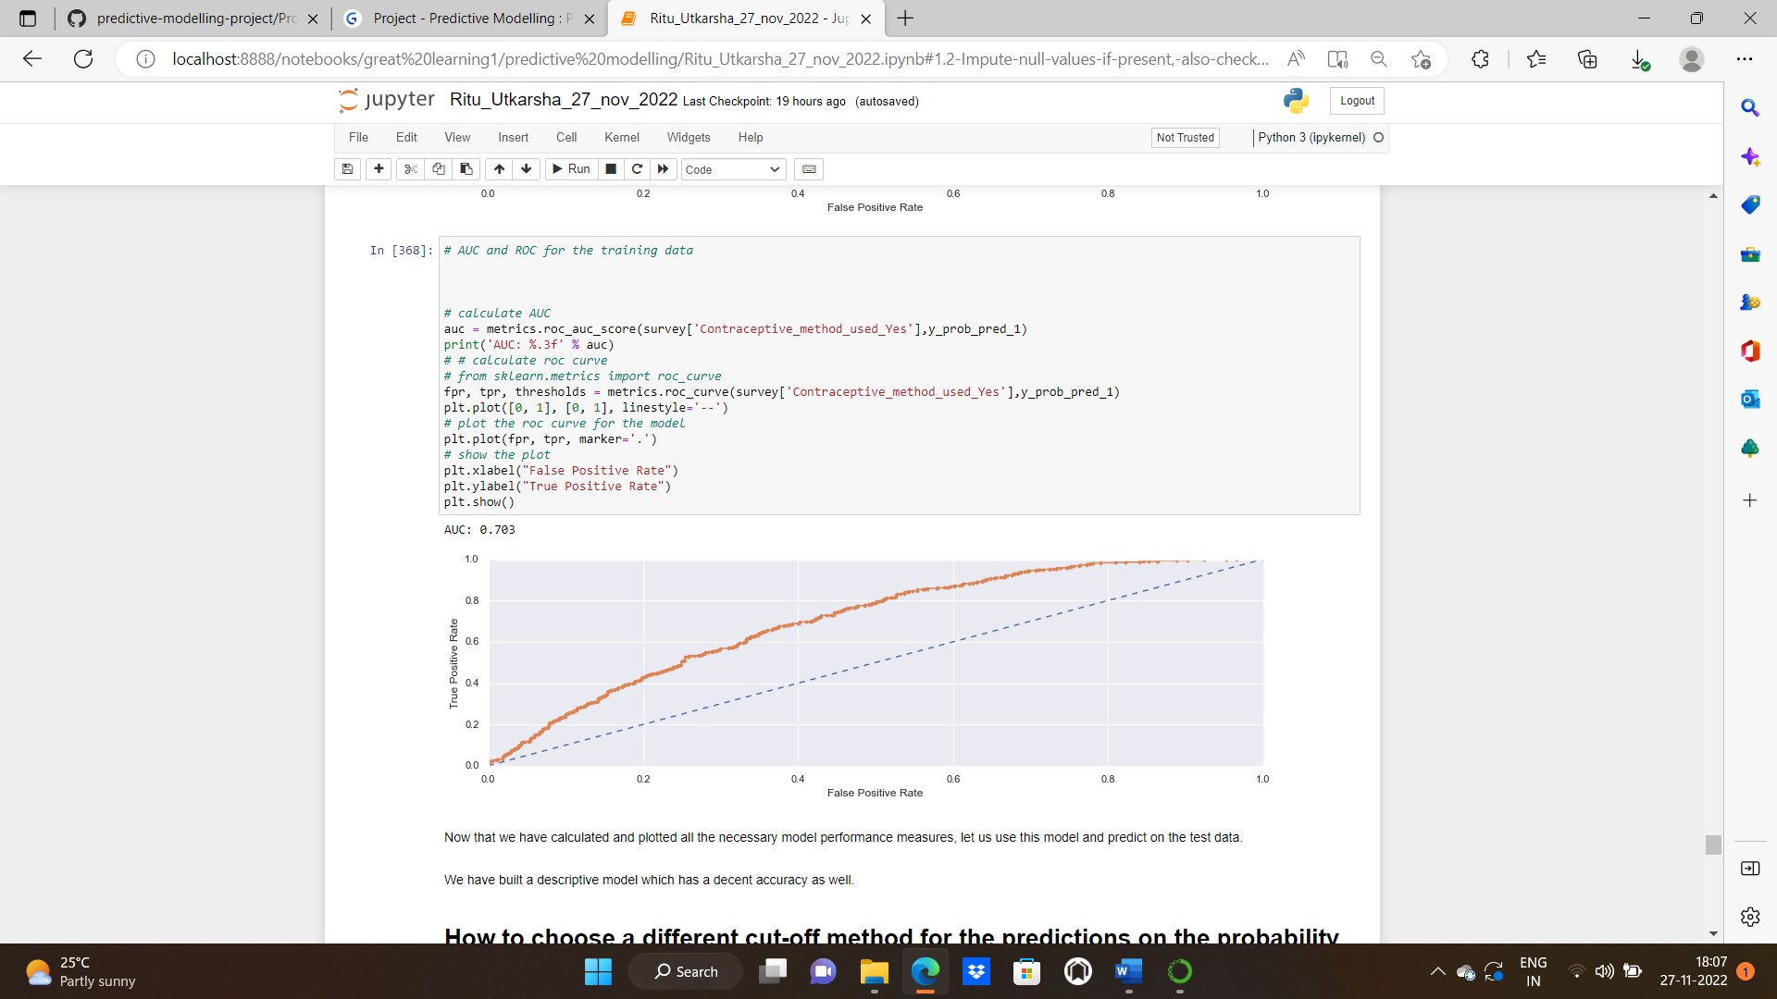

Now that we have calculated and plotted all the necessary model performance measures, let us use this model and predict on the test data.

We have built a descriptive model which has a decent accuracy as well.

How to choose a different cut-off method for the predictions on the probability predictions Data?

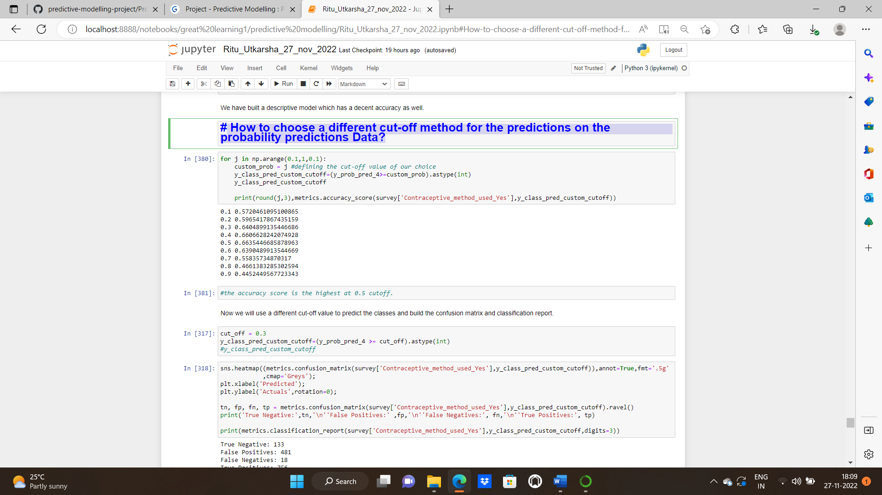

The accuracy score is highest at 0.5 cut-off.

Now we will use a different cut-off value to predict the classes and build the confusion matrix and classification report.

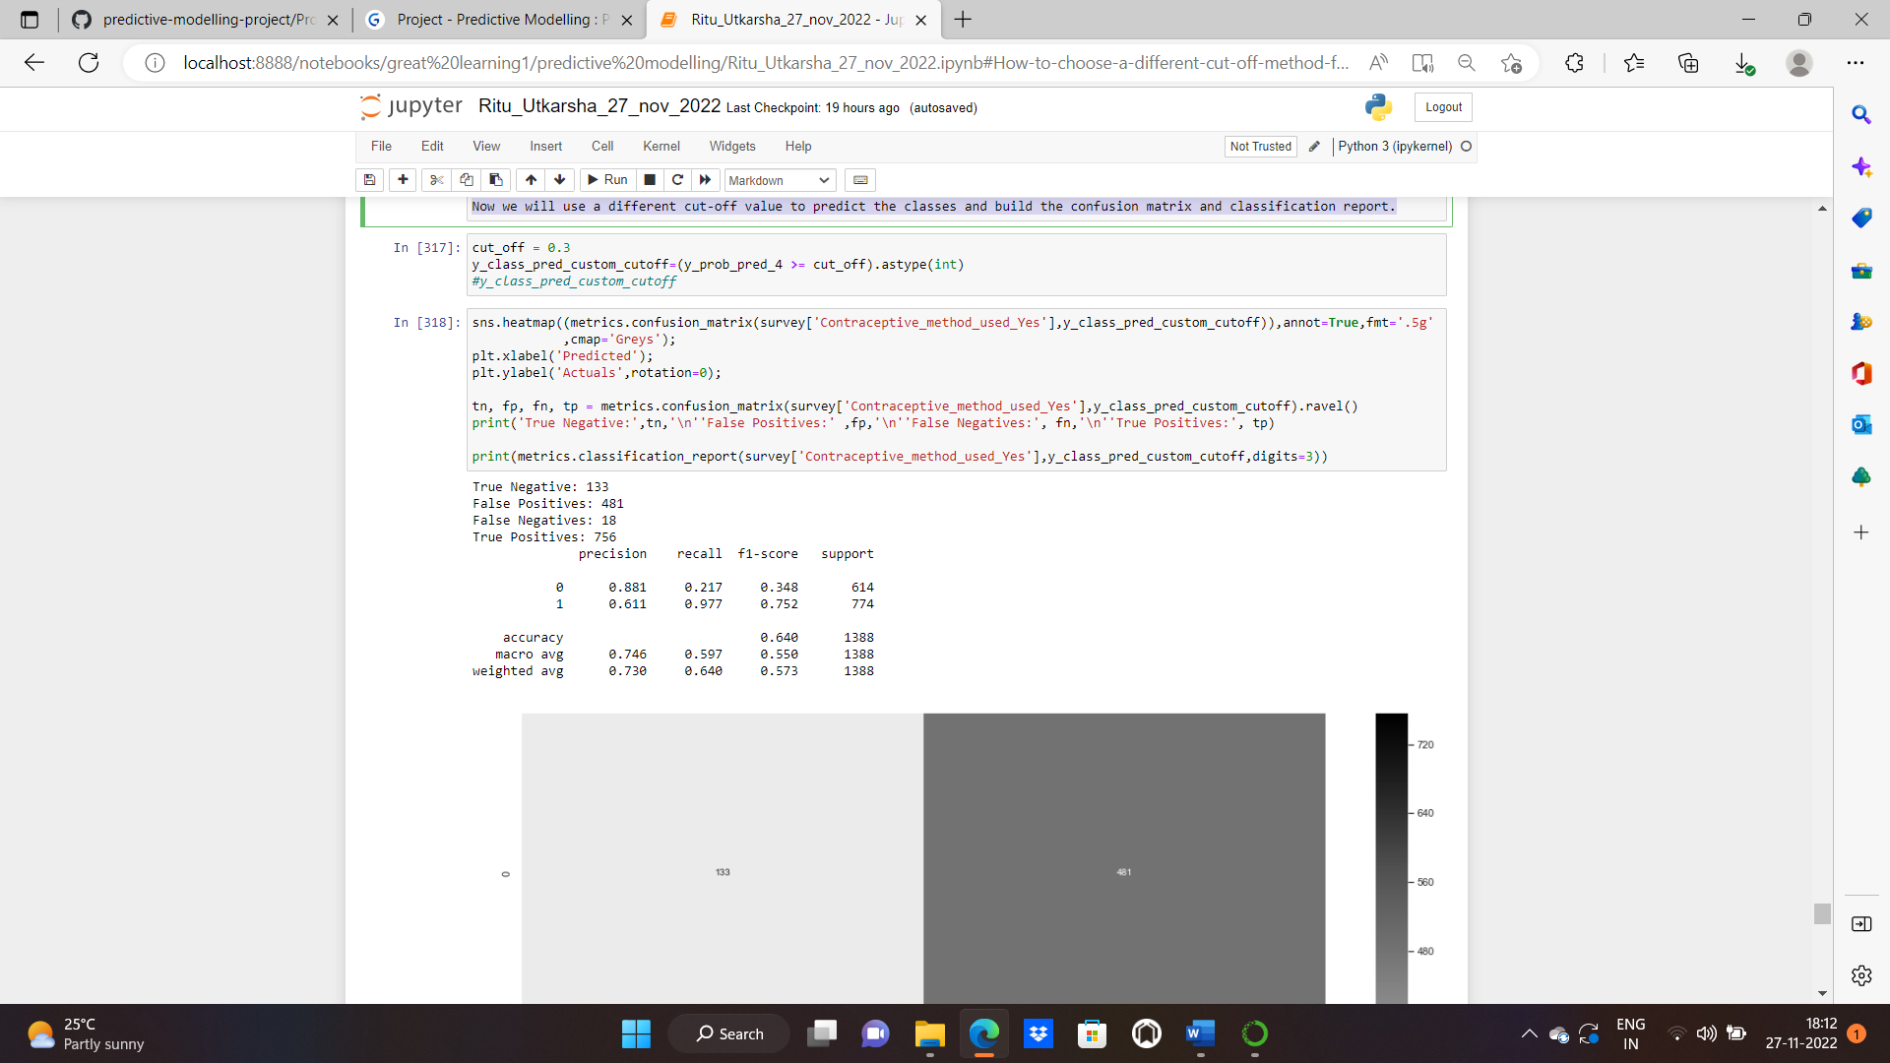

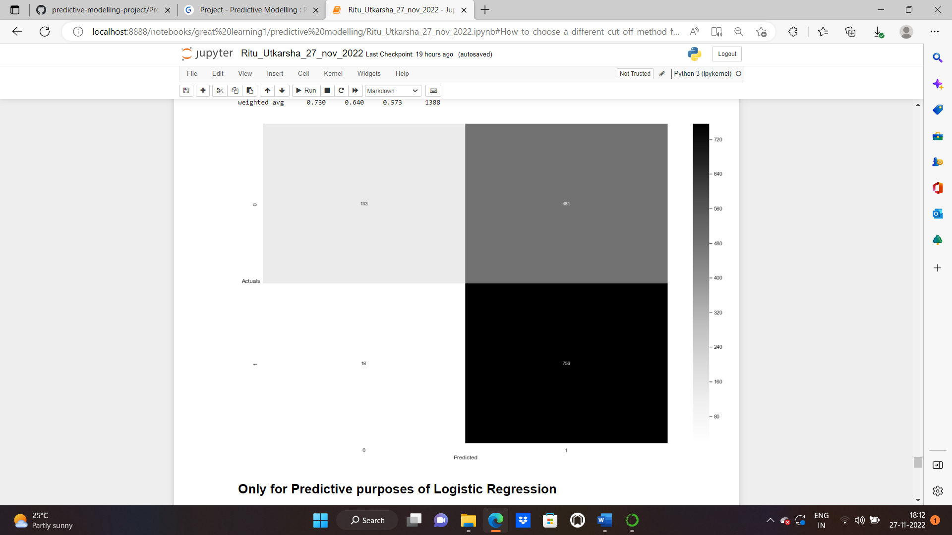

**CONFUSION MATRICES OF ALL THE 4 MODELS BUILT:**

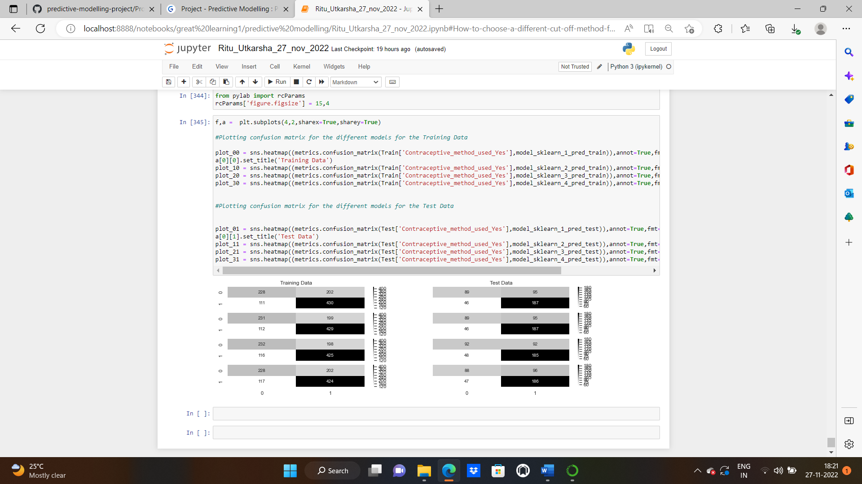

**2.4 Inference: Basis on these predictions, what are the insights and recommendations.**

**Solution:** In the given business problem, we need if they do/don't use a contraceptive method of choice based on their demographic and socio-economic characteristics We have carried out the predictions using 4 models and found out that the model_4 is the optimum one. The pseudo-R square is 0.1067 for the model built. We removed three columns husband_education,husband_occupation and wife_working_yes based on the p value as they were not significant. The accuracy score for my model is maximum at 0.5 cut off. We have been able to predict 67.6% of the target variables correctly. We plotted ROC Curve for all the 4 models and area under the curve is 0.703 in all the models.